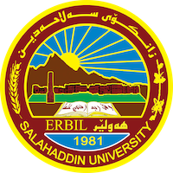
Academic Curriculum Vitae
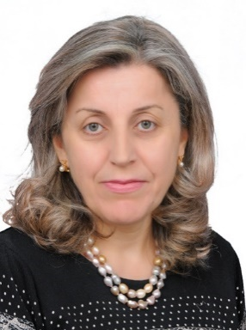
Personal Information:
Full Name: Shangar jamal Naqshbandi
Academic Title: Lecturer
Email: shangar.tajadeen@su.edu.krd
Mobile: 07512356084

Education:
Master of Administration / 2000
Institute of Arab History and Scientific Heritage  Iraq |  | A scientific heritage  Master of Arts | 2000-01-01
Academic Title: Lecturer

Employment:
- State employment starting from first employment

- Job Title (Research Assistant), Presidency of Salah Al-Din University / Dar Al-Kutub, 1989

- In 1991 she worked in the General Registration and Admission Center

- In 1998, she worked at the Information Technology Center / Presidency of Salah Al-Din University

- 2006-2010, member of the UNISCO Committee

From 2011 to 2012, she worked in postgraduate studies at the presidency of Salahaddin University
- 2013 I moved to the College of Administration and Economics / Salahuddin University

Qualifications
- Teaching qualifications
- IT qualifications
- Language qualifications such as TOEFL, IELTS or any equivalent
- Any professional qualification
- You could put any professional courses you have attended

Teaching experience:
- State all teaching courses you delivered, stating undergraduate or post graduate
- Courses, trainings, lab supervision, etc.,

Research and publications
Factors affecting job satisfaction of members
Teaching staff of Salahuddin University professors
An exploratory study of the opinions of a sample of professors of the faculties of Salah al-Din University
Assistant Lecturer Shankar Jamal Tajuddin
العوامل المؤثرة على الرضا الوظيفي لاعضاء
الهيئة التدريسية لاساتذة جامعة صلاح الدين
دراسة استطلاعية لأراء عينة من أساتذة كليات جامعة صلاح الدين
مدرس مساعد شنكار جمال تاج الدين

Conferences and courses attended
- Give details of any conferences you have attended, and those at which you have presented delivered poster presentations.

Funding and academic awards
- List any bursaries, scholarships, travel grants or other sources of funding that you were awarded for research projects or to attend meetings or conferences.

Professional memberships
- List any membership you hold of any professional body or learned society relevant to your research or other life activities.

Professional Social Network Accounts:

- List your profile links of ReserchGate, LinkedIn, etc.

It is also recommended to create an academic cover letter for your CV, for further information about the cover letter, please visit below link:
https://career-advice.jobs.ac.uk/cv-and-cover-letter-advice/academic-cover-letter/

