Lec. 1
Insect physiology
Introduction
Insects are the most diverse of all organisms on earth. Their general body plan allows for this great diversification in form. Insects are arthropods meaning they have an external skeleton that covers the internal tissues. The exoskeleton protects the internal tissue but also allows for sensory systems to function.
Insect physiology is the specialized study of how insects live and reproduce.
The Aim of insect physiology?
The aim of studying insect physiology is to understand the functions of the insects’ internal organs and their different structures and organs and function of each organ.
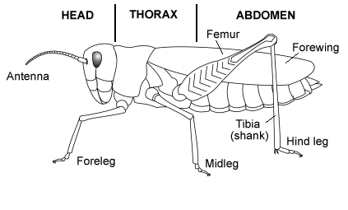
How many body parts do insects have?

Fig. 1 The body parts of insect.

The Body wall of an insect

Integument and Exoskeleton

The integument is the outer protective covering of insects and other arthropoda, forming the exoskeleton or body wall. Unlike
vertebrates that have an internal skeleton(endoskeleton), insects possess a capsule-like exoskeleton. The exoskeleton is produced by the underlying epidermal cells and is separated from the hemolymph by a basement membrane.

Roles And Functions of integument

1- Determine the habit of the insect body (form, surface markings).
2- Protects against harmful external effects (mechanical, physical, chemical and biological).
3- Keeps water, ion and thermal balance.
4-External skeleton (exoskeleton) providing places for muscle attachments within the body.
5. Forming Walls of fore gut, hind gut and external genitalia.
6. Forming Trachea system and sensory organs
7. Protection against germs and other parasites.

STRUCTURE, PARTS OF THE INTEGUMENT
- Cuticle (epicuticle & procuticle)
- Epidermis (hypodermis)
- Basement membrane

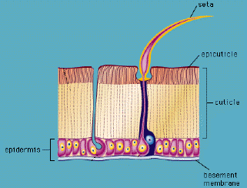
Fig. 2 General structure of the insect integument

The outer most layer, the Epicuticle, is the thinnest layer with its primary function of water protection. Lipids are found on the
surface of the epicuticle to provide protection against water loss in terrestrial insects and water gain in aquatic insects.
The exocuticle and endocuticle make up the majority of the
thickness of the exoskeleton.
These layers are primarily made up of a protein and chitin
complex that is held tightly together with small molecular
weight.

Epicuticle
The thin, top layer of the cuticle, consisting of the inner and outer epicuticles, the wax layer, and the cement layer.
Exocuticle
The outer layer of the procuticle that is sclerotized and incapable of resorption.
Endocuticle
The innermost layer of the cuticle secreted by epidermal cells. It is unsclerotized and capable of being resorbed during the molting process.
Procuticle
The undifferentiated chitinous cuticle that develops into the endocuticle and exocuticle.
Epidermis
The single layer of cells that secrete the cuticle.
Basement membrane

The innermost layer of the integument that is secreted by hemocytes, forming a continuous layer of connective tissue that separates the body cavity from the integument.

Dermal gland
A modified epidermal cell that produces the cement layer, as well as defensive secretions and pheromones.
Moulting (Ecdysis)
As an insect grows it needs to replace the rigid exoskeleton, regularly Moulting may occur up to three or four times or, in some insects, fifty times or more during its life. A complex process controlled by hormones, it includes the cuticle of the body wall, the cuticular lining of the tracheae, foregut, hindgut and endoskeletal structures. The time interval between the two subsequent molting is called as Stadium and the form assumed by the insect in any stadium is called as Instar.
The stages of molting
Step 1: Apolysis-separation of old exoskeleton from epidermis.
Step 2: Secretion of inactive molting fluid by epidermis.
Step 3: Production of cuticulin layer for new exoskeleton .
Step 4: Activation of molting fluid.
Step 5: Digestion and absorption of old endocuticle .
Step 6: Epidermis secretes new procuticle.
Step 7: Ecdysis -- shedding the old exo- and epicuticle.
Step 8: Expansion of new integument.
Step 9: Tanning - sclerotization of new exocuticle.

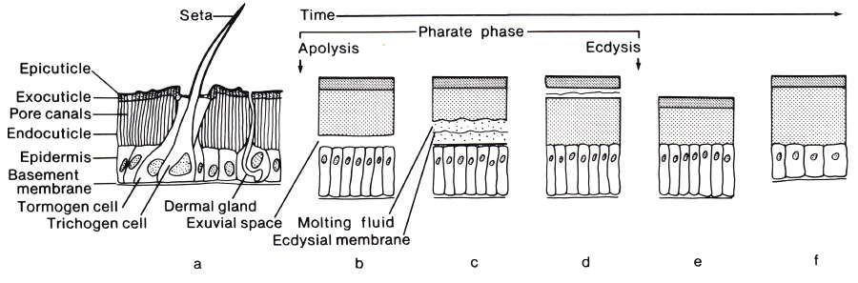
Fig (3) The stages of molting

Insect colouration: types and functions
Pigment and structural colouration in insects
Most insects exhibit colours via absorption or reflection of sunlight using pigments, cuticular surface structures, or their combination. Only some springtails, flies, and beetles possess luciferases—enzymes, which catalyze light-producing biochemical reactions, being capable of bioluminescence Several classes of pigments are involved with insect colouration. Generally, melanins produce shades from black to reddish-brown, and pterins, ommochromes, and carotenoids contribute to red, orange, and yellow colours Furthermore, flavonoids, which are plant secondary metabolites, also create orange colours in insects .Bile pigments or bilins result in greenish and bluish tints, violet, and golden colours often appear because of structural interference (Chapman et al. 2013) (Fig. 4). Interestingly, some insect taxa have specific pigments, like aphins, producing a variety of tints in aphids and papilochromes, resulting in yellow, orange, and red colours in butterflies. Despite all diversity, melanins and pterins are two prevalent classes of insects’ pigments. Sclerotisation (hardening) and melanisation (darkening) of insect cuticle can act in conjunction, and the appearance of a colour often is the result of both processes (Andersen 2010).
Functions of colour: body protection, signalling, physiology
We consider the variety of colour functions in insects can be summarised as (1) body protection (physical, immunological); (2) signalling (camouflage, warning colouration, rival quality, mate choice), and (3) physiology (thermoregulation, UV-resistance, drought-resistance) (Fig. 5). In many cases, these functions are interacting, which highlights the multifunctional and integrative role of colouration. For example, camouflage and warning colouration can be referred to as both body protection and signaling; or the thermoregulatory function of a colour can also possess a UV-radiation protective component. However, such a simplified classification clarifies the multifunctional and integrating role of colours in the insects’ life (Fig. 6).
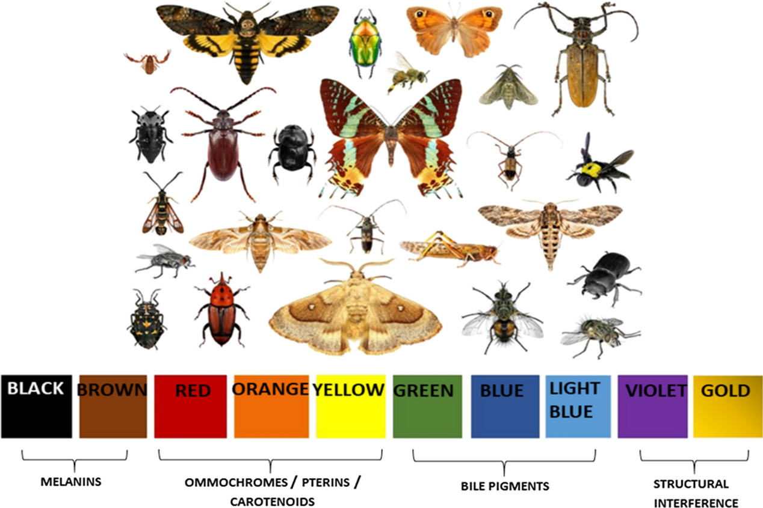
Fig.4 Main classes of pigment- and structure-based colours in insects.

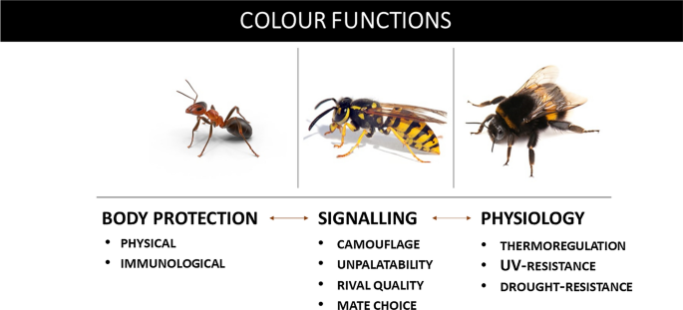
Fig. 5 Interconnections between colour functions in social insects (ants, wasps, and bees).

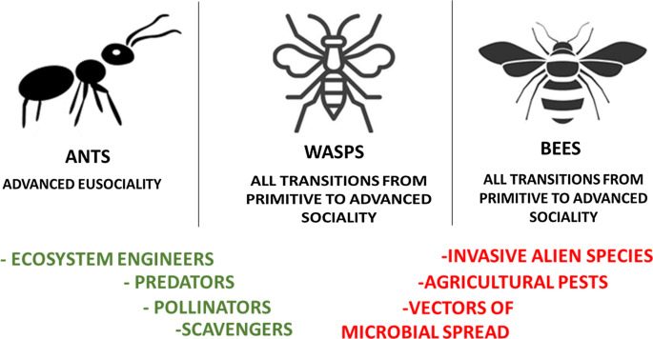
Fig. 5 Main groups of hymenopteran social insects (ants, bees, wasps), demonstrating different levels of sociality, and diverse aspects: (1) positive marked with green) and (2) negative (marked with red) of their ecological role.

