Insects External Anatomy
Lec. 2
Insect Morphology
MORPHOLOGY: IS THE STUDY OF FORM AND FUNCTION.
Insects are arthropods: Arthropoda: "jointed feet"
General characteristics of arthropods:
Exoskeleton
Bilateral Symmetry
Segmented bodies
Paired segmented appendages
Ventral nerve cord
Dorsal heart and open circulatory system
General characteristics of insects:
The body is comprised of 3 distinct body regions -- head, thorax, and abdomen
The thorax of adults bears 3 pairs of legs and 2 pairs of wings if present.
The "breathing" system is comprised of air tubes
The exoskeleton is comprised of( 3) types of sclerites( hardened plates)
Tergites: Dorsal plates
Sternites: Ventral plates
Pleuron: Lateral area, often membranous
The insect head bears: mouthparts, eyes, and antennae.

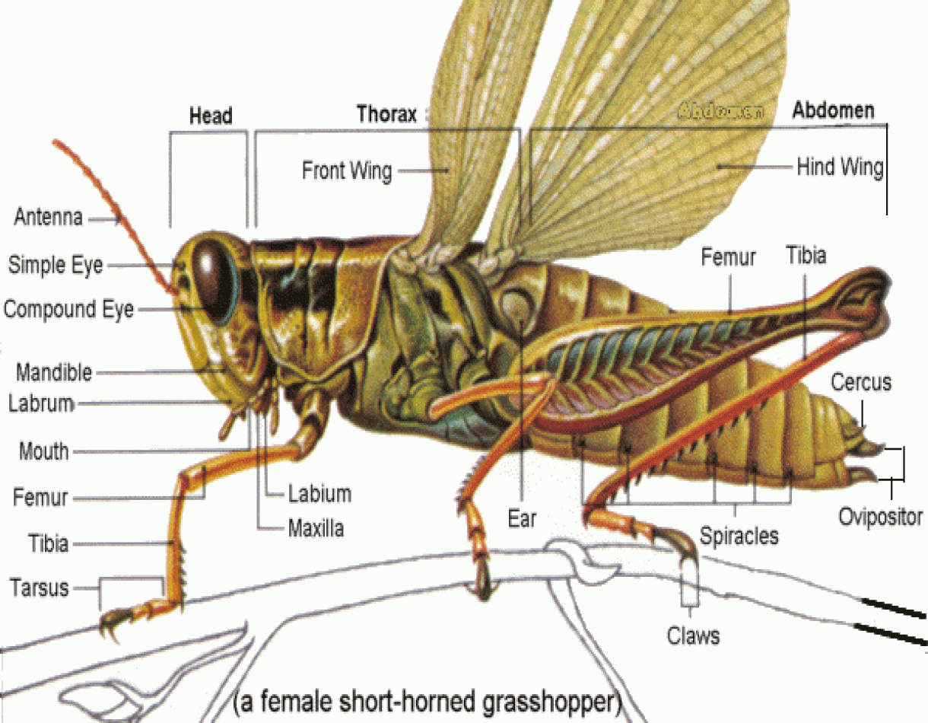
Head
Generally a head has four functions:
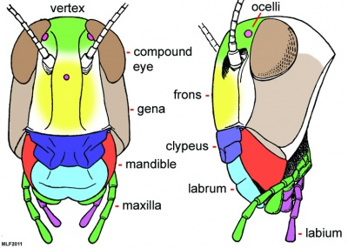
1. For food ingestion
2. For sensory perception
3.To coordinate body activities
4.To protect coordination centers
Mouthparts
Labrum (1) (Upper lip) The labrum partially or completely obscures the mandibles and helps hold food in a position when the insect feeds.
Mandibles (2) (upper jaws) A pair of jaws for crushing or grinding the food.
Maxillae (2) (More jaws) Sensory in function, taste.
Labium (1) (Lower lip) Typically, together with the maxillae, the labium assists manipulation of food during mastication.
Hypopharynx (1) (A tongue-like process that helps mix food and saliva)
Labrum-epipharynx (1) (Fleshy inner surface of labrum - sensory)

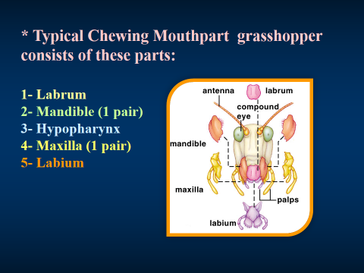

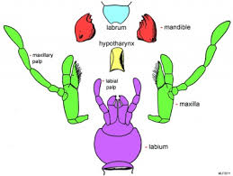
The mouthparts of Cockroaches

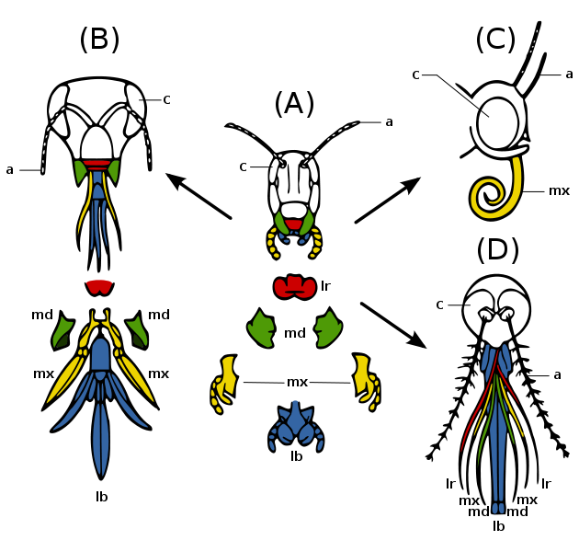
Modifications of mouthparts

The antennae

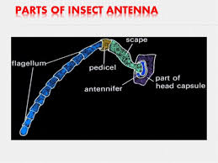

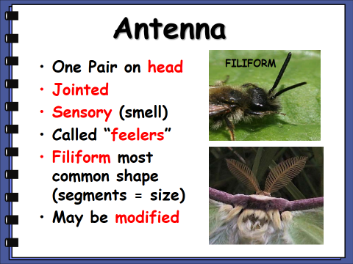
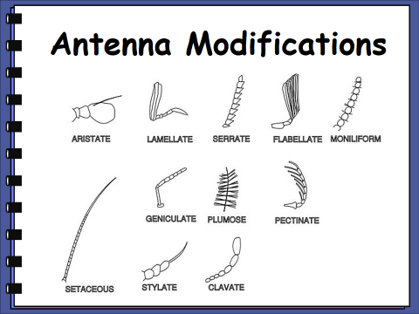

The legs

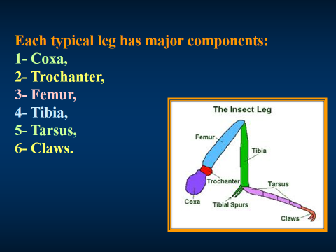

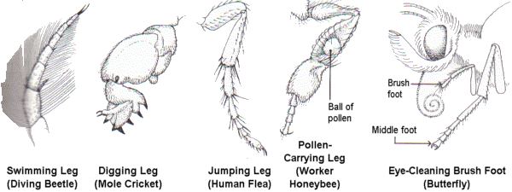
The modifications of insect legs

The wings
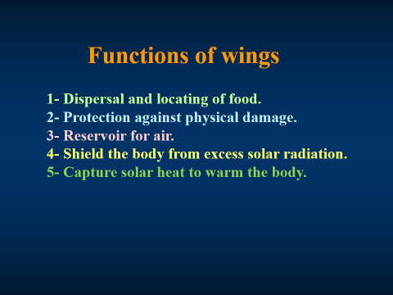

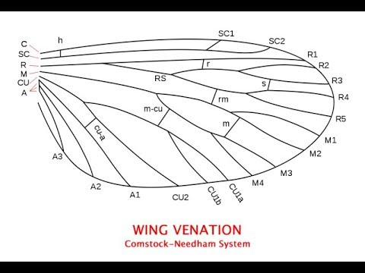

Abdomen

