**Lec. 5**

**The Open Circulatory System**

Vertebrates have a closed circulatory system of blood vessels with **arteries**; **veins** and **capillaries**. In insects however, ‘blood’ or **hemolymph** The blood consists of haematocytes and plasma,it is simply flowing through the body cavities driven by a primitive tube-like heart located in the dorsal part of the abdomen which is divided into chambers separated by small valve-like openings called ostia, through which blood enters the heart. Each chamber has a pair of alary muscles which expand and contract to facilitate the flow of haemolymph through the heart. Apart from the heart, independent accessory pulsatile organs can be found at the base of the antennae and legs to enhance their supply of blood. The section of the dorsal vessel after the heart does not possess valves or musculature but is instead simple tube called the aorta which facilitates transport of the hemolymph to the head (anterior end), where it empties into the body cavity.

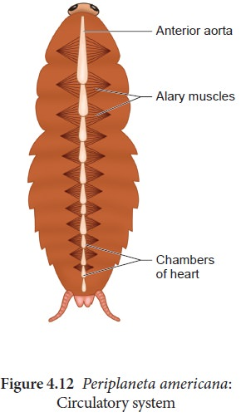

**Fig. (1) Shows the parts of Circulatory system**

**of Cockroaches**

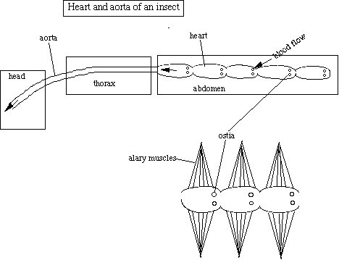



**Fig. (2) Circulatory system of grasshoppers**

**The main characteristics of circulatory system**

1. The major portion of the "blood" or hemolymph is not found within vessels.

2. The circulatory system of insects do not rely transport of oxygen. This instead is done by the tracheal system .

3. Hemolymph enters the dorsal vessel or heart via small openings called ostia.

4. The hemolymph is then pumped towards the head where it then returns to the hemocoel.

**What is hemolymph?**

Is a clear fluid, colourless ,or (slightly yellow and green) because of certain pigments. Is being about 5-40% of the total body weight with pH 6-7 slightly acidic.

**Contents of hemolymph**

1. Plasma (watery fluid) - about 90% , The water in the plasma serves as a useful reserve, and allows the insects to withstand considerable desiccation. Under such circumstances the blood becomes more concentrated and more viscous.

2. Inorganic ions - dissolved salts of Na, K, Ca, Mg.

3. Organic molecules - amino acids, sugars, lipids, glycerol& hormones.

4. Blood cells (hemocytes)

**A hemocyte** is a cell that plays a role in the immune system of invertebrates.It is found within the hemolymph. Most of the

haematocytes are phagocytic leucocytes. These alter considerably in appearance at different stages of development, assuming many different forms.

**Hemocytes functions**

1. Phagocytosis:- Phagocytosis is characterized by the uptake of large particles, parts of cells and even whole microorganisms or other cells. Whereas in insects it is achieved by granular cells and plasmatocytes

2. Coagulation

3.Encapsulation of foreign objects including parasite

**Types of Hemocyte cells**

1-Phagocytes 2- Plasmacytes 3- Lamellocytes 4- Prohemocytes

5- Granulocytes 6- Spherulocytes 7- Coagulocytes

8- Fibrocytes 9- Adipocytes 10- Oenocytes

11- Crystal cells 12- Secretory cells

13-Granual leukocytes cells.

**FUNCTIONS OF HEMOLYMPH**

a. Serves as a lubricant for the movement of internal structures relative to one another.

b. It is a hydraulic medium for applying pressure for molting.

c. Hemolymph transports various substances from one tissue to another including wastes.

d. Specialized cells that phagocytosis or encapsulate foreign particles are found in the hemolymph and are very important in the "immune" system of insects.

e. Storage(amino acids & glycerol).

f. Protection (reflex bleeding),the blood sometimes contains poisonous substances; “reflex bleeding” may then protect the insect from attack.

**Functions of the heart**

1) Transport of nutrients around the body

2) Movement of limbs, mouthparts, antennae

3) Moulting - by increasing pressure in certain parts of the body.

4) Thermoregulation, the heat is transferred to other parts of the body via the circulatory system are.

Heat for flying

Heat for brooding eggs and larvae

Heat to kill predator

Heat for maintaining hive temperature in winter.

**The Circulatory Path**

Haemolymph from the body cavities enters the ostia when the alary muscles of the heart chambers relax. The alary muscles then contract to close the ostia and their valve-like structure prevents the haemolymph from returning to the body cavities. The haemolymph moves through the dorsal vessel by continual peristaltic contractions of the alary muscles. The contractions begin at the posterior chamber of the heart and continue forward, pushing the haemolymph anteriorly, toward the aorta the continual pumping pushes the haemolymph through the aorta and into the head, where it bathes the organs and muscles, and then flows back down the body via a series of cavities until it reaches the abdomen and re-enters the heart.

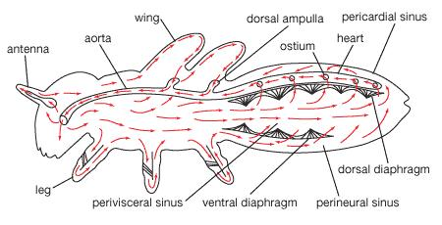

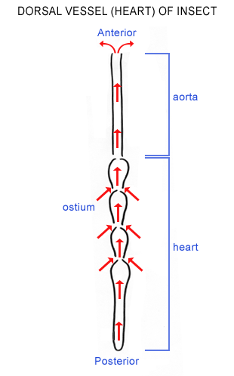



**The difference between insect blood and the blood of**

**vertebrates**

The major difference between insect blood and the blood of vertebrates

1. Humans, is that vertebrate blood contains **red blood cells.** Insects and other invertebrates, on the other hand, have what is called hemolymph heterogeneous fluid with yellow or green
2. Unlike the closed circulatory system found in vertebrates, insects have an open system lacking arteries and veins. The hemolymph thus flows freely throughout their bodies, lubricating tissues and transporting nutrients and wastes.
3. Whereas the vertebrate circulatory system serves primarily to carry oxygen throughout the body.
4. Insects do have hearts that pump the hemolymph throughout their circulatory systems. Though these hearts are quite different from vertebrate hearts.