**Lec. 7**

**Respiratory system (Ventilation system)**

All insects are aerobic organisms they must obtain oxygen (O2) from their environment to survive. The respiratory system of insects (and many other arthropods) is separate from the circulatory system. It is **a complex network of tubes (called a tracheal system) that delivers** **oxygen-containing air to every cell of the body**. Air enters the insect's body through valve-like openings in the exoskeleton.

Insects don't have lungs. The open respiratory system consists of air-filled tubes or tracheae, which open at the surface of the thorax and abdomen through paired [spiracles](https://www.britannica.com/science/spiracle). The muscular valves of the spiracles closed most of the time, open only to allow the uptake of oxygen and the escape of [carbon dioxide](https://www.britannica.com/science/carbon-dioxide). The tracheae are stiffened by spiral thickenings or threadlike ridges called taenidia.

The taenidia keep the tracheae swollen thus allowing free passage of air, the tracheae branch repeatedly, becoming reduced and ending in fine thin-walled tracheoles less than one micron in diameter.

The tracheoles insinuate themselves between cells, sometimes appearing to penetrate them, and push deeply into the plasma membrane. In addition, the most active insects have large thin-walled dilatations of the tracheae called [air sacs](https://www.britannica.com/science/air-sac), which serve to increase the volume of air displaced during respiratory movements.

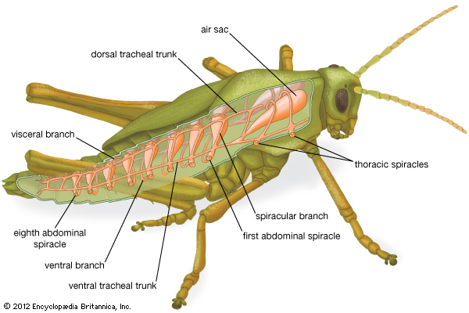

**Fig. 1 The respiratory system of a grasshopper, showing spiracles in the thorax**

**and abdomen.**

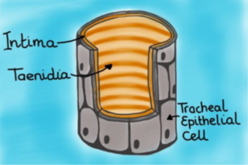

**Fig. 2 The structure of the trachea**

**Air sacs** are found as tiny **sacs** off the larger breathing tubes (tracheae) of **insects**, as extensions of the lungs in birds, and as end organs in the lungs of certain other vertebrates. They serve to increase respiratory efficiency by providing a large surface area for gas exchange.

**What do air sacs do in insects?**

❖ Act as air reservoir

❖ Shiny white vesicle, filled with air

❖ Assist flight by reducing gravity of insects

❖ Sound resonator of tympanic membrane

❖ Heat insulations

Larger insects may require active **ventilation** of the tracheal system (especially when active or under heat stress). They do this by opening some spiracles and closing others by using abdominal muscles to alternately expand and contract body volume.

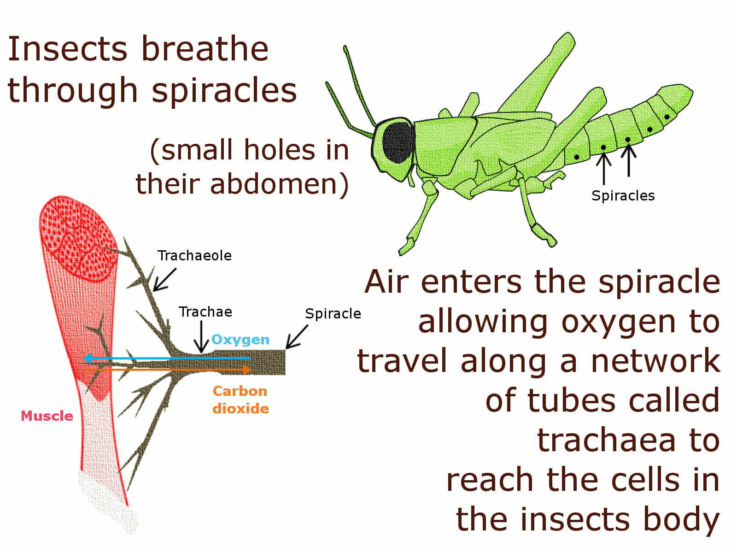

**Fig.3 Gaseous exchange of a grasshopper, showing spiracles in the abdomen.**

**Tracheae**

The tracheae are the larger tubes of the tracheal system, running

inward from the spiracles and usually breaking up into finer branches,

tracheae are formed by invaginations of the ectoderm and so are lined by a cuticular intima which is continuous with the rest of the cuticle.

**Tracheoles**

The tracheae give rise to finer tubes, the tracheoles. There is no

sharp distinction between tracheae and tracheoles, but the tracheoles always appear to be intracellular and often retain their cuticular lining at molting, which is not usually true of tracheae. They are formed in cells (often called tracheoblasts, which are derived from the epidermal cells lining the tracheae.

**Gaseous exchange**

**Oxygen** passes through the tracheal system to the tissues and ultimately must reach the mitochondria to play a part in oxidative processes.

**Carbon dioxide** follows the reverse path.



**Fig. 4 Gaseous exchange of tracheal system**

**Functions of the respiratory system:**

1. Provide the cells and tissues with oxygen.

2. To eliminate carbon dioxide a product of cellular respiration.

3. To work in conjunction with the circulatory system in providing

oxygen to the flight muscle system.

4. New hypothesis is that it prevents the accumulation of toxic oxygen molecules.

**The structure of spiracles**

The visible opening to outside leads into a cavity, the atrium, from which the tracheae arise.

The opening and the atrium is known as spiracle.

The wall of the atrium is lined with hairs which filter out dust.

In some Diptera, Coleoptera and Lepidoptera the spiracles are covered by a sieve plate with large numbers of pores (prevention of dust or from entry of water in aquatic insects).

**Opening and closure of the spiracles**

1. When closure muscle relaxes, the spiracles are opened.
2. When closure muscle contracts the spiracles are closed.

**What regulates their opening and closing?**

Under the control of the nervous system.

**Gas Exchange in Aquatic Insects**

Even aquatic insects use a tracheal system for gas exchange.

* Some, like mosquito larvae ("wigglers"), get their air by poking a breathing tube — connected to their tracheal system — through the water surface called Siphon.



* Some insects that can submerge for long periods carry abubble of air with them from which they breathe.



* Still others have spiracles mounted on the tips of spines. With these they pierce the leaves of underwater plants and obtain oxygen from the bubbles formed (by [photosynthesis](http://www.biology-pages.info/L/LightReactions.html)) within the leaves.
* Even in aquatic insects that have gills, after oxygen diffuses from the water into the gills, it then diffuses through a gas-filled tracheal system for transport through the body.

