***Lec. 11***

**Endocrine System of Insects Or Neuroendocrine System**

The endocrine organs produce hormones which travel, usually in the blood, to various organs of the body, coordinating their longer

term activities. The endocrine system is thus complementary to the nervous system.

The endocrine glands of insects are of 2 types:

**1) neurosecretory cells** within the central nervous system,

**2) Specialized endocrine glands** such as the corpora cardiaca, corpora allata, and the prothoracic glands.

***Hormones:***

Hormones are biologically active compounds which are produced to control certain life processes and development. Hormones attain to the place of their action through the hemolymph.

***Properties:***

-Hormones work along with the nervous system.

-Their effect is slower and more spreading.

-Most of them are not specific to certain species.

-Their effect can be excitatory or inhibitory.

-Their effect is realized by specific receptors or secondary messenger molecules.

-Their production is under complex control.

-Their secretion is often cyclic and connected to vital processes.

-They often have more places of action (polytropic effect).

-Their marking is based on the English abbreviations: (e.g. MH = moulting hormone, JH = juvenile hormone). in case of species

specificity (e.g., Lom-AKH = *Locusta migratoria* adipokinetic hormone).

***Classification of insect hormones according to the place of production:***

1.A glandular or tissue hormones: produced by special cells (neurosecretory neurons (e.g., neurohormones)

2. glandular or endocrine hormones: produced by epithelial, non-neural tissues, endocrine glands e.g. moulting hormones, juvenile hormones .

***Classification of insect hormones according to their chemical structure:***

1. Peptides – proteins with small or big molecule weight e.g., neurohormones

2. Steroides – compound based on sterane structure e.g., moulting hormones.

3. Terpenoids – certain compounds with sesquiterpene structure e.g. juvenile hormones.

***Neurohormones***

***Properties:***

-Produced by ***neurosecretory*** *(neurocrine)* in the central nervous system

-These cells are filled with secretion and located in typical groups in pairs on both side

-All neurohormones are peptides(***neuropeptides***)

-They are secreted in special anatomical sites into the hemolymph.

**The neurosecretory cell**

-Unipolar neuron, bigger than adjacent other neurons/

-Their secretion particles are white and blue, can be easily detect with histochemical processes.



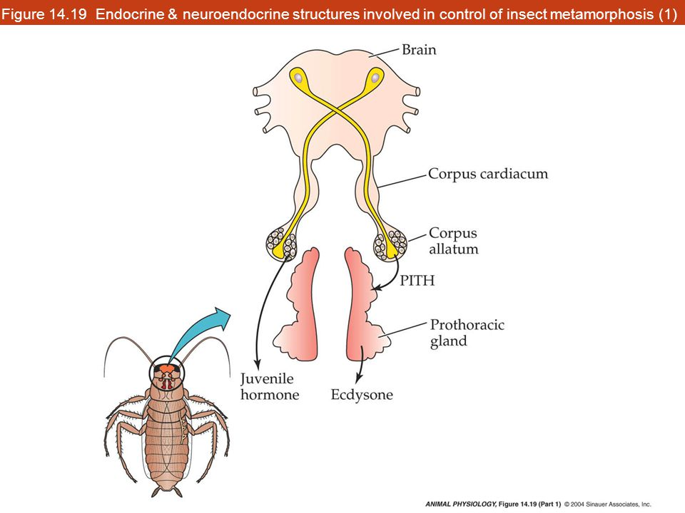

1. **Corpora allata (CA):**

• The corpora allata (CA) are endocrine glands which produce one of the most important hormones for insect development, the juvenile hormone (JH).

• Are seen as a pair of spherical bodies lying on each side of the gut, behind the brain

• In some species, the glands may be fused in a middorsal position above the aorta or each gland may fuse with the Corpus Cardiacum on the same side.

• In larvae of Cyclorrhaph Diptera the CA, CC and the moult glands fuse to form a composite structure, Weismann’s ring, which surrounds the aorta.

• In juvenile insects produce the gonadotropic hormone to indicate its function in adults.



**“ring gland”**

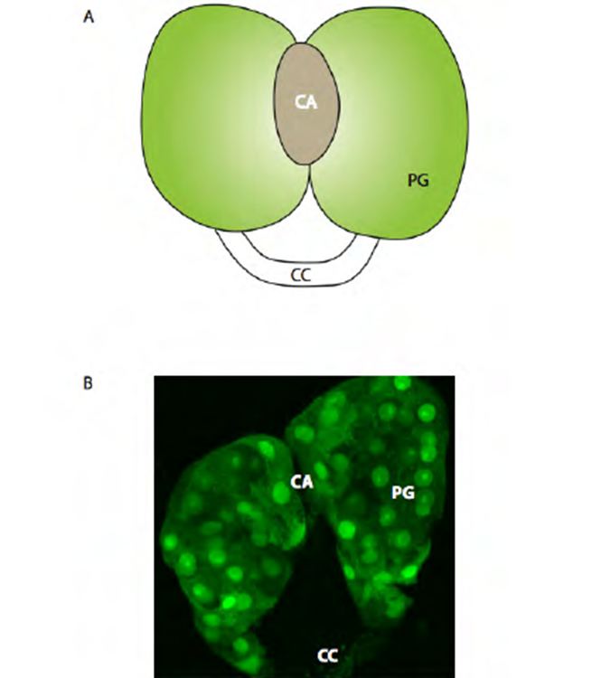

The ring gland organ in Drosophila

**Physiological role of Juvenile Hormones (JH) =** **Metamorphosis – inhibiting hormone.**

The main role of JH in immature insects is to inhibit the genes that promote development of adult characteristics, causing the insect to remain as nymph or larva. During the last larval or nymphal instar, the corpora allatum becomes atrophied and stops producing juvenile hormone.

•Inhibition of metamorphosis at the time of critical developmental stages.

•Its titre is high in the hemolymph till the moultings.

1. **CORPORA CARDIACA**

The **corpora cardiaca** are a pair of organs often closely associated with the aorta, and often forming part of its wall.

They also contain **glial cells**. The corpora cardiaca store and release hormones from the neurosecretory cells of the brain.

In addition, the **intrinsic secretory cells** produce hormones which are concerned with the regulation of the heartbeat.

**Which hormone is secreted by Corpora cardiaca??**

The corpus cardiacum, a transformed ganglion closely associated with the heart, produce a peptide, called the **prothoracicotropic hormone (PTTH)**, which stimulates the prothoracic gland to produce **ecdysone, a sterol hormone.**

1. **prothoracic glands or Molt glands:**

•paired, generally comprises two strips of tissue, frequently branched, which are interwoven among the tracheae, fat body, muscles, and connective tissue of the head and anterior thorax

•In accord with their varied position, they have been called prothoracic glands, ventral head glands, and tentorial glands, though these structures are homologous. The [prothoracic glands](https://en.wikipedia.org/wiki/Prothoracic_gland), which respond by releasing [molting hormone](https://en.wikipedia.org/wiki/Molting_hormone) (an [ecdysteroid](https://en.wikipedia.org/wiki/Ecdysteroid" \o "Ecdysteroid)) into the [haemolymph](https://en.wikipedia.org/wiki/Haemolymph" \o "Haemolymph). Molting hormone stimulates the molting process.