Lecture:2

ABIOTIC FACTORS
These factors are also known as physical factors, non-living factors, and density independent factors.
Physical factors are: Temperature, Moisture, Humidity, Rainfall Light, Atmospheric Pressure , Air currents, Water and Place to live (niche).
TEMPERATURE
Temperature affects directly on the dispersal, distribution, movement, development, metabolism, fecundity, reproduction, and longevity of insect by keeping other parameters constant.
Also, indirectly through influence on food availability (crops) and other environmental factors such as moisture, air movement etc.

Animals are generally divided into two types, Based on the maintenance of body temperatures
• Warm blooded (Endothermic): Animals maintains the body temperatures constant irrespective of atmospheric temperatures. Ex: Mammals, Birds.
• Cold blooded (Ectothermic): Animals change their body temperature when the atmospheric temperature changes. Ex: Insects Sociohomeothermic
animals such as honeybees can able to maintain their body temperatures slightly above the atmospheric temperatures, they maintain their own temperatures inside their colony irrespective of the temperature outside.

Temperature and Insect Development
Temperature is one of the most critical environmental factors influencing rate of insect growth and development (Taylor 1981). Developmental rate is usually used to quantify the effect of temperature.
Temperature regulates seasonal and daily cycles, and thus indirectly influences various aspects of insect biology, such as sex ratio (Zheng et al. 2008), adult life span, survival, fecundity, and fertility (Yang et al. 1994). As a result, temperature profoundly affects colonization, distribution, abundance, behavior, life history, and fitness of insects (Hoffman et al. 2003).
• The optimum temperature for the normal development of insects is 10-35°C and is known as Zone of Optimum or Normal Development.

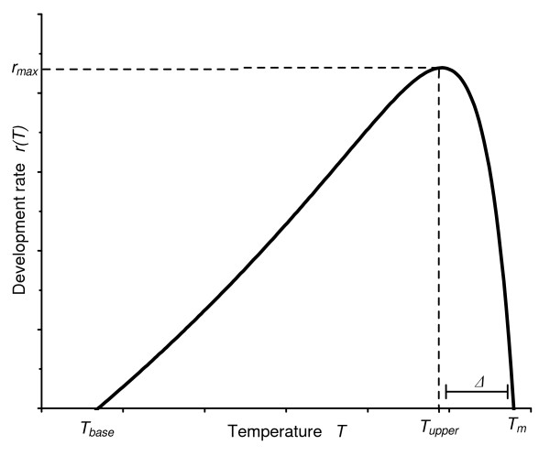

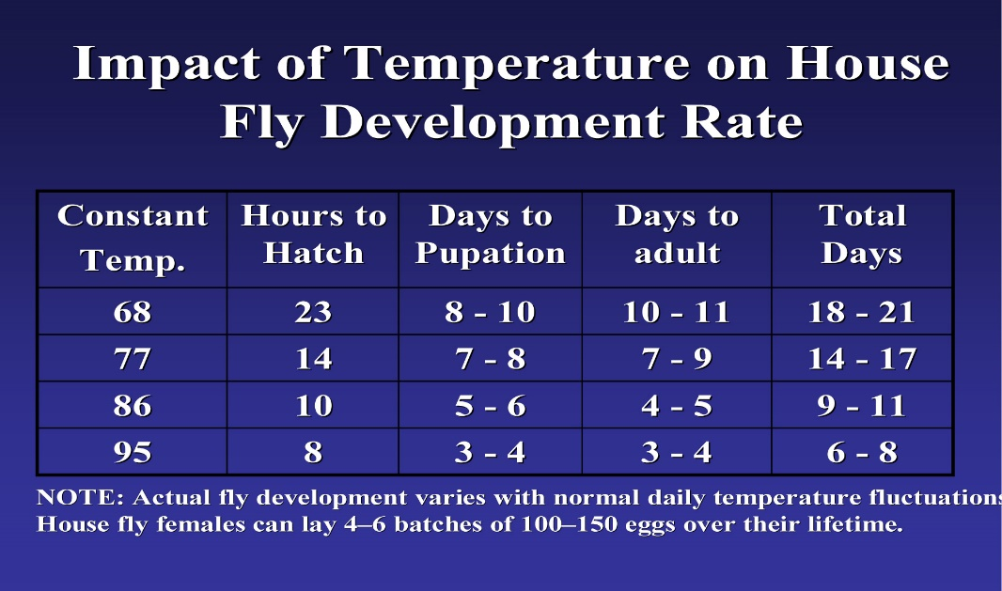

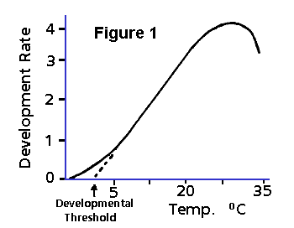
The different temperature zones from low to high are:
Zone of Fatal Low Temperature (-14oC to -5oC).
Zone of Inactivity due to low Temperature(-5oC-10oC).
Zone of effective temperature(10oC-35oC)
Zone of Inactivity due to high Temperature (35oC-50oC)
Zone of fatal high Temperature (50-60oC)
Certain insects do not get freezes even the surrounding temperatures go below the freezing point (cold hardiness/super cooling). These insects have Cryoprotective compounds like glycerol, sorbitol and erythritol which help insects not forming ice crystals in haemolymph by depressing the freezing point.
The freezing point of most insects is between ( -100C to -2oC).

Insects suspend their activities, and these are two types.
• Hybernation is the period of suspended activity in individuals occurring during seasonal low temperatures, while Aestivation is a period of suspended activity in individuals occurring during seasonal high temperatures or in dry season. This reversible inactivity can last for number of weeks during winter and summer, respectively. As soon as the temperature becomes moderate, these insects resume activity.

Temperature and Fecundity
In insects, fecundity (egg laying ability) is maximum at moderately high temperatures and decline at both upper and lower limits of favorable temperature. Aphids remain parthenogenetic under high temperatures and many hours of sunshine, while the opposite condition gives rise to oviparous forms.
Temperature and Insect Distribution:
Tropical and sub-tropical conditions like in India are favorable for distribution and establishment of insects.
Mediterranean fruit fly Ceratitis capitata (Tephritidae-Diptera) could not establish in England and North Europe, because it cannot withstand temperature below 10oC.
Mosquitoes (Culicidae-Diptera) are abundant at 70-80oF (=10oC) but are rare at 100-113oF (30oC).
Temperature and Dispersal
Insects tend to move away from unfavorable temperatures.
The rice weevil Sitophilus oryzae (Curculionidae: Coleoptera) found in the upper layers of storage bins, because the inner layers are warm, and it cannot tolerate beyond 32oC and hence adults migrate to upper layers of the bins.
Desert locust Schistocerga gregaria (Acrididae: Orthoptera) start gathering in basking groups to gain warmth and they take flight only when the temperature near the ground is between 17-22oC and stop migrate when the temperature goes down to 14-16oC.

Adaptations to Temperatures (Acclimatization)
The effect of temperature on growth can be quite complicated. The reaction to a certain changed temperature depends on whether that change has been brought gradually or suddenly. By a gradual change, the insects become conditioned, and that conditioning is called acclimatization or acclimation.
Various scientists suggests that the rate of acclimatization is dependent on the duration for which they are conditioned, and depends upon whether the change in temperature is brought about suddenly or gradually.
At high temperatures, locusts expose minimum body surface to sun rays by lying parallel to them (changes body angle) while they expose maximum body surface to sun rays at low temperatures laying at right angles to them.

Thermal Constant
The total heat energy required to complete a certain stage of development in the life history of a species or in the completion of the physiological process is constant and is termed as thermal constant and will be expressed in day/hour degrees.

MOISTURE
In nature, insects are found under a wide range of moisture conditions from fresh water to the driest sun-dunes in deserts.
In aquatic insects, the dryness is expressed in terms of osmotic pressure of the water.
The truly terrestrial insects can live in dry places under varying conditions of moisture.
The desert insects can survive in air containing less than 10% moisture.
Since food is the source practically for all insects, their feeding habits
reflects adaptations to cope with conditions of excessive moisture or shortage of water, for example, aphids and bugs, ingest large quantities of plant sap and get rid of excessive water through excretion and special arrangement in digestive system (filter chamber).

Adaptations to conserve water in body
- Morphological adaptations include:
- Body pigmentation
- Integument
- Pilocity / hairiness
- Winglessness
- Form of the body
- Other characters
- Biological adaptations
- Physiological adaptations

