Lecture 4
Defense & mimicry in insects
Insects have a wide variety of predators,including birds, reptiles, amphibians, mammals, carnivorous plants, and other arthropods. The great majority (80–99%) of individuals born do not survive to reproductive age, with perhaps 50% of this mortality rate attributed to predation. In order to deal with this ongoing escapist battle, insects have evolved a wide range of defense mechanisms.
Walking sticks (order Phasmatodea), many katydid species (family Tettigoniidae), and moths (Order Lepidoptera) are just a few of the abundance of insects that have evolved specialized cryptic morphology. This adaptation allows them to effectively hide within their environment because of a resemblance to the general background or an inedible object. When an insect looks like an inedible object in the environment that is of no interest to a predator, such as leaves and twigs, it is said to display mimesis, a form of crypsis.
Crypsis:- Is the ability of an organism to avoid observation or detection by other organisms. It may be either a predation strategy or an antipredator adaptation, and methods include camouflage.

Mimicry: mimicry is the similarity of one species to another. This similarity can be in appearance, behaviour, sound, scent and even location, with the mimics found in similar places to their models.>It is a three part system that involves a model species, a mimic of that species, and a predatory observer that acts as a selective agent.
Behavioral responses
Behavioral responses to escape predation include
- burrowing into substrate
- being active only through a restricted period of the day.
- Insects may feign death, beetles, particularly weevils, are especially fond of this sort of acting.
- Bright colors may also be flashed underneath cryptic ones, display occurs when prey takes advantage of these markings after being discovered by a predator. The striking color pattern,which often includes eyespots, better formed eyespots seem to result in better deterrence.
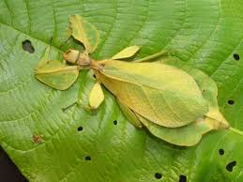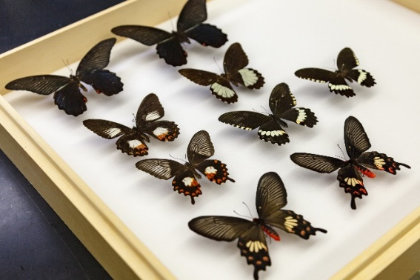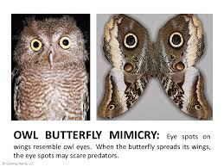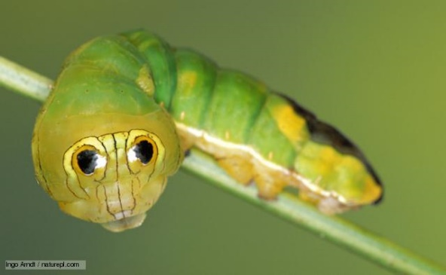
Mechanical defenses
Insects have had millions of years to evolve a variety of mechanical defenses. Perhaps the most obvious is the cuticle. Although its main role lies in support and muscle attachment, when extensively hardened by the cross-linking of proteins and chitin, or sclerotized, the cuticle acts as a first line of defense. Additional physical defenses include modified mandibles, horns, and spines on the tibia and femur. When these spines take on a main predatory role, they are termed raptorial.
Some insects uniquely create retreats that appear uninteresting or inedible to predators.This is the case in caddisfly larvae (order Trichoptera) which encase their abdomen with a mixture of natural materials like leaves, twigs, and stones.
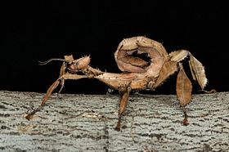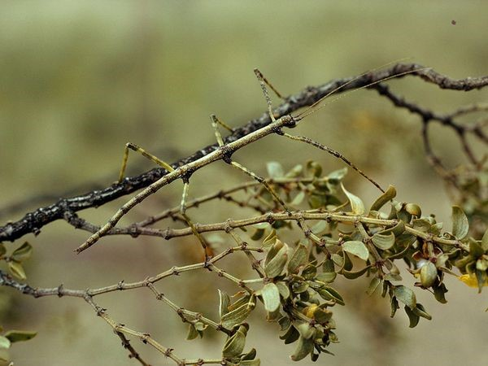
Exatosoma tiaratum
Chemical defenses
Insects with chemical weaponry usually make their presence known through aposematism. Aposematism is utilized by non-palatable species as a warning to predators that they represent a toxic danger Additionally, these insects tend to be relatively large, long-lived, active, and frequently aggregate. Indeed, longer-lived insects are more likely to be chemically defended than short lived ones.
There is great variation in the presence and absence of chemical arms among orders and families. Moreover, there is diversity among insects as to whether the defensive compounds are obtained internally or externally. Many compounds are derived from the main food source of insect larvae, and occasionally adults, feed, whereas other insects are able to synthesize their own toxins. In reflex bleeding, insects dispel their hemolymph, or a mixture of exocrine secretions and blood as a defensive maneuver. As previously mentioned, the discharged blood may contain toxins produced within the insect source or externally from plants that the insect consumed. Reflexive bleeding occurs
in specific parts of the body; for example, the beetle families Coccinellidae (ladybugs) and Meloidae bleed from the knee joints.it
Immunity defenses
Insects, like nearly every other organism on Earth, are subject to infectious diseases caused by viruses, bacteria, fungi, protozoa, and nematodes. These encounters can either kill the insect or greatly weaken it. Insects protect themselves against these detrimental microorganisms in two ways. Firstly, the body-enveloping chitin cuticle, in conjunction with the tracheal system and the gut lining, serve as major physical barriers to entry. Secondly, hemolymph itself plays a key role in repairing external wounds as well as destroying foreign organisms within the body cavity. Interestingly, insects, along with having passive immunity, also show evidence of acquired immunity.
Batesian: Apalatable mimic looks like an unpalatable model, and so gains protection, The imitating species is called the mimic, while the imitated species (protected by its toxicity, foul taste or other defenses) is known as the model.
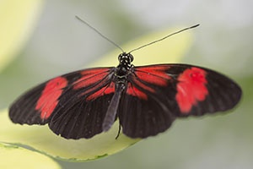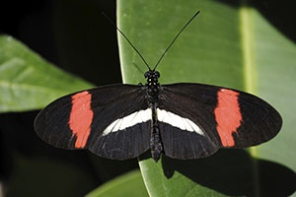
The Red Postman Butterfly The Common Postman Butterfly

Müllerian mimicry
In Müllerian mimicry, a group of species benefit from each other's existence because they all are warningly colored in the same manner and are distasteful. The best examples of this phenomenon can be found within the Heliconius butterfly genus. Like in Batesian mimicry, the mimics are not necessarily related, although they obviously are in Heliconius.
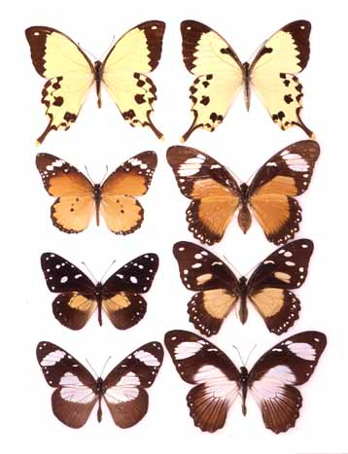
Three female morphs of a single palatable species; each mimics an unpalatable species in its range.
Non-mimetic morphs of the same species, Papilio dardanus (African Swallowtail)
Non-mimetic morphs of the same species, Papilio dardanus (African Swallowtail)
Three female morphs of a single palatable species; each mimics an unpalatable species in its range.
Non-mimetic morphs
of the same species,
Papilio dardanus
(African Swallowtail)

Three different, unpalatable species

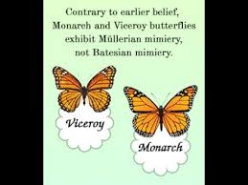
The difference between batesian and mullerian mimicry
The difference between Batesian and Müllerian mimicry. Batesian mimicry is a form of mimicry wherein one harmless species that is palatable to a predator, mimics the appearance of a harmful or noxious species. ... In Müllerian mimicry, two equally noxious species evolve to look similar to each other.

