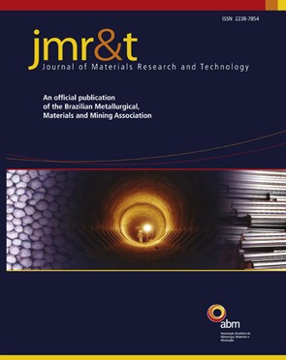
j m a t e r r e s t e c h n o l . 2 0 1 9;8(5):4766–4777
Available online at www.sciencedirect.com

www.jmrt.com.br

Original Article
Reinforcement and processing on the machinability and mechanical properties of
aluminum matrix composites
Fakhir Aziz Rasul Rozhbiany ∗, Shawnim Rashied Jalal
Department of Mechanical & Mechatronics Engineering, College of Engineering, Salahaddin University-Erbil, Erbil, Iraq

a r t i c l e i n f o a b s t r a c t

Article history:
Received 25 March 2019
Accepted 16 August 2019
Available online 30 August 2019

Keywords:
Mechanical properties Chip formation style Surface roughness
Metal matrix composites (MMCs)
Metal matrix composites are an essential product used in engineering materials. This prod- uct has wide applications in automotive, aerospace, and other uses. In this paper, four different reinforced such as (MA), (MCA), (NFC) and (SA) with a constant rate of 5 wt. % for each reinforced element used and mixed with Al 6063 alloy to produced composite by using modiﬁed two-step mechanical stirrer and having three blades at each step. Coated carbide tool insert was carrying out the turning process. The chip volume ratio and chip shape style formation were performed within cutting speeds of 10 and 90 m/min, which appears in different length and shapes especially at 90 m/min. The chip volume ratio is not increased by all four types of reinforced metal but still maintain in the standard range according to the shape of chips. NFC increasing average chip length during cutting speed of 10 m/min, but within cutting speed of 90 m/min, MA has an important role to change the volume and formation style of a chip from discontinuous chip to continuous chip. It should be noted from the results, that the NFC has decreased surface roughness dramatically for all cutting speeds and followed by MCA, but the MA and SA have less effect compared to NFC and MCA. The mechanical properties such as yield ultimate tensile strength and hardness of the composites are much more than Al 6063 alloy especially when adding all four types of reinforcement together moreover the effect of NFC is very less compared with other types of reinforced materials. MA increase hardness more than the different types of reinforcement. Microstructure observation produces compact grain boundaries with strong grains of metal matrix composites compared to Al 6063 alloys.
© 2019 The Authors. Published by Elsevier B.V. This is an open access article under the CC BY-NC-ND license (http://creativecommons.org/licenses/by-nc-nd/4.0/).

Introduction

∗ Corresponding author.
E-mail: fakhir.rozhbiany@gmail.com (F.A. Rozhbiany). https://doi.org/10.1016/j.jmrt.2019.08.023
Most of the researchers during the last three decades have been generated tremendous interested to use aluminum and its alloys due to their properties such as lightweight, excellent mechanical properties, low cost, good tribological properties,

2238-7854/© 2019 The Authors. Published by Elsevier B.V. This is an open access article under the CC BY-NC-ND license (http:// creativecommons.org/licenses/by-nc-nd/4.0/).

