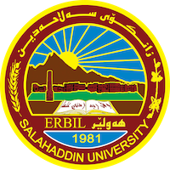
Academic Curriculum Vitae
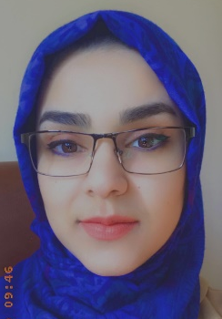
Personal Information:
Full Name: Shawnm Mudhafar Saleh
Academic Title: Assistant lecturer
Email: shawnm.saleh@su.edu.krd
Mobile: 07501905684

Education:
- Bachelor degree in Dams and Water Resources/ 2012
- Master Degree in Water Resources/ 2020

Employment:
- Engineer from 2012
- Assistant lecturer from 2021

Qualifications
- Pedagogical course, 2019, Salahaddin University-Erbil
- Computer Skills:
  - Microsoft Office (Excel, Word, Power-Point)
  - Operation Systems: Win xp, Win Vista, Win 7, Win 8, Win 10
  - Modeling Software: AutoCAD, ANSYS Fluent, Flow3d.
- IELTS
Teaching experience:
- Math I (Architecture Department)
- Math II (Civil Department)
- Math II (Water Resources Department)
- Design of Hydraulic Structures
- Irrigation Engineering
- Engineering Drawing
- Soil Lab.
- Surveying Lab.
Research and publications
- Flood Disaster in Erbil City: Problems and Solutions
- Effect of Pooled and Flat Stepped Spillway on Energy Dissipation Using Computational Fluid Dynamics
- Numerical Study to Evaluate the Performance of Non-uniform Stepped Spillway using ANSYS-CFX
- Computational Study to Predict the Free-Surface Flow over Non-uniform Stepped Spillway Using ANSYS-CFX
- Validation of the Computational ANSYS-CFX code for free Surface Flow: Skimming Flow over Non-uniform Step Size Stepped Spillways
- Essential Treatment Processes for Industrial Wastewaters and Reusing for Irrigation

Conferences and courses attended
- Second International Conference on Engineering and Innovative Technology SU-ICEIT-2019
- بەخشینی گرانت بۆ باشترین پرۆژەی دەرچوون و ئایدیا بە قوتابیانی زانکۆی سەلاحەددین-هەولێر
- Educational Effectiveness: Assessment and Evaluation
- Water Crisis and Paths of Cooperation Between the Federal government and the KRG

Funding and academic awards
- List any bursaries, scholarships, travel grants or other sources of funding that you were awarded for research projects or to attend meetings or conferences.

Professional memberships
- Kurdistan Engineering Syndicate

Professional Social Network Accounts:

- https://www.researchgate.net/profile/Shawnm-Saleh
- https://www.linkedin.com/in/shawnm-saleh-09907225a/
- https://scholar.google.com/citations?user=dvu9y7YAAAAJ&hl=en
- https://salahaddin-erbil.academia.edu/ShawnmSaleh
- https://orcid.org/0000-0002-5420-3159
It is also recommended to create an academic cover letter for your CV, for further information about the cover letter, please visit below link:
https://career-advice.jobs.ac.uk/cv-and-cover-letter-advice/academic-cover-letter/

