Practical Genetics Study of Cancer
Cancer, known medically as a malignant neoplasm, is a broad group of various diseases, all involving unregulated cell growth. In cancer, cells divide and grow uncontrollably, forming malignant tumors, and invade nearby parts of the body. Cancer may also spread to more distant parts of the body through the lymphatic system or bloodstream.
Not all tumors are cancerous. Benign tumors do not grow uncontrollably, do not invade neighboring tissues, and do not spread throughout the body.
Determining what causes cancer is complex. Many things are known to increase the risk of cancer, including :- Exposure to chemicals, tobacco use, certain infections, radiation, lack of physical activity, obesity, and environmental pollutants. Those can directly damage genes or combine with existing genetic faults within cells to cause the disease.
Cancer can be detected in a number of ways, including the presence of certain signs and symptoms, screening tests, or medical imaging. Once a possible tumors detected it is diagnosed by microscopic examination of a tissue sample.

Cancer is usually treated with chemotherapy, radiation therapy and surgery.

Cancers are classified by the type of cell that the tumor cells resemble and is therefore presumed to be the origin of the tumor. These types include:
- Carcinoma: Cancers derived from epithelial cells. This group includes many of the most common cancers, include nearly all those developing in the breast, prostate, lung, pancreas, and colon.
- Sarcoma: Cancers arising from connective tissue (i.e. bone, cartilage)
- Lymphoma and leukemia: These two classes of cancer arise from hematopoietic (blood-forming) cells that leave the bone marrow and tend to mature in the lymph nodes and blood respectively.
- Germ cell tumor: Cancers derived from pluripotent cells, most often presenting in the testicle or the ovary .
- Blastoma: Cancers derived from immature "precursor" cells or embryonic tissue.

Metastasis
Symptoms of metastasis are due to the spread of cancer to other locations in the body. They can include enlarged lymph nodes (which can be felt or sometimes seen under the skin and are typically hard), hepatomegaly (enlarged liver) or splenomegaly (enlarged spleen) .
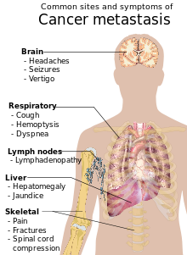

Fig.(1):- Cancer metastasis
Heredity Approximately five to ten percent of cancers are entirely hereditary. Cancers are caused by a series of mutations. Each mutation alters the behavior of the cell Cancer is fundamentally a disease of failure of regulation of tissue growth. In order for a normal cell to transform into a cancer cell, the genes which regulate cell growth and differentiation must be altered.
The affected genes are divided into two broad categories.
- Protooncogen are genes which normally promote cell growth .The mutated form called Oncogene that leading to cancer.
- Tumor suppressor genes are genes which inhibit cell division.
Changes in many genes are required to transform a normal cell into a cancer cell. Genetic changes can occur at different levels and by different mechanisms. The gain or loss of an entire chromosome can occur through errors in mitosis, more Common are mutations.
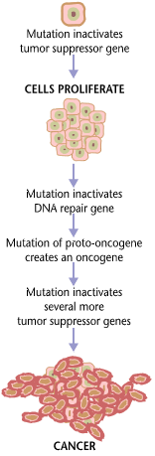
Fig (2):- The genes involved in carcinogenesis.
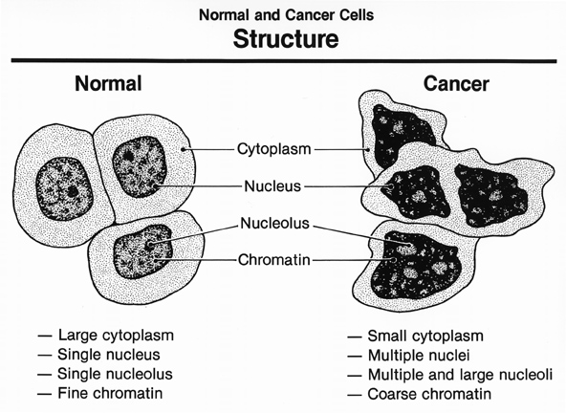 Fig(3) The differences between Normal cell and Cancer cell

