LAB/ 23 Sickle Cell Anemia
What is sickle cell anemia?
Sickle cell anemia (sickle cell disease) is a disorder of the blood caused by an inherited abnormal hemoglobin The abnormal hemoglobin causes distorted (sickle) red blood cells. The sickle red blood cells are fragile and prone to rupture. When the number of red blood cells decreases from rupture (hemolysis), anemia is the result. This condition is referred to as sickle cell anemia. The irregular sickle cells can also block blood vessels causing tissue and organ damage and pain. caused by a point mutation in the hemoglobin beta gene (HBB) found on chromosome 11p15.4.

. 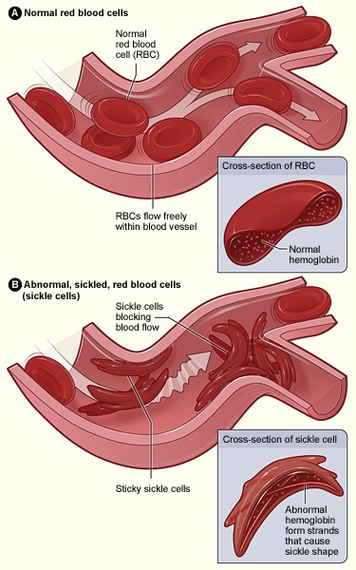
How is sickle cell anemia inherited?
Sickle cell anemia is inherited as an autosomal (meaning that the gene is not linked to a sex chromosome) recessive condition whereas sickle cell trait is inherited as an autosomal dominant trait. This means that the gene can be passed on from a parent carrying it to male and female children. In order for sickle cell anemia to occur, a sickle cell gene must be inherited from both the mother and the father, so that the child has two sickle cell genes

The inheritance of just one sickle gene is called sickle cell trait or the "carrier" state. Sickle cell trait does not cause sickle cell anemia. Persons with sickle cell trait usually do not have many symptoms of disease and have normal hospitalization rates and life expectancies. Sickle cell trait is present in some two million blacks in the United States (8% of the U.S. black population at birth). When two carriers of sickle cell trait mate, their offspring have a one in four chance of having sickle cell anemia.
- Autosomal recessive genetic disease.
- B-globin gene(chromosome 11 ,mutation(GAG→GuG )at 6 th codon.
- Glutamic acid → Valine at the 6 th amino acid along the b- globin chain
- 2α 2 B = Normal hemoglobin. Hb Hb
- 2α s B = heterozygote = sickle trait. ,carrier .Hb Hbs
- 2α 2s = homozygote recessive = sickle cell disease. Hbs Hbs

- How is sickle cell anemia diagnosed?
Sickle cell anemia is suggested when the abnormal sickle-shaped cells in the blood are identified under a microscope. Testing is typically performed on a smear of blood using a special low-oxygen preparation. This is referred to as a sickle prep. Other prep tests can also be used to detect the abnormal hemoglobin S, including solubility tests performed on tubes of blood solutions. The disease can be confirmed by specifically quantifying the types of hemoglobin present using a hemoglobin electrophoresis test.
- Prenatal diagnosis (before birth) of sickle cell anemia is possible using amniocentesis or chorionic villus sampling. The sample obtained is then tested for DNA analysis of the fetal cells.
What are the symptoms and treatments of sickle cell anemia?
Virtually all of the major symptoms of sickle cell anemia are the direct result of the abnormally shaped, sickled red blood cells blocking the flow of blood that circulates through the tissues of the body. The tissues with impaired circulation suffer damage from lack of oxygen. Damage to tissues and organs of the body can cause severe disability in patients with sickle cell anemia..
1-Fatigue and Anemia 2- swelling and inflammation of the hands and/or feet) and Arthritis 3-Pain Crises 4- Bacterial Infections 5-Splenic Sequestration (sudden pooling of blood in the spleen) and Liver Congestion 6--Aseptic Necrosis and Bone Infarcts (death of portions of bone) 7- Eye Damage 8-WBC count are elevated 9- Lung and Heart Injury

.

.

