LAB-5------------- Pedigree analysis

Today...
- In humans, pedigree analysis is an important tool for studying inherited diseases
- Pedigree analysis uses family trees and information about affected individuals to:
  - figure out the genetic basis of a disease or trait from its inheritance pattern
  - predict the risk of disease in future offspring in a family (genetic counseling)

Basic Symbols
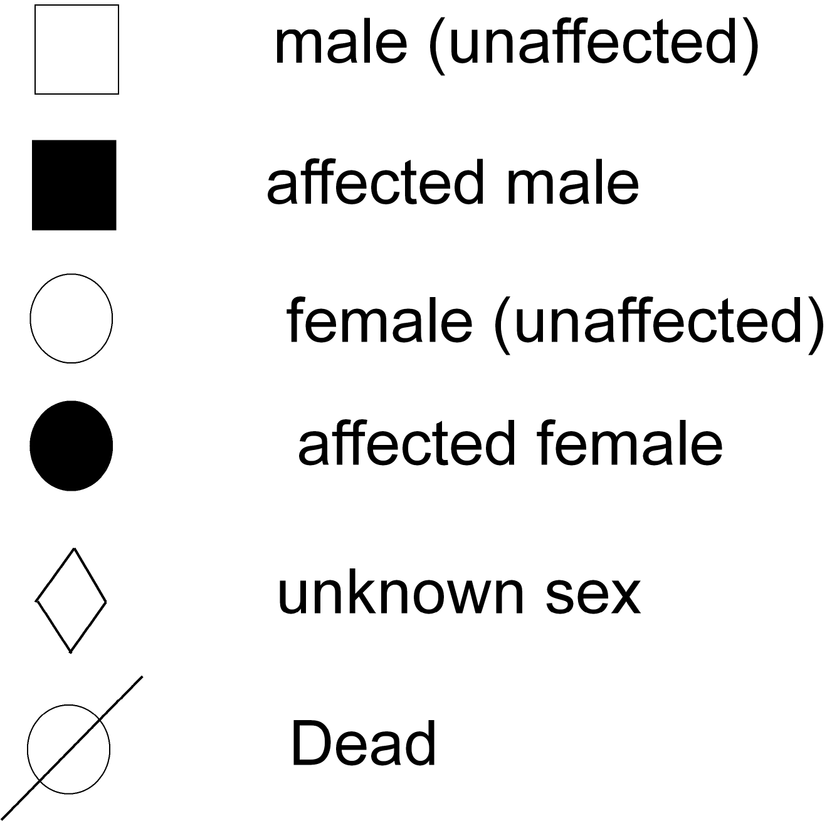
- Basic patterns of inheritance
  - Autosomal, dominant Inheritance
  - Autosomal, recessive Inheritance
  - X-linked, recessive Inheritance
  - X-linked, dominant (very rare)
  - Y-Linked Inheritance
  - Sex-Influenced Inheritance
  - Sex-Limited Inheritance
  - Mitochondrial Inheritance
  - Multifactorial inheritance.

Autosomal: the gene responsible for the phenotype is located on one of the 22 pairs of autosomes (non-sex determining chromosomes).
X-linked: the gene that encodes for the trait is located on the X chromosome.
Dominant: conditions that are manifest in heterozygotes (individuals with just one copy of the mutant allele). they are called "dominant" because a single copy—inherited from either parent—is enough to cause this trait to appear.
Recessive: conditions are only manifest in individuals who have two copies of the mutant allele (are homozygous).

1--Autosomal Dominant  - Dominant conditions are expressed in individuals who have just one copy of the mutant allele..  - Affected males and females have an equal probability of passing on the trait to offspring.  - Affected individual's have one normal copy of the gene and one mutant copy of the gene, thus each offspring has a 50% chance on inheriting the mutant allele. | Autosomal Dominant Conditions:  • Huntington Disease  • acondroplasia (short-limbed dwarfism)  • polycystic kidney disease.
2--Autosomal Recessive  - Recessive conditions are clinically manifest only when an individual has two copies of the mutant allele.  - When just one copy of the mutant allele is present, an individual is a carrier of the mutation, but does not develop the condition.  - Females and males are affected equally by traits transmitted by autosomal recessive inheritance.  - When two carriers mate, each child has a 25% chance of being homozygous wild-type (unaffected); a 25% chance of being homozygous mutant (affected); or a 50% chance of being heterozygous (unaffected carrier). | Affected individuals are indicated by solid black symbols and unaffected carriers are indicated by the half black symbols.  Autosomal recessive diseases:  • Cystic fibrosis.  • Tay-Sachs.  • hemochromatosis(iron overload)  • phenylketonuria (PKU)  - Albinism.
3--X-linked Recessive  - X-linked recessive traits are not clinically manifest when there is a normal copy of the gene present.  - All X-linked recessive traits are fully evident in males because they only have one copy of the X chromosome, thus do not have a normal copy of the gene to compensate for the mutant copy. For that same reason, women are rarely affected by X-linked recessive diseases, however they are affected when they have two copies of the mutant allele.. | X-linked Recessive Disorders:  • Duchenne muscular dystrophy  • Hemophilia A  • X-linked severe combined immune disorder (SCID)  • some forms of congenital deafness  - Color blindness.  - G-6 P-dehydrogenes.
4-X-linked Dominant  - Because the gene is located on the X chromosome, there is no transmission from father to son, but there can be transmission from father to daughter (all daughters of an affected male will be affected since the father has only one X chromosome to transmit).  - Children of an affected woman have a 50% chance of inheriting the X chromosome with the mutant allele. X-linked dominant disorders are clinically manifest when only one copy of the mutant allele is present. |  |  | X-linked Dominant Disorders  • some forms of retinitis pigmentosa  • Chondrodysplasia Punctata(stippled epiphyses and skeletal changes)  • hypophosphatemic rickets X-linked hypophosphatemia (XLH), also called X-linked dominant hypophosphatemic rickets, X-linked vitamin d-resistant rickets ,^{[1]} is an X-linked dominant form of rickets (or osteomalacia) that differs from most cases of rickets in that ingestion of vitamin D is relatively ineffective. It can cause bone deformity including short stature and genu varum (bow leggedness). It is associated with a mutation in the PHEX gene sequence (Xp.22) and subsequent inactivity of the PHEX protein.^{[2]} The prevalence of the disease is 1:20000.^{[3]} The leg deformity can be treated with Ilizarov frames and CHAOS surgery. )

.5--Y-liked inheritance

- The Y- chromosomes is relatively small and contains very few genes, there are relatively few Y-linked disorders.
- Male Infertility
- Excessive hair on the ear pinna (Hypertrichosis pinnae)
- Retinitis pigmentosa .

- 6-- SEX INFLUENCED INHERITANCE:
- These traits are expressed to some degree in both sexes, but are differentially.
- The amount of thinning of the hair or balding that is observed depends both on genotype and the amount of testosterone exposure
- . A male who is BB will show severe balding.
- A female who is BB will also be affected, but later in life and usually less severely, with a thinning of the hair, rather than total loss.
- A male who is heterozygous (Bb) will also become bald, whereas a female who is heterozygous will not be affected. Individuals of either sex who are fully recessive (bb) will not be affected.

- 7--Sex-limited inheritance
- When genes are present in both sexes of sexually reproducing species but expressed in only one sex. In other words, sex-limited genes cause the two sexes to show different traits or phenotypes eg s ,production of milk in female
- 8-Multifactorial inheritance  - Most diseases have multifactorial inheritance patterns.  - As the name implies, multifactorial conditions are not caused by a single gene, but rather are a result of interplay between genetic factors and environmental factors.  - Diseases with multifactorial inheritance are not genetically determined, but rather a genetic mutation may predispose an individual to a disease. Other genetic and environmental factors contribute to whether or not the disease develops.  - Numerous genetic alterations may predispose individuals to the same disease (genetic heterogeneity).  - For instance coronary heart disease risk factors include high blood pressure, diabetes, and hyperlipidemia. All of those risk factors have their own genetic and environmental components.  - Thus multifactorial inheritance is far more complex than Mendelian inheritance and is more difficult to trace through pedigrees.  Some of the factors which contribute to the development of breast cancer |  |  | .
A typical pedigree from a family with a mutation in the BRCA1 gene. Fathers can be carriers and pass the mutation onto offspring. Not all people who inherit the mutation develop the disease, thus patterns of transmission are not always obvious. |  |  | Conditions with multifactorial inheritance:  • Alzheimers disease  • heart disease  • some cancers  • neural tube defects  • schizophrenia  • insulin-dependent diabetes mellitus  • intelligence
- 9—Mitochondrial inheritance.
- Mitochondrial inheritance also called(Maternal inheritance ,Extra nuclear inh., Cytoplasmic inh.).
- Mitochondria are organelles found in the cytoplasm of cell
- Mitochondria are unique in that they have multiple copies of a circular chromosome.
- Mitochondria are only inherited from the mother's egg, thus only females can transmit the trait to offspring, however they pass it on to all of their offspring.
- The primary function of mitochondria is conversion of molecule into usable energy. Thus many diseases transmitted by mitochondrial inheritance affect organs with high-energy use such as the heart, skeletal muscle, liver, and kidneys
- Leber's hereditary optic atrophy
- Myoclonus epilepsy w ith ragged-red fibers (MERRF

i

