LAB -7-
Mitosis in Allium cepa root tips
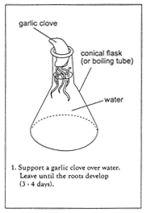 | 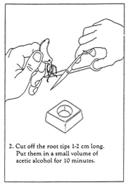 | 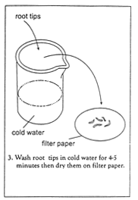
1. Support a Allium cepa over water. Leave until the roots develop, (3 - 4 days).
2. Cut off the root tips 1 - 2 cm long. Put them in a small volume of acetic alcohol for 10 minutes.
3. Wash root tips in ice cold water for 4 - 5 minutes, then dry them on filter paper.
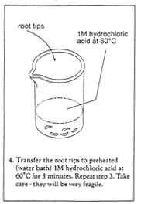 | 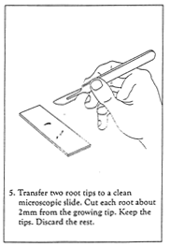 | 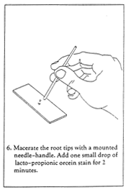
4. Transfer root tips 1M hydrochloric acid for 5 minutes. Repeat step 3. Take care - they will be very fragile.
5. Transfer two root tips to a clean microscope slide. Cut each root tip about 2 mm from the growing tip. Keep the tips, discard the rest.
6. Macerate the root tips with a mounted needle. Add one small drop of Geimza stain for 2 minutes.
7. Cover with a cover slip.
8. View under the microscope (x400 magnification is adequate) and look for cells with chromosomes.
5. Calculate the mitotic index.

Mitotic index = number of cells containing visible chromosomes divided by the total number of cells in field of view
-------------------------------------------------------------------------------------------------------------------------------------------------------------------------------------------------------------------------

