LAB -26- Gel electrophoresis
- is a method for separation and analysis of macromolecules (DNA, RNA and proteins) and their fragments, based on their size and charge.
- It is used in clinical chemistry to separate proteins by charge and/or size and in biochemistry and molecular biology to separate a mixed population of DNA and RNA fragments by length, to estimate the size of DNA and RNA fragments or to separate proteins by charge.
- Nucleic acid molecules are separated by applying an electric field to move the negatively charged molecules through an agarose matrix. Shorter molecules move faster and migrate farther than longer ones because shorter molecules migrate more easily through the pores of the gel. This phenomenon is called sieving.
- Proteins are separated by charge in agarose because the pores of the gel are too large to sieve proteins. Gel electrophoresis can also be used for separation of nanoparticles.
- Gel electrophoresis uses a gel as an anti convective medium and/or sieving medium during electrophoresis, the movement of a charged particle in an electrical field.
- DNA Gel electrophoresis is usually performed for analytical purposes, often after amplification of DNA via PCR, but may be used as a preparative technique prior to use of other methods such as mass spectrometry, RFLP, PCR, cloning, DNA sequencing, or Southern blotting for further characterization. 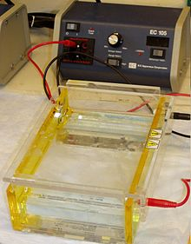
- The molecules being sorted are dispensed into a well in the gel material.
The gel is placed in an electrophoresis chamber, which is then connected to a Power source.
- When the electric current is applied, the larger molecules move more slowly through the gel while the smaller molecules move faster. The different sized molecules form distinct bands on the gel
- Buffers in gel electrophoresis are used to provide ions that carry a current and to maintain the pH at a relatively constant value. There are a number of buffers used for electrophoresis. The most common being, for nucleic acids Tris/Acetate/EDTA (TAE), Tris/Borate/EDTA (TBE).

- After the electrophoresis is complete, the molecules in the gel can be stained to make them visible. DNA may be visualized using ethidium bromide( EtBr) which, when intercalated into DNA, fluoresce under ultraviolet light, EtBr is a known mutagen, and safer alternatives are available, such as GelRed, which binds to the minor groove.
- SYBR Green I is another dsDNA stain, produced by Invitrogen. It is more expensive, but 25 times more sensitive, and possibly safer than EtBr, though there is no data addressing its mutagenicity or toxicity in humans.

- After electrophoresis the gel is illuminated with an ultraviolet lamp (usually by placing it on a light box, while using protective gear to limit exposure to ultraviolet radiation). The illuminator apparatus mostly also contains imaging apparatus that takes an image of the gel, after illumination with UV radiation. The ethidium bromide fluoresces reddish-orange in the presence of DNA, since it has intercalated with the DNA. The DNA band can also be cut out of the gel, and can then be dissolved to retrieve the purified DNA. The gel can then be photographed usually with a digital camera. 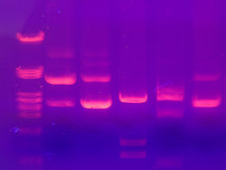DNA gel electrophoresis

