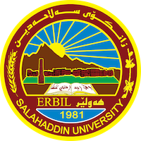
Academic Curriculum Vitae

Personal Information:
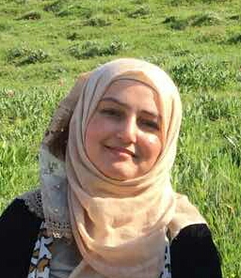
Full Name: SHAYDA KHUDUR KARIM
Academic Title: (Lecturer)
Email: (university email): shayda.karim@su.edu.krd
Mobile: 07518685456

Education:
_ 2011 TO 2014 SALAHADDIN UNIVERSITY HAWLER (ERBIL) - IRAQ.
M.A DEGREE AT ARABIC LANGUAGE
TITLE OF THE THESIS
((LINGUISTIC, OF ARGUMENTATIVE DISCOURSE IN (HAWA MEEM) SURATS).
_ 2005-2009 B.A. IN ARABIC LANGUGE
SALAHADDIN UNIVERSITY, ERBIL, IRAQ. COMING THE SECOND IN THE ARABIC DEPARTMENT. IT WAS ACCEPTED ((V. GOOD)).

Employment:
_ 2015_ON GOING INSTRUCTOR AT UNIVERSITY OF SALAHADDIN/ERBIL (ARBIC) DEPARTMENT – COLLEGE OF EDUCATION/ MAKHMUR.
_ 2009_2014 ASSISTANT RESEARCHER IN UNIVERSITY OF SALAHADDIN (ARABIC DEPARTMENT).
Qualifications
- I HAVE PARTICIPATED IN THE METHODS OF TEACHING COURSE.
- I HAVE PARTICIPATED IN THE ENGLISH COURSE.
- I HAVE PARTICIPATED IN THE COMPUTER COURSE.
Teaching experience:
- State all teaching courses you delivered, stating undergraduate or post graduate
- Courses, trainings, lab supervision, etc.,

Research and publications
I HAVE WRITTEN IN SOME JOURNAL AND MAGAZINES AS:
1-. المقصدية التداولية في سورة الزمر IN JOURNAL ISLAMIC SCIENCES COLLEGE/ BAGDAD , ISSN 2075_8626.
2- THE FOUNDATIONS OF THE TETUAL HARMORY IN SURAT AL_TAGHABININ ZANCO JOURNAL OF HUMANITY SCIENCES.
Conferences and courses attended

Funding and academic awards
- List any bursaries, scholarships, travel grants or other sources of funding that you were awarded for research projects or to attend meetings or conferences.

Professional memberships

Professional Social Network Accounts:

- List your profile links of ReserchGate, LinkedIn, etc.

It is also recommended to create an academic cover letter for your CV, for further information about the cover letter, please visit below link:
https://career-advice.jobs.ac.uk/cv-and-cover-letter-advice/academic-cover-letter/

