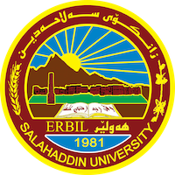
Academic Curriculum Vitae
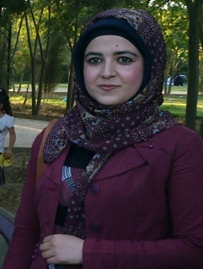
Personal Information:
Full Name: Shaymaa Rostam Khorsheed
Academic Title: Assistant lecturer
Email: (shayma.khorsheed@su.edu.krd)
Mobile: 07507059126

Education:
- 2018- Master Degree, private law, Selcuk University, Turkey.
- 2013- Undergraduate Degree, Law, Salahaddin University, College of Law and Political Science. Erbil, Iraq.

Employment:
- Assistant lecturer at law Department, College Law, Salahaddin University (now)
- Served at the Salahaddin University such as a legal assistant. (2012-2018)

Qualifications
- Pedagogy ( methods of teaching) 2020
- International English Language Testing System (IELTS) 5 score
- Language center- Salahaddin University, English language course 2013
- International Turkish Language Testing System (IELTS) 91 score
- Language center- Selcuk University, Turkish language course until (C2) 2014
- Languages:
- English: good – speaking & writing.
- Kurdish: Excellent – speaking & writing.
- Turkish: Excellent – speaking & writing.
- COMPUTER SKILLS
- Word, Excel, Prezi, Powerpoint,Modle, Edmodo, Padlet, Zoom, ResearchGate, Google Scholar: Excellent

Teaching experience:
- Personal Status Law / the third stage students/undergraduate.(2020-2023)

Research and publications
- State all researches, publication you made.

Conferences and courses attended
- Participation as a guest in many conferences and courses since 2020 until now..

Funding and academic awards
- List any bursaries, scholarships, travel grants or other sources of funding that you were awarded for research projects or to attend meetings or conferences.

Professional memberships
- List any membership you hold of any professional body or learned society relevant to your research or other life activities.

Professional Social Network Accounts:

- https://www.researchgate.net/profile/Shayma-Zangana
- https://scholar.google.com/citations?view_op=list_works&hl=en&user=ftBQx5IAAAAJ&gmla=AJsN-F47OGIGe1CIhnLfgINIJCIFcNiWlCVYfKi9iaTzEjpaHdyW-cPWydqqOc--EhIVjH92uwdfAzY5KL-0O8-n5udOaEtsPZzlurqBxRTjabNkZfeYoFuOKAwn8kpy3fGiUXET7p6S

It is also recommended to create an academic cover letter for your CV, for further information about the cover letter, please visit below link:
https://career-advice.jobs.ac.uk/cv-and-cover-letter-advice/academic-cover-letter/

