Academic Curriculum Vitae
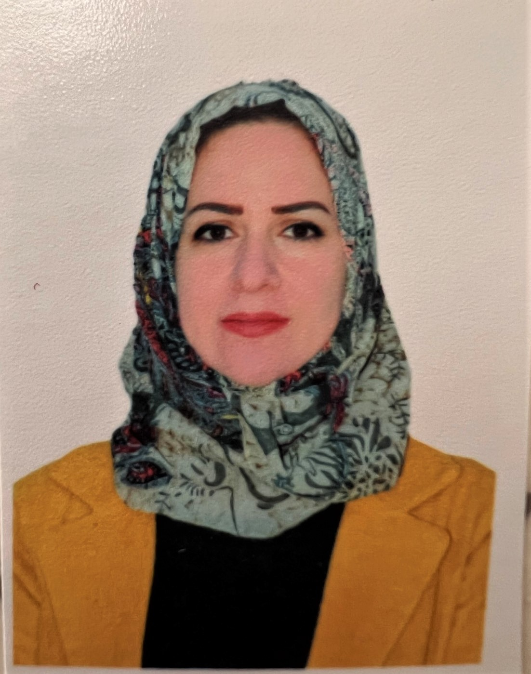The Impact of Subtitled Videos on Accidental Vocabulary Learning of EFL students
Personal Information:
Full Name: Sheelan Ahamd hamadameen
Academic Title: instructor
Email: sheelan.hamadameen@su.edu.krd
Mobile: 07507766171

Education:
- State all educations accomplished
- University: BA in English Language from college of basic education /Salahaddin University/ Erbil (2005-2006)
- MA in English Language and Applied Linguistics- college of basic education / Salahaddin University/ Erbil (2010-2012)

Employment:
- State employment starting from first employment
- I got employed by Salahaddin University- College of Basic Education in 2007, as an assistant researcher.
- On June 28th, 2012 I obtained my MA in English language and Applied linguistics from the same College. Then, I started teaching in 2013 at College of Basic Education as an assistant lecturer until now. - after that , I got the scientific name of lecturer on march,31^{h} 2021

Qualifications
-Graduated from pedagogy course, Salahaddin University 2012 –
E-Learning and Moodle / 2020/ College of Basic Education / Salahaddin University

Teaching experience:
- Started teaching at College of Basic Education/Salahaddin University in 2013 till now. I mainly taught subjects related to English language and applied linguistics. I taught various subjects: text book analysis, communication, pronunciation, classroom management, observation, essay writing, paragraph writing. - Supervised fourth year under graduation projects..,

Research and publications
- I have two published researches:
- The Impact of English Club Activities on EFL Students’ Communicative Skills ID No. 3525 (PP 285 - 295) https://doi.org/10.21271/zjhs.24.4.18
-The Impact of Subtitled Videos on Accidental Vocabulary Learning of EFL students

Conferences and courses attended
------------------------------------------------------------------------
Funding and academic awards
.------------------------------------------------------------

Professional Social Network Accounts:

- List your profile links of ReserchGate, LinkedIn, etc.
- https://scholar.google.com/citations?view_op=new_profile&hl=en&imq=sheelan+ahmad+hamadameen
- https://orcid.org/orcid-search/search?searchQuery=sheelan
- https://www.facebook.com/

