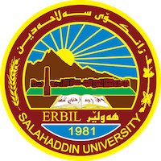
Academic Curriculum Vitae
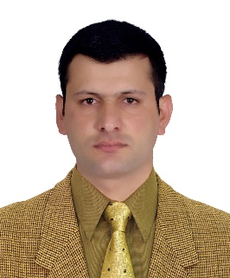

Personal Information:
Full Name: Sherwan Jalil Ahmed
Academic Title: Lecturer
Email: sherwan.ahmed1@su.edu.krd
Mobile: +9647504528240

Education:
B.SC : 2007-2008 / Economics / College of Administration & Economics/ Salahaddin University-Erbil
M.SC : 2014/ Agriculture Economic/ Department of Economics/College of Commerce/ Mansoura University, Egypt

Employment:
Assistant Researcher/ College of Administration & Economics / Salahaddin University-Erbil 2009
Assistant Lecturer / College of Agricultural Engineering Science/ Salahaddin University-Erbil 2015

Teaching experience:
- I have taught undergraduate courses:
- Agriculture Economics (stage 2)
- Marketing of Horticultural Products (stage 4)
- Agricultural Extension (stage 4, 2, 3)
- Elective (Feasibility Study) (stage 4)
- Economic of industrial Projects (stage 2)
- Plant Projects Management (stage 2)
- Industrial Marketing (stage 2)
- Academic skills (stage 1)
- English language (stage 1)
- I have also taught the practical version of all the subjects listed above.
- I have done training courses for the graduation Students about Management of greenhouse projects (College of Agricultural Engineering Science) 2023
- I have done training courses for the graduation Students about Production inside and outside green house (Young and Agriculture Projects) 2019
Research and publications
- نحو توجيه الخريجين الزراعيين الى المشاريع الزراعية الصغيرة . 2022
- دور عناصر التكلفة (الموارد الاولية المحلية والمستوردة) في تسعير المنتجات الانشائية في اقليم كوردستان للفترة من 2005-2015 2019
- شرۆڤەی واقعی بیكاری دەرچووانی زانكۆی سەلاحەددین لە نێوان هۆكار و چارەسەردا. 2018
- Interaction effect of planting date and foliar application on some vegetative growth characters and yield of broccoli (Brassica olerasea var italica) grown under unheated … 2017
- The role of agricultural development in the face of food gap in the Kurdistan Region. 2014

Conferences and courses attended
- Course from Hungarian Organization about Permaculture (College of Agricultural Engineering Science) 2023
- training courses from Horticulture Department about Mushroom Production (College of Agricultural Engineering Science) 2022HSAD Extension workshop 2013
- 2nd Scientific Agricultural conference 2016
- Training for ICDL, 2022
- Workshop about saving water in kurdistan 2022

Professional memberships
- Member of Teacher's syndicate
- Member of Economists syndicate
- Member of examination committee 2016-2017
- Member of examination committee 2019-2020
- Member of examination committee 2020-2021
- Member of examination committee 2021-2022

Professional Social Network Accounts:
- https://www.researchgate.net/profile/Sherwan-Ahmed
- https://web.facebook.com/sherwan.jalil.3
- https://www.linkedin.com/in/sherwan-ahmed-892328122/
- https://scholar.google.com/citations?user=T9ChqYcAAAAJ&hl=en
- https://orcid.org/my-orcid?orcid=0009-0000-9796-0849

