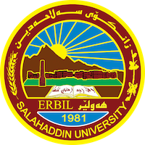
Academic Curriculum Vitae
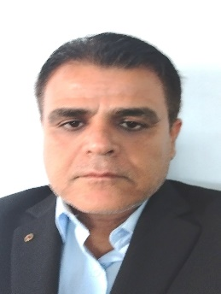
Personal Information:
Full Name: Sherwan Hadi Mohammed
Academic Title: Assistant lecture
Email: (Sherwan.Mohammed@su.edu.krd)
Mobile: 07504530067- 07507543300

Education:
- State all educations accomplished
- I have a higher diploma in the Teachers' Center Institute, in 1999-2000, then my bachelor's degree in the College of Arts in the Department of Sociology in 2005- 2006, then I obtained my master's degree in the same department in 2017. University of Salahaddin.

Employment:
- State employment starting from first employment
- I was employed in the Ministry of Education in Shaqlawa Directorate and Ziarat Khoshnaw School for two years from 2000-2022, then I returned to study in 2002-2006 to study bachelor's degree in sociology in the College of Arts in Salahaddin University After three years in 2009, I was transferred to the Ministry of Higher Education and Salahaddin University to the College of Arts. I have continued to serve as a university professor for 23 years.

Qualifications
- Teaching qualifications
- IT qualifications
- Language qualifications such as TOEFL, IELTS or any equivalent
- I have obtained the English Language Certificate of Salahaddin University Language Center at Pre-Intermediate
- Any professional qualification
- You could put any professional courses you have attended

Teaching experience:
- State all teaching courses you delivered, stating undergraduate or post graduate
- Courses, trainings, lab supervision, etc.,

Research and publications
- State all researches, publication you made.
- We have published a scientific research entitled (Social Movements and Globalization in the Journal of Halabja University

Conferences and courses attended
- Give details of any conferences you have attended, and those at which you have presented delivered poster presentations.

Funding and academic awards
- List any bursaries, scholarships, travel grants or other sources of funding that you were awarded for research projects or to attend meetings or conferences.

Professional memberships
- List any membership you hold of any professional body or learned society relevant to your research or other life activities.

Professional Social Network Accounts:

- List your profile links of ReserchGate, LinkedIn, etc.

It is also recommended to create an academic cover letter for your CV, for further information about the cover letter, please visit below link:
https://career-advice.jobs.ac.uk/cv-and-cover-letter-advice/academic-cover-letter/

