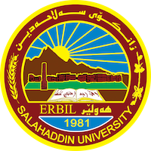
Academic Curriculum Vitae
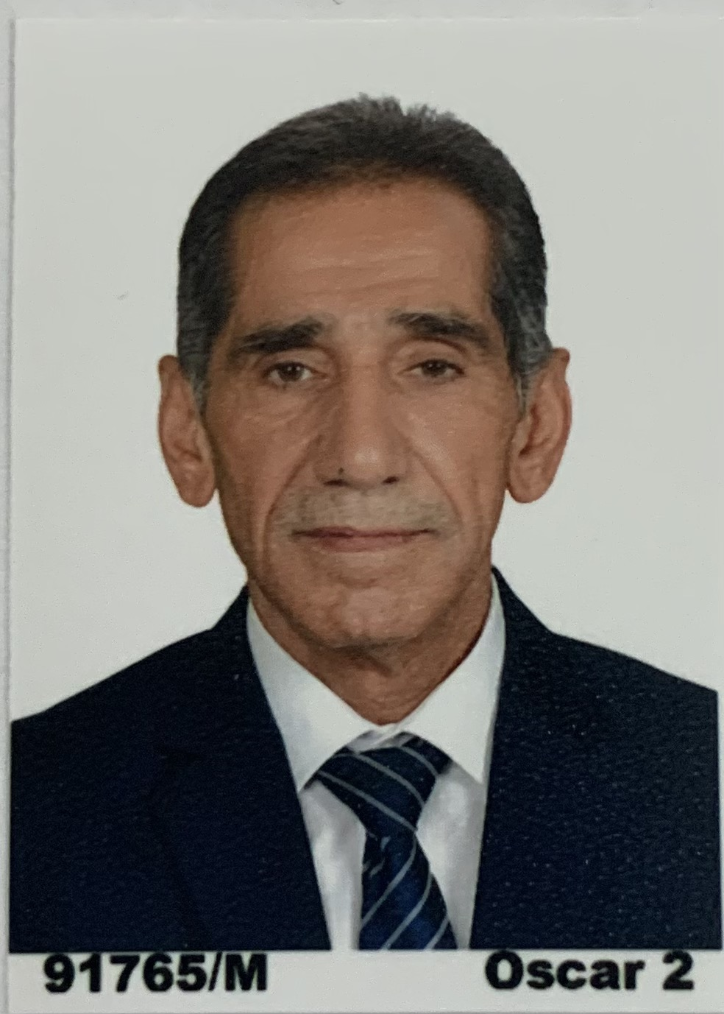
Full Name: Sherzad Ahmed Mustafa
Academic Title: Assistant Professor
Email: sherzad.mustafa@su.edu.krd
Mobile:07504684750

Education:
- Bachelor’s degree in accounting 1986-1987 Salahuddin University /Erbil - College of Administration and Economics- Department of Accounting
- Master degree in accounting from Administration &Economic college / Salahuddin University / Erbil 2003-2004

Employment:
- Assistant Lecture in accounting department from 2004 till 2017
- Lecturer in the accounting department from 2017till 2021
- Assistant Professor in accounting department from2021-till naw

Qualifications
- Teaching qualifications
- IT qualifications, Using word, Excel and financial data basis and internet
- Language qualifications such as TOEFL
- Government accounting
- Auditing and monitoring

Teaching experience:
1. principle of accounting –first stage-statistics department- College Of Administration and Economy- Salahaddin university

2Accounting system –third stage-accounting department- College Of Administration and Economy- Salahaddin University.

3. Auditing& monitoring fourth stage- accounting department- College Of Administration and Economy- Salahaddin university.

4. Tax accounting third stage- accounting department- College Of technical –Erbil(foreign lecturer).

5.Financial Matmatic- first stage-statistics department- College Of Administration and Economy- Salahaddin university

Research and publication
- دور التدقيق الاجتماعي في فحص الانشطة الداعمة للرفاهية الاجتماعية بالتطبيق على عينة من الاكاديميين و مراقبي الحسابات في مدينة اربيل
بواسطة: مجلة تكريت للإدارة والاقتصاد
https://www.facebook.com/photo/?fbid=3402715879839439&set=pcb.3402717126505981
- مدى استخدام تكنلوجيا المعلومات في عملية التدقيق الخارجي ( دراسة استطلاعية )
بواسطة: مجلة زانكو – جامعة صلاح الدين المجلد21 – العدد 6-2017

- استخدام نظام محاسبة المسؤولية في الرقابة وتقويم الاداء – دراسة تطبيقية في جامعة صلاح الدين ــ أربيل. Journal of Humanity Sciences 21 (5), 279-295

Professional memberships

- Membership in Kurdistan Teachers Union
- Membership in Accountants and Auditors Syndicate

Professional Social Network Accounts:

- Reserch Gate,
https://www.researchgate.net/topics
- Google scholarship
https://scholar.google.com/citations?hl=en&user=M1h5WmoAAAAJ&scilu=&scisig=AMD79ooAAAAAXNEb2kHnGRiZaBfDBJDUMO_8XsCzJVaV&gmla=AJsN-F5YGmsJxPBcAcs0rZzuoS8HHxJRWKdDh2NHtnedhuZS3hK7VxzRzNVHzxPO9x3ZR438vHd4gh52z6ZTHJ18_9eQnteEpfCk_feYPy2imU3fOGRUc4I&sciund=148842086027098986

