Formation of seeds in Gymnosperms
Gymnosperm: - (Greek for "naked seed") is a vascular plant that produces seeds that are not protected by fruit but are hidden in a woody cone. Like pine trees.
They do not have flowers, but most retain their leaves year round.
Gymnosperms include over 600 species.

Gymnosperm is classified into in four divisions namely:
1- Coniferophyta 2- Cycadophyta 3- Ginkgophytya 4- Gnetophyta.

Pine life cycle
- Pollen cones (male cones) with microsporephylls and microsporangia that contain numerous microsporocytes,2n undergoing meiosis to produce haploid pollen grains, and has two air sacs that function as "wings". The yellowish pine pollen is produced and dispersed by wind in spring.
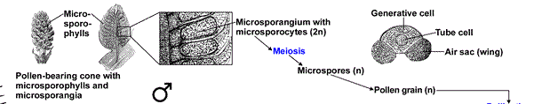
Fig. (1) Pine pollen cones development

- Ovulate cones (female cones,seed cones) with megasporophylls that produce ovules.
The pine megasporophylls are modified leaves called ovulate scales.
Each ovulate scale forms two ovules. Each ovule contains a single megasporangium (nucellus, 2n) with a single megaspore mother cell (megasporocyte, 2n), surrounded by integument tissue (later becomes the seed coat of the seed) produced of the sporophyte. Pollen grains can enter through a small opening in the integument, called micropyle.
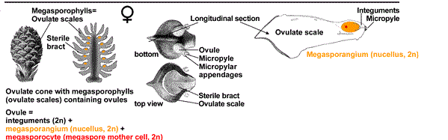
Fig.(2) Pine ovulate cone and ovulate scale

- Pollination and fertilization
Pollination
Wind-blown pollen grains land on drops of fluid produced by the ovules on the ovulate scales. As the pollination drop of an ovule evaporates, several pollen grains are brought through the micropyle into contact with the megasporangium (nucellus, 2n), where they germinate. A germinating pine pollen grain (mature microgametophyte, n) contains four haploid nuclei, one of which will later fertilize the egg.
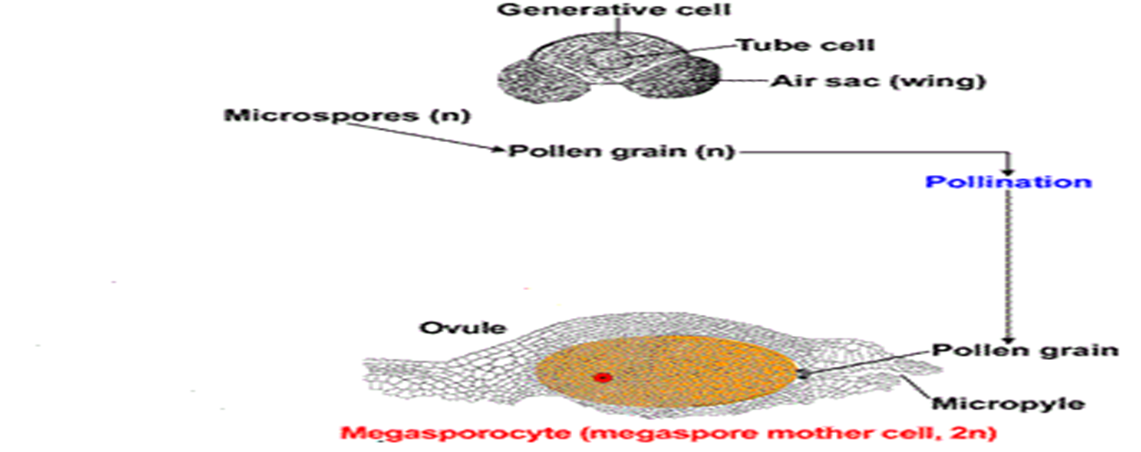

Fig (3) pollination processes in pine seed

Conifer ovule development and fertilization:
1- Pollen germination stimulates megagametophyte development within the megasporangium.
2- The single megaspore mother cell (megasporocyte, 2n) undergoes meiosis and forms four haploid megaspores (n).
3- Only one megaspore survives (functional megaspore,n) and becomes the megagametophyte (n).
4-The megagametophyte matures, which takes about one year in pine, two to five archegonia each with one egg (n) develop within the megagametophyte close to the micropyle.
5- It takes about a year for the germinating pine pollen grains to mature and grow into the megasporangia with their pollen tubes.
6- Fertilization of the egg in each archegonium is achieved by one sperm nucleus. Nourishment of the embryo during its development is achieved by the megagametophyte.
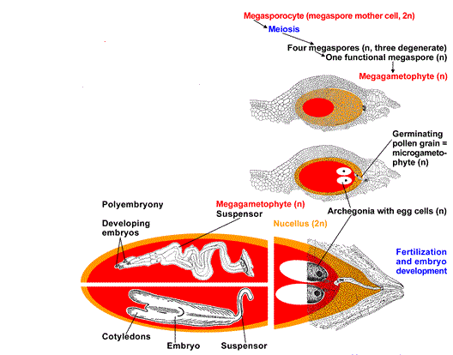
Fig.(4) Fertilization and embryo development

Since often multiple pollen tubes grow and multiple archegonia are fertilized, more than one embryo develops. This initial poly embryony is typical for gymnosperms, but in most cases only one embryo survives and grows.

Pine seed: the mature pine seed contain an
A- un curved embryo with many cotyledons
B- nutritional tissue which is megagametophyte (n) tissue also called primary endosperm
C- Seed coat (integument tissue)
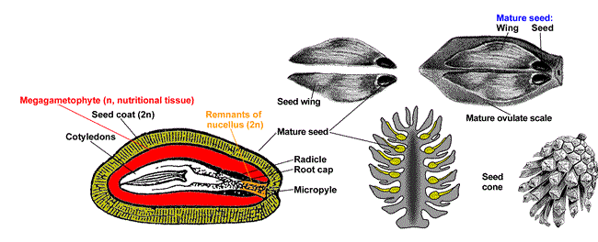
Fig.(5) Mature pine seed

Differences between male cones and female cones
Male cone:
1- The male cones produce sperm, which are contained in pollen grains
2- Male cones are normally smaller than female cones
3- Male cones grow in the lower branches

Female cone:
1-The female cones produce eggs, which are contained in ovules.
2- Female cones have a sticky resin that “catches” the pollen released by the male cone
3- Female cones grow in the upper branches

Seed Structure:
The seed is composed of the following main parts:
1- Seed coat (Testa)
2- Endosperm: Food stored for the growth of the embryo
3- Embryo

parts of the Embryo
- Embryonic root (Radicle) that grows and gives the root system
- Embryonic shoot (Plumule) which grows to be a shoot
- Cotyledon (mono cotyledon, di cotyledon, multi-cotyledons)
- Hypocotyl associated with radicle cotyledon
- Epicotyl associated with Plumule cotyledon

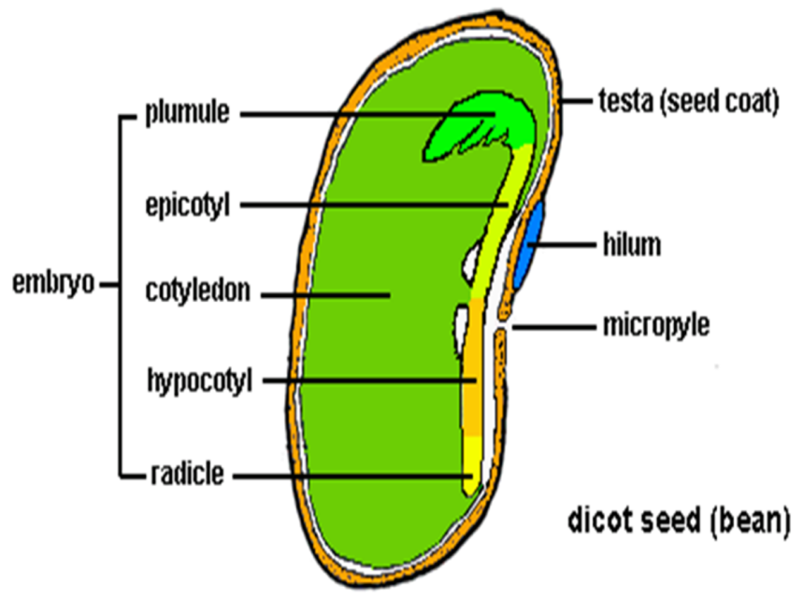
Fig.(6) Typical seed structure

