Forest plantation/ Practical Third stage

Forestry Department

**Planting Methods**:

1. **Planting in hole**: this method is usually used in plain or flat area, and it is applicable by labor hands or by mechanical auger using a dimension 25×25cm or 30×30 cm, that depends on type of soil and size of planted seedlings. This method can be used for planting both Bare root (Naked) and Balled seedlings.

1. **Compression method**: the hole of planting to be made by use especial axe (hack) then the seedling is planted in the prepared hole. This method is used for planting bare root (Naked plant) of coniferous species in soft soil in moist area.

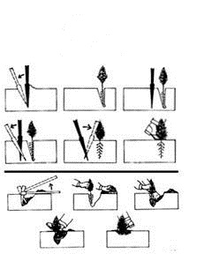

**Planting methods used in Iraq:**

1. **Planting in hole**
2. **Crescent-shaped holes**: by making up a big particular hole in the form of crescent in order to catch a large quantity of rain water during winter and spring seasons to enable new planted seedlings to grow and resist able to drought during dry seasons. This method is often used in mountain steep slopes containing natural obstructions such as rocks; valley.

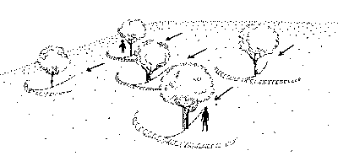

1. **Gradonies (contour line)**: by making up parallel linked lines with (1 – 1.5m) a width, so as to be vertically on the slope direction. This method is used in mountain steep slope without natural obstruction.

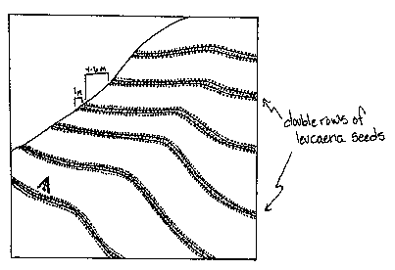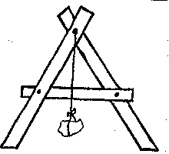

1. **Terraces**: by making up strips with (2 – 4m) width which are vertical on the slope direction also, this method is used in slight mountain slopes without natural obstructions.



**Planting Seasons**

The best time to plant trees is in early spring, well before bud break. Bare roottrees can be planted as soon as soils become workable in early spring, but should be installed before buds swell and new growth begins. Besides early spring, container-grown and balled and burlapped trees may be planted later in spring, in early summer, or early fall. Plantings made in mid-summer (July and early August), late fall, and winter (November to early March) are more prone to failure.

**Care Before Planting**

As trees await installation, they must be protected from mechanical injury, drying out, and overheating. The best protection is to plant trees as soon as possible after they are delivered.

Bare-root trees are especially susceptible to harmful drying of the roots. They should be held in a cool, sheltered location with the roots covered with moist straw, hay, or damp burlap.

Similarly, balled and burlapped, and container-grown trees are best held in a cool, shady area and kept moist until they are planted.