**Containers (Pots)**

**1 - Earthen Containers**

Use for training of seedling, covering bottom and sides with paper coated of asphalt or cement and then divides the bed by wooden board or metal into sections appropriate and planted the seeds in the middle of each section, and when seedlings reached to the suitable size for planting raising separation walls and remaining seedlings with the mass of soil ready for transfer to afforestation areas.

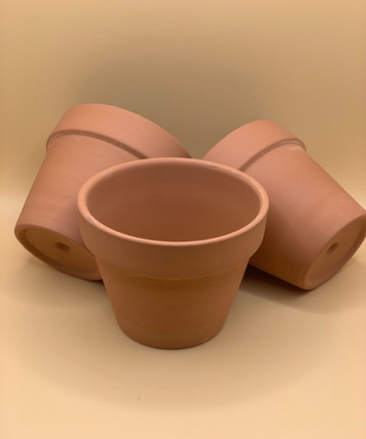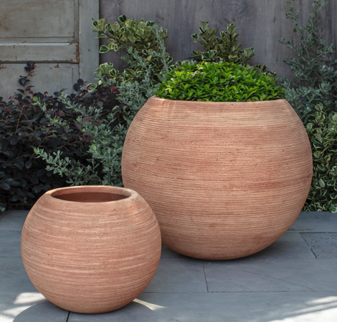

**2- Pottery Containers**

These Anvils consists of the mud and by conical or round form by different sizes, and contains Pottery anvils at the bottom on the hole for the purpose of discharge of excess water from the process of irrigation and put small pieces of pottery on the hole to prevent leakage of roots and soil from them.

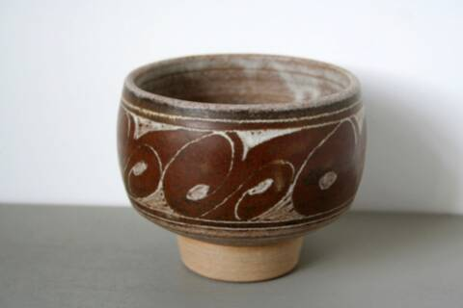

**3- Concrete Containers**

These Anvils consists mixture of component of cement and sand in the form of square or rectangular of different sizes.

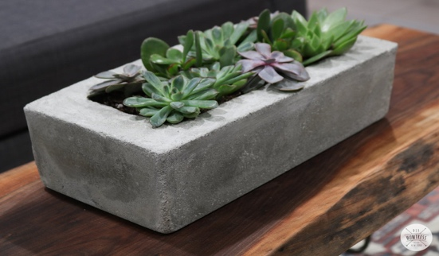

**4- Plant Pipe**

Used the stem of sunflower for this purpose, the length of the plant pipe that used in the training of seedlings (25cm) and the diameter (2.5cm) filled of humus and placed in wooden boxes, and cultivate (2-3) seeds in each tube and leave one seedling in the pipe for growth after germination seeds.



**5- Metal Containers**

The metal containers made of iron with zinc. When using the container, use the hole of box from one place or more to facilitate the leakage of excess water. Use the container for one time and use for raising of seedling with mud of planting.

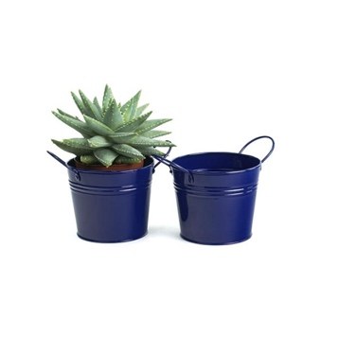

**6- Plastic Containers**

Make this kind of pots of different sizes of plastic individually or in groups (blocks or books). Make this kind of pots of different sizes of plastic individually or in groups (blocks or books).

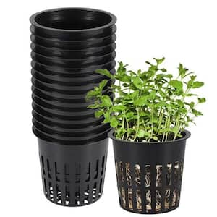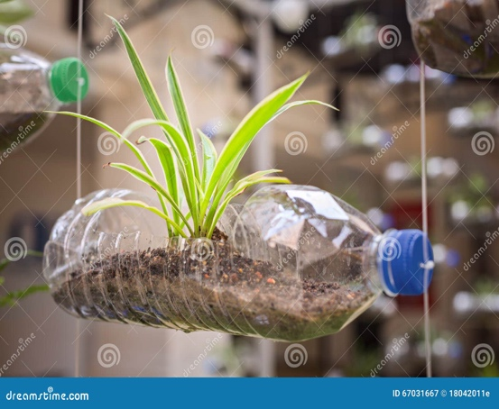

**7- Containers made of hay or animal manure with soil**

Made this type of anvils of mixture (50%) of sand with (50%) of clay. Add hay or animal manure to the mixture if the amount of sand is high or add sand to the mixture if the amount of clay is high. Made anvils after converting the mixture into paste and placed in the sun in order then planting the seedlings after the completion of drying.

Put the containers in order on the lines or plates furnished with layer of leaves to prevent the penetration of the roots of seedlings into the soil and cover the lines of containers with layer of sand to prevent the disintegration of the containers during the irrigation.

**8- Wooden Containers**

This type of anvil makes of wood by suitable size for the purpose of planting seeds in it after filled these anvils by loam.

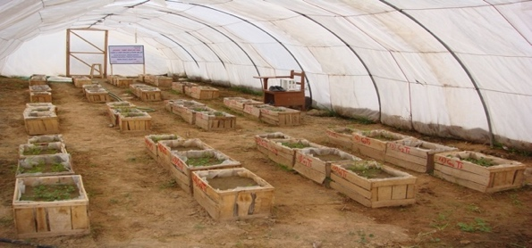

**9- Paper and Cartoon Containers**

Paper pots made of special type of paper containing artificial fibers and linking in groups by gum that soluble and be in the form of hexagonal or in the form of set of pots like beehive or individually.

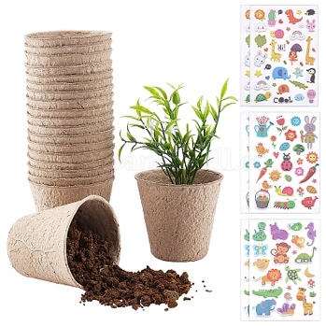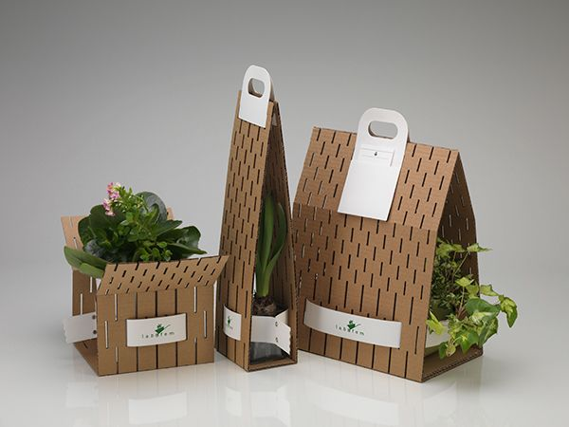

**10- Styroblocks Containers**

These containers consisting of rectangular templates from polystyrene and contain of rounded holes in the bottom of each gap to ensure the discharge of excess water.

