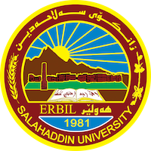
Academic Curriculum Vitae

Personal Information : : 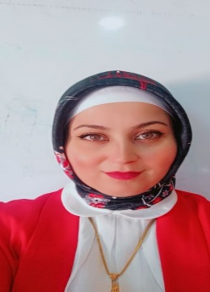
Full Name: shireen kamil ibrahim
Academic Title:teacher assistant
Email: (university email):salahaddin university
Mobile:07504148923

Education:
- I graduated in Salahuddin university -college of basic education
- I finished my teach successfully and I employed as assistant research
- Then I finshed MA degree in general science department in 2015

Employment:
I employed as assistant research in general science department in 2009
Qualifications
- Teaching qualifications
- IT qualifications
- Language qualifications such as TOEFL, IELTS or any equivalent
- Any professional qualification
- You could put any professional courses you have attended

Teaching experience:
- I State my teaching courses that I , stating undergraduate in kindergarten department and Arabic department and general social department
- I presented siminars to the teacher in many kindergartens
Research and publications
- I supervisors mor than 10 researches to the 4th stage student in kindergarten department ,

Conferences and courses attended
- I attended in 9 conferences while I finished my ma degree and I had attended
- Funding and academic awards
- List any bursaries, scholarships, travel grants or other sources of funding that you were awarded for research projects or to attend meetings or conferences.

Professional memberships
- List any membership you hold of any professional body or learned society relevant to your research or other life activities.

Professional Social Network Accounts:

https://scholar.google.com/scholar_settings?hl=ar

It is also recommended to create an academic cover letter for your CV, for further information about the cover letter, please visit below link:
https://career-advice.jobs.ac.uk/cv-and-cover-letter-advice/academic-cover-letter/

