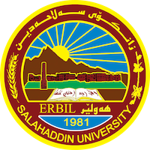
Academic Curriculum Vitae

Personal Information:
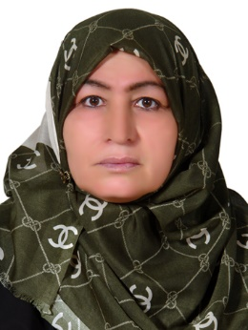
Academic Title: ماموستاي ياريدةدةر
Email: (university email) :shirin.hassan@su.edu.krd
Mobile:07504973490

Education: primary-
- State all educations accomplished: سةرةتاي- ناوندي- ىامادي- بةبمانكاي ماموستايان – كوليزي بةروةدة- ماستةر كوليزي ئاداب / صلاح الدين
Employment:
- State employment starting from first employment:وةزارةتي بةروةدة ي عراق 1987

Qualifications
- Teaching qualifications: شارةزا لة وانة ووتنةوةي زماني عربي و زانستةكاني
- IT qualifications: وورد- باوربوينت- انترنت
- Language qualifications such as TOEFL, IELTS or any equivalent: نية
- Any professional qualification:
- You could put any professional courses you have attended:
Teaching experience:
- State all teaching courses you delivered, stating undergraduate or post graduate
- Courses, trainings, lab supervision, etc.,: وانة ووتنةوة لة وةزارةتي بةروةردة لة خولي ريكاكاني وانة ووتنةوةي زماني عربي

Research and publications
- State all researches, publication you made.: ية

Conferences and courses attended
- Give details of any conferences you have attended, and those at which you have presented delivered poster presentations: نية

Funding and academic awards
- List any bursaries, scholarships, travel grants or other sources of funding that you were awarded for research projects or to attend meetings or conferences.

Professional memberships
- List any membership you hold of any professional body or learned society relevant to your research or other life activities.: نية

Professional Social Network Accounts:

- List your profile links of ReserchGate, LinkedIn, etc.:
- https://www.linkedin.com/in/shirin-hassan-9a310b141/?originalSubdomain=iq
- https://www.researchgate.net/

It is also recommended to create an academic cover letter for your CV, for further information about the cover letter, please visit below link:
-https://career-advice.jobs.ac.uk/cv-and-cover-letter-advice/academic-cover-letter/

