Subject: Practical Organic Chemistry Mrs. Darwin Hawar
Dept.: Field Crop Class: 2nd / Exp.: 2

Purification of Liquid Organic Compounds by Distillation
Distillation is the process of heating a liquid until it boils, capturing and cooling the resultant hot vapors, and collecting the condensed vapors. Distillation was probably first used by ancient Arab chemists to isolate perfumes.
Distillation is used for the identification and purification of organic compounds. The boiling point of a compound determined by distillation is well-defined as one of the physical properties of a compound by which it is identified. Distillation is used to purify a compound by separating it from a non-volatile or less-volatile material. When different compounds in a mixture have different boiling points, they separate into individual components by distillation.
The boiling point is the temperature at which the vapor pressure of the liquid phase of a compound equals the external pressure acting on the surface of the liquid. The external pressure is usually the atmospheric pressure. For instance, consider a liquid heated in an open flask. The vapor pressure of the liquid will increase as the temperature of liquid increases, and when the vapor pressure equals the atmospheric pressure, the liquid will boil. Different compounds boil at different temperatures because each has a different, characteristic vapor pressure: compounds with higher vapor pressures will boil at lower temperatures.
Types of distillation
- Simple Distillation
- Fractional Distillation
- Vacuum distillation
- Steam distillation

Simple Distillation
It is used for separating liquids having boiling points differing by 50 degree. The liquid having the lower boiling point distills over first, and the other liquid component it is left behind. In this process, vaporization and condensation occur side by side.
Simple distillation apparatus contents as following:
- Distillation flask.
- Thermometer.
- Condenser.
- Bunsen burner.
- Receiving flask.
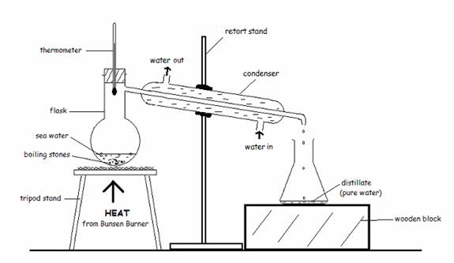
Setup for distillation of simple distillation
Mixtures of liquids whose boiling points are similar (separated by less than 50 °C) cannot be separated by a single simple distillation. In these situations, a fractional distillation is used.
Fractional Distillation: The only difference between this system and that of a simple distillation system is the inclusion of a fractionating column between the round bottom and the Y-adaptor. The fractionating column is regular condenser filled with glass beads.
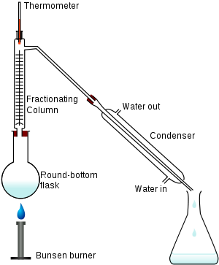
Setup for distillation of fractional distillation
Fractional distillation is the separation of a mixture of multiple components into its various fractions according to the difference in their boiling temperatures. This is the process used in the separation of Crude Oil into useful fractions and other mixtures like light Gases (Methane and Ethane), Naphtha, LPG, Gasoline, Kerosene, Diesel, Fuel Oils, Heavy fuel, Lube oils, Waxes and asphaltic products.
Vacuum distillation
Vacuum distillation is distillation at a reduced pressure. Vacuum distillation is used to distill compounds that have a high boiling point or any compound which might undergo decomposition on heating at atmospheric pressure.
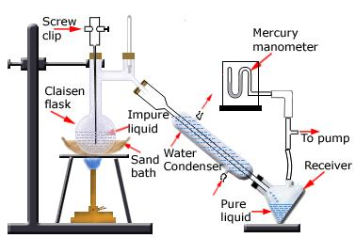
setup for distillation under reduced pressure
Steam distillation
Steam distillation is a special type of distillation for temperature sensitive materials which are immiscible with water, volatile in steam and have high vapor pressure at the boiling temperature of water like natural aromatic compounds. Eucalyptus oil and orange oil are obtained by this method on the industrial scale.
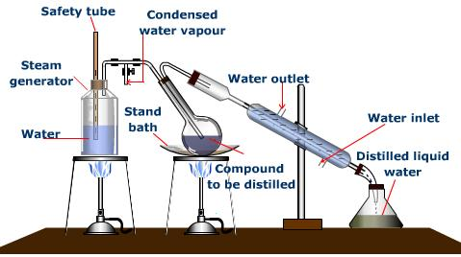
Note: boiling stones are used to prevent local super heating which in turn cause bumping
Procedure
The impure liquid or a mixture of two liquids is taken in a distillation flask fitted with a thermometer and a condenser. The flask is heated on a sand bath, on wire gauze or in a water bath. The more volatile liquid, i. e. the one having a lower boiling point, boils first and the vapors distill over from the outlet near the top. These vapors pass through the condenser and get condensed into the liquid. This condensed liquid collected in a receiver is called the distillate. The less volatile liquid, i.e. the one having a higher boiling point, gets left behind in the distillation flask. To avoid bumping of liquid, a few boiling stones are placed in the distillation flask.

