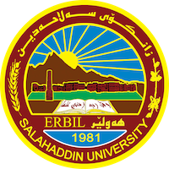
Academic Curriculum Vitae
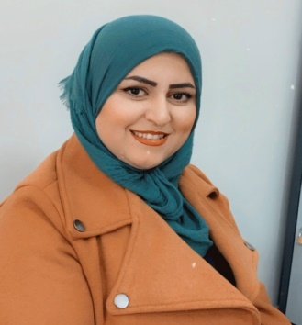
Personal Information:
Full Name: shno hsdi nabi
Academic Title: assistant Lecturer
Email: shno.nabi@su.edu.krd
Mobile:07504680575

Education:
- B.Sc. in Mathematics. Mathematics Department- College ofBasic Education- Salahaddin University- Erbil in 2007.
- M.Sc. in Methods of teaching Mathematics. Psychology and educational science Department- College of education - Salahaddin University- Erbil in 2015.
Employment:
- Teaching assistant at the College of basic education / Salahuddin University, Erbil, on 2/12/2007.
- I started a master's degree in 2011-2012 at Salaheddin University / College of education / Department of Psychology and educational science.
- I have been teaching in the Department of Mathematics, College of Basic Education, Salaheddin University, Erbil, since 2015 until now.

Teaching experience:
- Working as Teacher in University of Salaheddin Erbil– College of basic education – Mathematics Department since 2015.
Lessons taught:
- Methods of teaching mathematics/ fourth stage
- Methods of teaching and educational technology and viewing / third stage
- Education psychology/ second stage
- General psychology/ first stage
- Curriculum teaching/ forth stage

Other Qualifications
- Teaching methods course 2015
- English language course 2019

LANGUAGES
Good on English, very good in Arabic, and Kurdish (Mother Language).

Professional Social Network Accounts:

- https://www.researchgate.net/profile/Shno-Hadi
- https://www.linkedin.com/in/shno-hadi-1ba5591a0
- https://scholar.google.com/citations?hl=en&user=d2oD6TMAAAAJ

