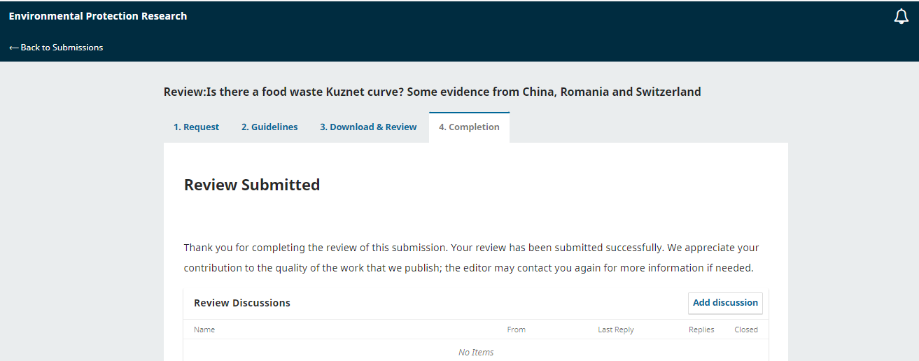
Julia <julia.z@universalwiser.com>
To:Shuokr Qarani Aziz
Mon, 27 Mar at 3:18 am
Dear Shuokr Qarani Aziz:
Thank you for completing the review of the submission, "Is there a food waste Kuznet curve? Some evidence from China, Romania and Switzerland," for Environmental Protection Research. We appreciate your contribution to the quality of the work that we publish

