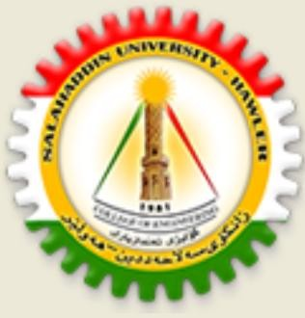
Kurdistan Region
Ministry of Higher Education & Scientific Research
Salahaddin University – Erbil
College of Engineering
Water Resources Engineering Department

Design of
Storm and Sewerage Network
in Zaner City / Erbil

A Project Submitted to the Water Resources Engineering Department
Salahaddin University – Erbil
in the Partial Fulfillment of the Requirement for the Degree of Bachelor of Science in
Water Resources Engineering

Prepare By:
Rovar Ayoob Ali
Alan Sartip Khalid

Supervisor
Mr. Shuwan J. Barzanjy

2022 – 2023

