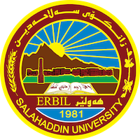
Academic Curriculum Vitae

Personal Information:
Full Name: shvan Hamasdiq AbdulrahmanAssistant lecturer
Academic Title: Assistant lecturer
Email: (university email) shvan.abdulrahman@su.edu.krd
Mobile: 07501042324

Education:
- PHD student
- MA in Global Security at the University of Sheffield 2014.
- Bachelor in political science, Salahaddin University-Erbil 2009

Employment:
- Assistant lecturer at Slahaddin University_Erbil
- Researcher at the Center for Political & Strategic Studies
- Public Relations Director of Kurdistan24
- Freelance Interpreter - coordinator with local & international news agencies.

Qualifications
- Nine years of teaching experience in the political science
- IT qualifications
- Gained 6:5 in English Language, IELTS.
- professional interpreter
- Participated in countless training courses in the past eight years

Teaching experience:
- Taught introduction to international relations.
- Taught political media and public opinion
- Taught political system

Research and publications
- I am in the final stage of my PHD

Conferences and courses attended
I attended many conferences as an organizer but not given any paper and speeches.

Funding and academic awards
- No academic awards.

Professional memberships
- No professional memberships

Professional Social Network Accounts:

Google Account
Home Feed | ResearchGate
Shvan Shwani (0009-0005-1161-4950) (orcid.org)
Shvan (Hamasdiq) Shwani (linkedin)

