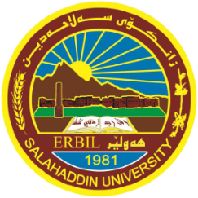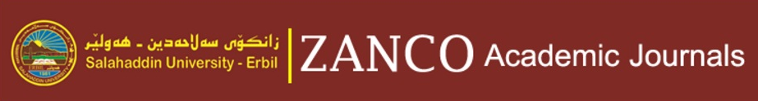

**Prof. Dr.Sinan Abdulkhaleq Yaseen**



Dr. Mustafa S. Al-Attar

Editor-in-Chief

For reviewing the manuscript of ID no. 509 on August 27 , 2022.

We highly appreciate your valuable comments on the above mentioned manuscript and your reviewing services have helped us maintain the quality of our journal. Thank you very much for your support to ZJPAS

Figure

**CERTIFICATE OF REVIEWING**

**A SCIENTIFIC MANUSCRIPT WITH**

**ZANCO Journal of Pure and Applied Sciences**

Awarded to

http:// zancojournals.su.edu.krd/