Effect of Concrete Strength and Stirrup Position on Shear Behavior of Semi Light Weight High Strength Self-Compacting Concrete Beams
Himdad Mohammed Mohammed ^{1*} and Sinan Abdulkhalq Yaseen ²
^{1*}Department of Civil Engineering, Faculty of Engineering, Soran University, Soran, Erbil-IRAQ
² Department of Civil Engineering, Faculty of Engineering, Salahaddin University, Erbil-IRAQ

Article History
Received: Day Month Year
Revised: Day Month Year
Accepted: Day Month Year
Communicated by: Asst. Prof. Dr.
*Email address: some.one@uni.edu
*Corresponding Author
Civil Engineering Department, Soran University, Kawa St, Soran, Kurdistan Region, Iraq.
Tel: +9647504444267
Email:
hmm510h@cive.soran.edu.iq
Copyright: © 2023 by the author. Licensee Tishk International University, Erbil, Iraq. This article is an open access article distributed under the terms and conditions of the
Creative Commons Attribution-Noncommercial 2.0 Generic License (CC BY-NC 2.0) https://creativecommons.org/licenses/by-nc/2.0/

Abstract: Self-compacting concrete (SCC) is a new technology of concrete, requiring no consolidation work at site and it can pass through closely spaced reinforcing bars and restricted sections without loss of homogeneity. SCC makes pouring concrete easier and solves construction issues, while lightweight concrete (LWC) is a great way to reduce the dead load on the structure. Combining the benefits of LWC with SCC is a new field of study. This research aims to study the shear behavior of Semi light-weight high strength self-compacting concrete (SLW-HSCC) beams with different concrete strength (${f'}_{c}= 55, 65 and 75 MPa )$ and stirrup positions (without stirrups, stirrups along the shear span and stirrups along the span). To examine the shear behavior, twelve beams manufactured and tested with SLW-HSCC as well as high strength self-compacting concrete (HSCC) to compare them with a constant beam depth, width and (a/d) ratio. The test variables include the concrete strength, concrete type and stirrup positions. In SLW-HSCC beams, the first shear crack was seen to develop at lower loads than in HSCC beams. Stirrups added inside the shear span improved the shear strength of SLW-HSCC beams on average by 117.8%, but stirrups added within the shear span increased the shear strength of HSCC beams by 24.16%.
It is critical to investigate the shear behavior of SLW-HSCC in structural members such as beams for the future.
Keywords: Concrete strength; Stirrup position; Shear; SLW-HSCC.

1. Introduction
Engineers have been dealing with the issue of concrete construction durability for several years. Concrete constructions must be adequately compacted by a vibrator to be made of durable material. In heavily reinforced areas of conventional concrete, it is difficult to guarantee homogenous material quality and good density.
Fresh and mechanical properties of self-consolidating concrete have seen considerable developments in the recent years.[1]. With the introduction of self-compacting concrete, there is no need for on-site concrete consolidation, and it is able to pass through tightly spaced reinforcing bars and limited sections without any loss of homogeneity.[2,3]. The fundamental advantage of SCC over regular concrete (NC) is that it can completely fill the formwork with just its own weight. This means that no vibration or professional employees are required to operate vibration equipment. As a result, construction time, labor costs, noise pollution, and worker health issues are significantly decreased.[4–6].
Self-weight of concrete is critical in structural applications since it accounts for a significant amount of the overall load. Using LWC will result in smaller members and less foundation force because of its lower self-weight. As a consequence, the construction may be less expensive because of decreased dead weight and cheaper foundation cost.[7]. Due to its freeze-thaw resistance, thermal conductivity, low density, lower seismic demand, smaller cross-section, fire resistance, and high strength-to-weight ratio, LWC may be utilized in place of traditional standard weight concrete in the construction industry.[8,9]. In spite of this, lightweight concrete has numerous disadvantages, main among them the segregation of aggregate from the mix due to the low density of lightweight particles in conventional concrete. In addition, light particles float to the top of lightweight concrete, resulting in a weak layer in the concrete surface as a result of incorrect compaction.[10].
Light weight self-compacting concrete (LW-SCC), which combines the greatest features of LWC and (SCC), is becoming more popular due to its unique combination of characteristics.[11]. The use of lightweight aggregates (LWA) in SCC may be particularly helpful in resolving the problem of segregation of LWA since SCC does not require to be compacted and therefore prevents the segregation of LWA. Therefore, LW-SCC combines the beneficial qualities that are present in both LWC and SCC, while also removing some of the drawbacks that are associated with each type.[10,12].
Nowadays, the fresh characteristics and durability behavior of LW-SCC have been extensively studied in the literature, however the mechanical characteristics, such as shear behavior, which is received less attention.
Hossain et al. (2020) evaluated the shear behavior of slag aggregate-based light weight self-compacting concrete beams (with and without shear reinforcement) to see how they compared to normal weight SCC beams. As long as diagonal fractures didn't emerge, LW-SCC beams reinforced with stirrups exhibited identical shear performance to those without. LW-SCC beams with no shear reinforcement had lower post-cracking shear resistance than regular weight SCC beams with shear reinforcement. Additionally demonstrated, when the a/d was reduced, the shear strength of LW-SCC/SCC beams increased.[13].
In 2016, Kokilan Sathiyamoorthy looked into the flexural and shear behavior of self-consolidating concrete beams made from a lightweight material. The geometry of the cross section, the ratio of the shear span to the depth of the test specimen, the flexural reinforcement, and the transverse reinforcement were all factors. Three flexural beams and nine shear beams (three with shear reinforcement and six without shear reinforcement) were tested to failure using four-point static loading. The a/d ratio was maintained between 1.05 and 2.14 to ensure shear failure. The six shear beams without shear reinforcement were cast with either standard weight SCC or LWSCC. Beams made of SCC were used as a benchmark against beams made of LWSCC to determine which material performed better structurally. In comparison to SCC beams, LWSCC beams had a greater number of cracks and a wider crack size after failure. With a reduction in a/d ratio, the variation in shear resistance capability between these two types of concrete beams increased.[1].
Abouhussien et al. (2015) studied the fresh properties, mechanical performance, and shear resistance of semi-lightweight normal vibrated concrete and SCC mixtures. Eleven beams were cast in full-scale construction elements without shear reinforcement to assess their shear strength and cracking behavior. To guarantee that shear failure occurs before bending failure, the a/d ratio of all beams was maintained at 2.5. The authors came at the conclusion that high strength beams in both conventional vibrated concrete and SCC semi-lightweight mixes showed more fractures and wider final cracks at failure than standard strength beams. Additionally, at the same SG/S ratio, high strength and normal strength SCC beams showed somewhat larger normalized shear loads than high strength and normal strength vibrated concrete beams.[14].
The results of an experimental research of the shear behavior of SLW-HSCC beams with various concrete strengths and stirrup positions are presented in this research. The test variables are concrete type, concrete strength, and stirrup position. Shear behavior of semi light weight high strength self-compacting concrete investigated in terms of shear strength and first Shear crack load.
2. Experimental Program
2.1 Test Specimen
Twelve beams were cast and tested with either SLW-HSCC or SCC. Each beam has a 2000 mm length and a 100 mm x 200 mm overall cross-section. Over a span of 1860mm, all test specimens were simply supported. There are three series of the tested beams. The characteristics and details of the tested specimens are shown in table 1, table 2 and figure 1. The purpose of each specimen was to demonstrate the impact of shear reinforcement quantity and location. To provide shear failure rather than bending failure of all beams, the shear span-to-depth ratio (a/d) was maintained constant at a value of 3.69. The flexural reinforcement ratio (ρw) was about 0.0373 (2 Ø 20 at bottom and 2 Ø 16 at top). Shear reinforcement provided with (${v f}_{y}$ = 1.703) and stirrups added within the shear span for the four beams in group one (G11 to G14). The stirrups added in the overall span of the four beams evaluated in group two (G21 to G24) had the same shear reinforcement as that provided in group one. The four beams tested in group three (G31 to G34) had no shear reinforcement. In each series three beams casted with SLW-HSCC ($f^{'}c$= 55, 65 and 75 MPa), and one beam casted with HSCC ($f^{'}c$= 65MPa) to compare the results as shown in table 1.
Table 1. Properties of tested beams
Group  No | Beams | Concrete Type | b  (mm) | d  (mm) | a/d | $$ρ_{w}\%$$ | $${f'}_{c}$$  (MPa) | $$ρ_{v}f_{y}$$  (MPa)
Group 1 | G11 | SLW-HSCC | 100 | 168 | 3.69 | 3.73 | 55 | 1.703
 | G12 | SLW-HSCC |  |  |  |  | 65
 | G13 | SLW-HSCC |  |  |  |  | 75
 | G14 | HSCC |  |  |  |  | 65
Group 2 | G21 | SLW-HSCC | 100 | 168 | 3.69 | 3.73 | 55 | 1.703
 | G22 | SLW-HSCC |  |  |  |  | 65
 | G23 | SLW-HSCC |  |  |  |  | 75
 | G24 | HSCC |  |  |  |  | 65
Group  3 | G31 | SLW-HSCC | 100 | 168 | 3.69 | 3.73 | 55 | ---
 | G32 | SLW-HSCC |  |  |  |  | 65
 | G33 | SLW-HSCC |  |  |  |  | 75
 | G34 | HSCC |  |  |  |  | 65
Table 2. Properties and drawings of tested beams
Group No | Tested beams | Detail of tested beams
Group 1 |  | $ρ_{v}f_{y}$=1.703MPa,diameter= 4mm , S=100 mm, 7 stirrups X 2
Group 2 |  | $ρ_{v}f_{y}$=1.703MPa,diameter= 4mm , S=100 mm, 19 stirrups
Group 3 |  | ----

Figure 1. Dimensions of specimens
2.2 Material Properties
All of the concrete mixtures in this investigation were made using ordinary Portland Cement in accordance with EN 197-1:2011 CEM I 42.5R type 1. This cement has a Blaine fineness and specific gravity of 325 m2/kg and 3.15, respectively. Class f fly ash (FA) type according to ASTM standard C618-95 was used as a secondary binder of cement. The Blaine fineness of class f fly ash was 380 $m^{2}/Kg$ whereas the specific gravity was 2.01. After being washed, crushed gravel with a maximum particle size of 10 mm, a specific gravity of 2.72, and water absorption of 0.83% was used as natural coarse aggregates. After washing, a natural fine aggregate with a maximum size of 4.75mm was also used as fine aggregate; the specific gravity and water absorption of this aggregate were 2.65 and 2.41%, respectively. Ponza, a lightweight aggregate LWA, was a crushing stone brought from the Iranian hills and is utilized as a volume replacement level for crushed gravel after washing. The specific gravity of the Ponza aggregate was measured under saturated surface dry conditions and water absorption were 0.76 and 69.78%, respectively. High range water reducing admixture HRWRA was used to improve the fresh properties of all mixes (Superplasticizer: Sika viscocrete5930).
The main tensile reinforcement was made out of deformed steel bars with a yield strength of approximately 575 MPa and a 20 mm diameter. Two bars were hooked at the ends and reinforced each beam. The quantity of reinforcement in each beam corresponds to a value of ${}_{w}$ =0.0373. Compression reinforcement was provided by deformed steel bars with a yield strength of about 594 MPa and a 16mm diameter. Stirrups were made out of deformed steel bars with a yield strength ($f_{y}$) of nearly 678 MPa and a diameter of 4mm.
2.3 Mix Proportions
Four mixes have been prepared to show the effect of concrete strength on shear behavior of light weight self-compacting concrete beams. Three SLW-SCC mixes with different concrete strength (55, 65 and 75 MPa), and one mix as control mix HSCC without light weight aggregate with (65 MPa) concrete strength have been prepared. Depending on the literature through those who works on fresh properties of LWSCC, the trial mix have been done. Twenty trial mixes done with different proportion to achieve the required concrete strengths. The only problem with concrete was the light weight aggregate will make a rough surface to the concrete. During trial mixes, it was observed that using electrical pan mixer instead of hand mixing made a great change in strength. Crushed gravel replaced with light weight aggregate at 60% by volume to achieve light weight self-compacting concrete. Table 3 shows the concrete mix proportions in kg/m3.
Mix No | w/c | Binder content |  | Crushed gravel $Kg/m^{3}$ | Sand $Kg/m^{3}$ | Light-weight aggregate  $$Kg/m^{3}$$ | Water  $$Kg/m^{3}$$ | HRWRA  $$Kg/m^{3}$$
 |  | Cement $Kg/m^{3}$ | Fly ash $Kg/m^{3}$
SLW-HSCC55 | 0.385 | 360 | 100 | 316 | 850 | 223.6 | 177 | 10
SLW-HSCC65 | 0.38 | 342 | 100 | 316 | 850 | 223.6 | 168.15 | 10
SLW-HSCC75 | 0.3 | 400 | 100 | 316 | 850 | 223.6 | 150.45 | 10
HSCC65 | 0.356 | 342 | 100 | 500 | 850 | --------- | 157.5 | 10
Table 3. Concrete mix proportions.

2.4. Casting of Beam Specimens
Immediately after concrete mixtures prepared, fresh properties of the concrete mixtures tested as shown in figure 2. The flowability of the concrete mixes was evaluated using the conventional slump flow test, which measures the slump flow diameter in millimeters and the slump flow duration to generate a 500mm concrete spread T500mm in seconds. Concrete mixture passing ability was evaluated using the L-box test. This test examines how an impediment, such as steel reinforcement, affects the flow of concrete. Segregation resistance was assessed using sieve segregation. The V-funnel test was used to determine how long it took newly mixed self-compacting concrete to pass through a small hole. It provides a general idea of SCC's filling ability under the assumption that blocking, or segregation do not occur. Following that, beams were cast using wooden forms that had been fabricated. The mold was put in a horizontal position, and the inside face of the mold was oiled and the reinforcement cage was placed and fixed in position to control cover. SCC beams were made by pouring concrete into the formwork from one side and letting it flow to the other without needing any consolidation. Visual inspection proved that the SCC had filled out the forms correctly while moving around the reinforcing bars easily in each reinforcement configuration. Four 100mm cubes were cast with each mix to determine the concrete compressive strength. The beam specimens and cubes were removed from mold 48hr after casting, then put it in water. The curing was continued for about 27 days, after that left in air temperature and humidity inside the laboratory until date of testing.
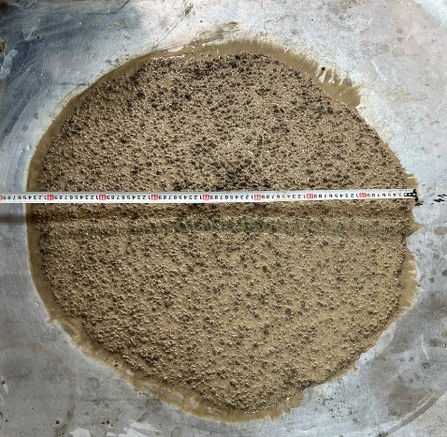 | 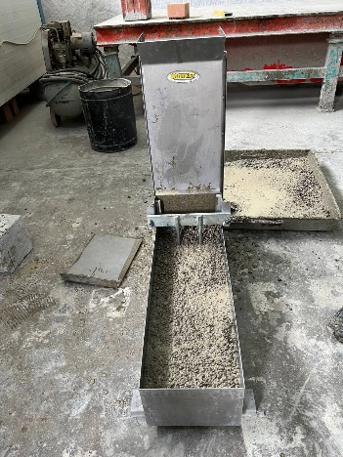 | 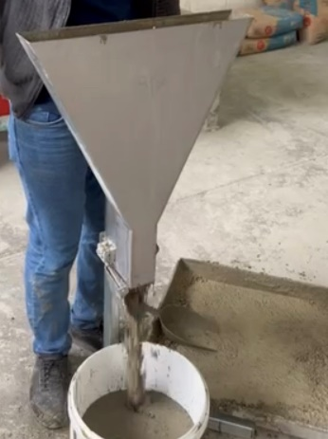 | 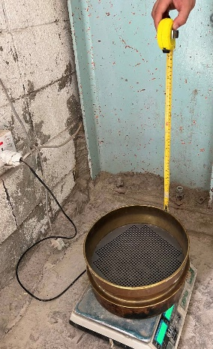
Slump flow test | L-box test | V-funnel test | Sieve segregation test
Figure 2: Fresh property tests.
2.5. Instrumentation
All beams were tested under two-point loading by a 1000kN capacity universal testing machine as shown in Fig. To transmit the load and stop the concentration of strains, two bearing steel plates of constant width were put under the loading points and above the supports. Linear variable displacement transducers (LVDTs) were installed under the beam's mid span to measure displacement throughout loading history. In addition, the two cameras were placed to read the load magnitude on the computer screen, while an excel sheet kept track of the deflection measurements as well as the strain in the concrete and steel as shown in figure 3.
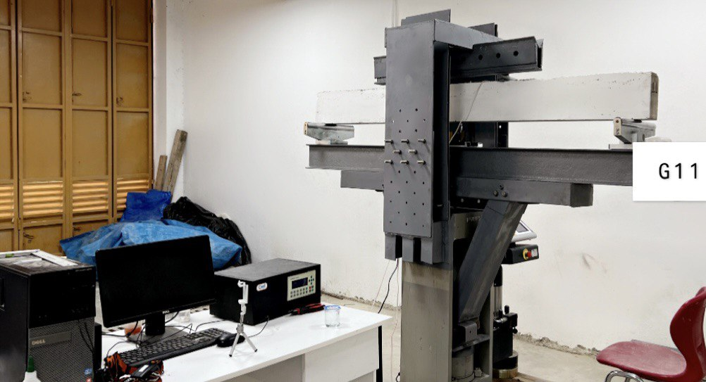
Figure 3: instrumentation of beam specimen (civil engineering laboratory of Soran University).
3. Findings and Disscussion
3.1 Fresh Properties
The fresh properties of HSCC and SLW-HSCC are summarized in table 4. All mixtures that have been produced have good flowing ability, passing ability, and segregation resistance characteristics. According to EFNARC, the slump flow time (T500mm), slump flow diameter, L-box (blocking ratio H2/H1), v-funnel time, and sieve segregation (segregation resistance %) matched the standards of SCC.[15].
Table 4: Fresh properties of HSCC and SLW-HSCC.
Mix NO | Slump flow diameter (mm) | T500mm  (S) | v-funnel time  (S) | Lbox (H2/H1) | SR %
SLW-HSCC55 | 710/770 | 2.12 | 9.28 | 0.86 | 14.5
SLW-HSCC65 | 770/740 | 2.36 | 14.23 | 0.99 | 8.96
SLW-HSCC75 | 760/760 | 3.12 | 23.4 | 0.84 | 7.8
HSCC65 | 810/780 | 3.22 | 8.85 | 0.9 | 13.2
Range | $≥$650 | 2-5 | 9-25 | 0.8-1 | <20

3.2 General cracking and failure behavior
Figure 4 shows the cracking behavior and failure modes of the tested beams. Table 5 summarizes experimental results indicating density of concrete, concrete compressive strength, first shear crack load, ultimate load, ultimate shear strength, and failure modes of tested beams. The three types of failure seen in this research were shear-compression or shear tension, diagonal splitting, and support failure. The shear compression failure may be identified from other types of failures by the crushing of the concrete that occurs above the upper end of the inclined crack. Shear tension failure occurs due to diagonal crack propagating horizontally along the longitudinal tensile reinforcement. For the diagonal splitting mode to take place, there must be a crucial diagonal crack connecting the loading point and the support. Support failure occurs in case of low reinforcement ratio or movement of longitudinal bars through casting.
3.2.1 SLW-HSCC and HSCC beams without shear reinforcement (Group 3)
Fine vertical flexural cracks in the center of each beam occurred during the early stages of loading (zero shear area). As the load increased, more flexural cracks formed before the initial shear cracks occurred in the shear span and in the zero shear zones. The inclined shear crack initially emerged near the support, as expected. As the load rose, additional shear and flexural cracks formed all over the beam, and diagonal shear fractures propagated toward the point where the beam was loaded. After a dominant diagonal shear fracture had developed on one or more sides of the shear span, sudden shear failure finally occurred as shown in figure 5. In comparison to HSCC beams, SLW-HSCC beams showed the first flexural crack to form at lower loads. During the loading process, the first diagonal crack's formation was detected visibly. The diagonal crack first showed up between 52.1% and 61.7% for SLW-HSCC compared with 72.8% for HSCC of the maximum load and quickly propagated towards loading point and support. In addition, SLW-HSCC beams developed more cracks than HSCC as it can be seen in figure 4.

3.2.2 SLW-HSCC and HSCC beams with shear reinforcement (Group 1 and Group 2)
Until diagonal cracks develop, the crack pattern of SLW-HSCC beams with shear reinforcement along the shear span and along the span is almost the same to that of those without shear reinforcement. However, after the formation of a diagonal cracks, beams with shear reinforcement demonstrated higher load carrying capacity until failure. Shear reinforcement picked up the load immediately after the inclined crack developed. Shear reinforcement that is properly spaced holds the inclined fracture together and prevents further shear crack opening. The diagonal crack first showed up between 29.2% and 41.3% for SLW-HSCC compared with 48.3% and 53.7% for HSCC of the maximum load.
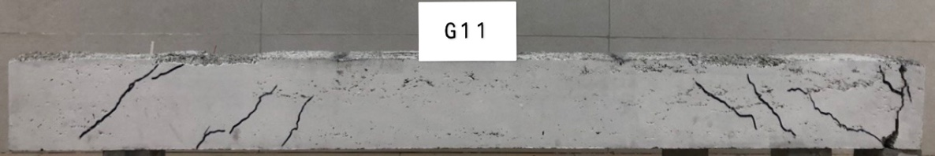
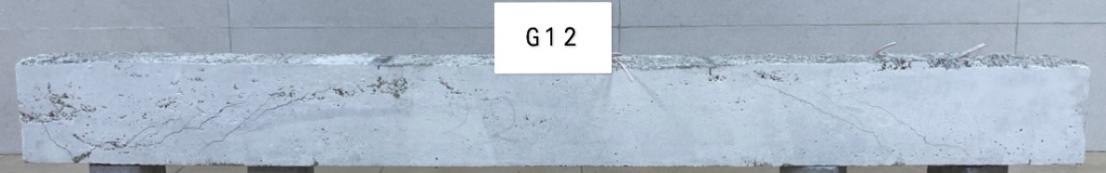
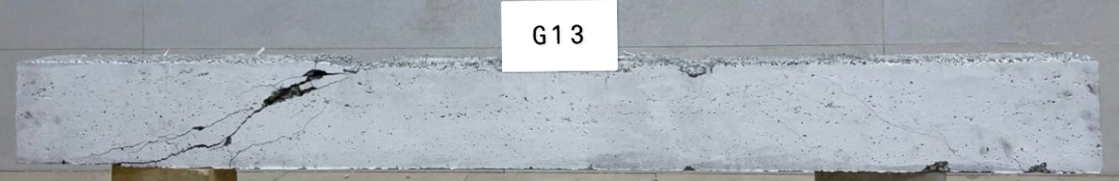
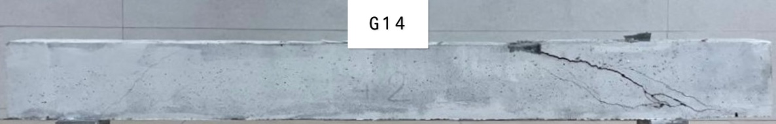
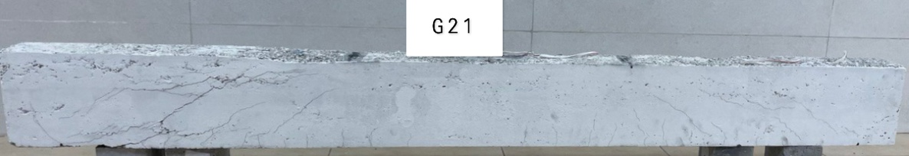
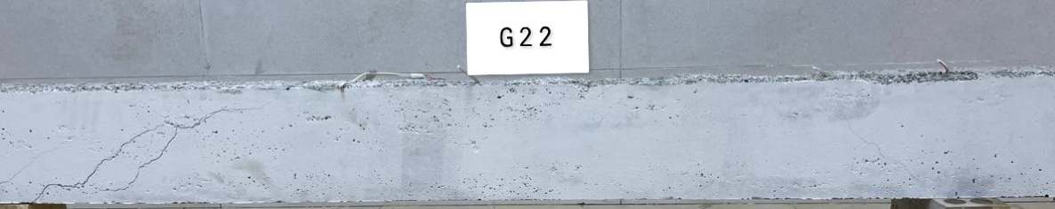
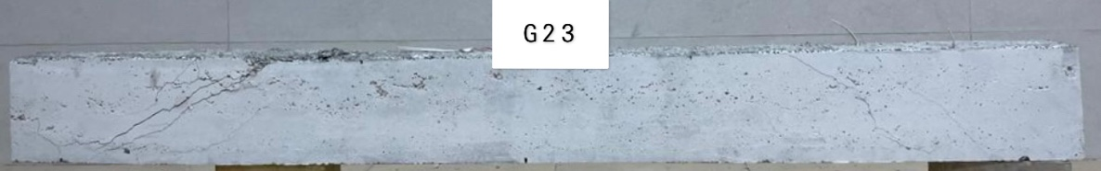
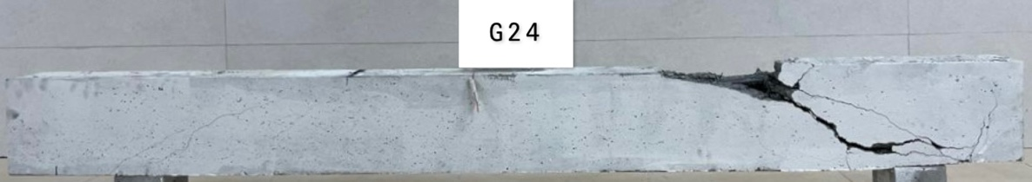
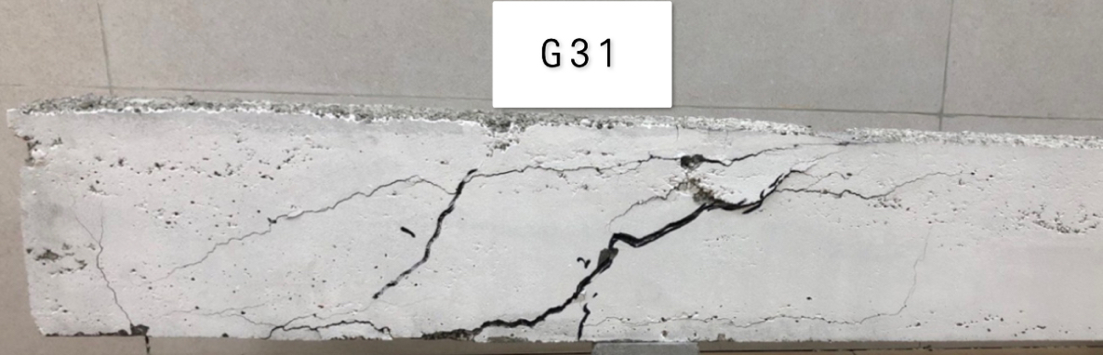
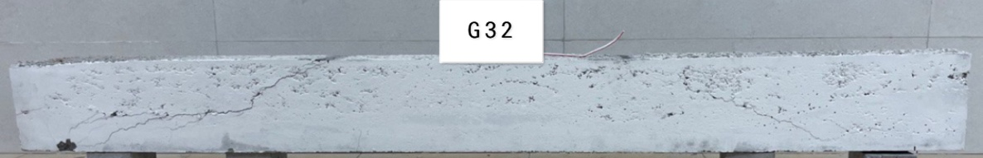
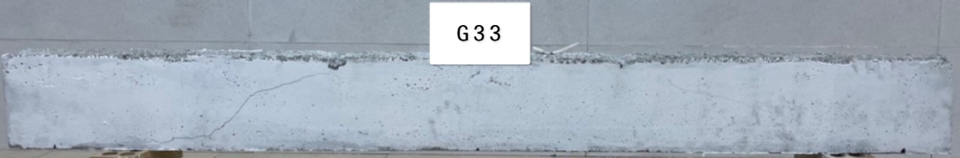
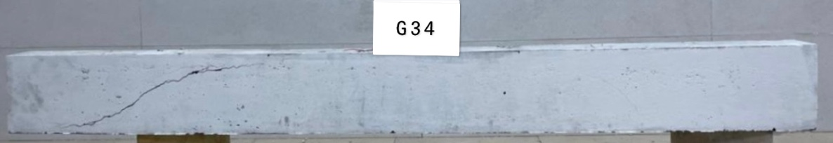

Figure 4: Failure modes of tested beams.
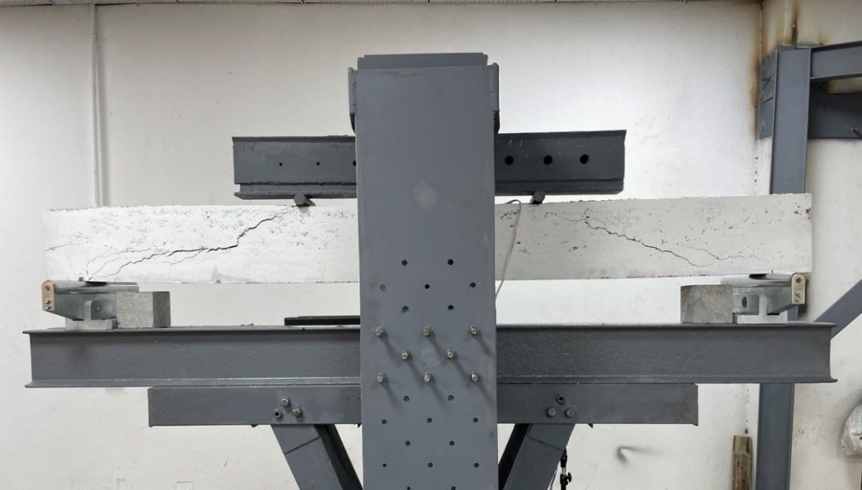
Figure 5: Typical shear failure of an experimental beam.

Table 5: Summary of test results.
Group | Beams | Density  Kg/$m^{3}$ | Concrete type | $${f^{'}}_{c}$$  MPa | First shear cracking load, KN | Ultimate load, KN | Ultimate Shear strength  (MPa)  $$\frac{V_{u}}{b.d}$$ | Failure mode
 |  |  |  | 83 days
Group 1 | G11 | 2161 | SLW-HSCC | 56.7 | 30.4 | 104.1 | 3.095 | Support
 | G12 | 2123 | SLW-HSCC | 63.6 | 41.8 | 136.3 | 4.047 | Shear
 | G13 | 2171 | SLW-HSCC | 77.45 | 49.1 | 145 | 4.315 | Diagonal splitting
 | G14 | 2397 | HSCC | 67.55 | 78.7 | 146.5 | 4.434 | Diagonal splitting
Group 2 | G21 | 2161 | SLW-HSCC | 56.7 | 55.8 | 135 | 4.017 | Shear
 | G22 | 2123 | SLW-HSCC | 63.6 | 58.7 | 144.4 | 4.297 | Shear
 | G23 | 2171 | SLW-HSCC | 77.45 | 60 | 154.9 | 4.61 | Shear
 | G24 | 2397 | HSCC | 67.55 | 73.1 | 151.3 | 4.502 | Diagonal splitting
Group 3 | G31 | 2161 | SLW-HSCC | 56.7 | 27.4 | 44.4 | 1.315 | Shear
 | G32 | 2123 | SLW-HSCC | 63.6 | 34.6 | 66.4 | 1.976 | Shear
 | G33 | 2171 | SLW-HSCC | 77.45 | 38.5 | 68.1 | 2.023 | Shear
 | G34 | 2397 | HSCC | 67.55 | 88.4 | 121.4 | 3.571 | Shear

3.3 Load-Deflection Relationships
During beam testing, midspan deflection was recorded using an LVDT while a load was gradually applied. Figure 6 (a) shows the load against mid-span deflection responses for group 3 (Beams without shear reinforcement). A decrease in the stiffness of the beam is shown by variations in the curve's slope. The first straight-line part of the curve demonstrates that the beam's stiffness was constant before flexural cracking. Unexpected variations in the load-deflection curves are a sign that a crack has occurred while being loaded. The stiffness of the beams suddenly decreased following the development of inclined/diagonal cracks, particularly in SLW-SCC beams. A sudden shear failure happened when the load exceeded its maximum shear capacity. The load bearing capacity was significantly reduced immediately after the shear failure. HSCC65 beam without shear reinforcement showed higher maximum deflection compared with SLW-SCC65 counterpart by 39.8%. The stiffness of SLW-HSCC beams increase with increase in compressive strength of concrete and become more brittle, but the maximum deflection decreases with increase in compressive strength as shown in figure 6 (a).
Figure 6 (b) displays the load-mid span deflection responses for group 1 beams with shear reinforcements along shear span. The straight-line portion of the curve shows that the stiffness of the beams was comparable to the stiffness of beams without shear reinforcement before flexural cracking. The formation of the inclined crack resulted in a little slope reduction, but the slope reduction was greater in beams without shear reinforcement. This shows that when inclined cracks formed, the beams with shear reinforcement were stiffer than the beams without shear reinforcement. Even after the development of an angled fracture, the deflection curve remained substantially straight until failure or the yielding of reinforcement. As predicted, the beams with shear reinforcement failed at a considerably higher load and showed more deflection than those without shear reinforcement. When compared to beams without shear reinforcement, the SLW-HSCC beams with shear reinforcement showed more ductile behavior in terms of greater deflection development. HSCC65 beam with shear reinforcement along shear span showed higher deflection compared with SLW-HSCC65 counterpart by approximately 9%. It can be observed that with existing shear reinforcement along shear span the deference between SLW-HSCC and HSCC beams mid-span deflection reduced. Also, it was observed that by increasing the compressive strength of SLW-HSCC beams with shear reinforcement along shear span the mid-span deflection increased.
Mid-span deflection versus load for group 2 beams with shear reinforcement along the span shown in figure 6 (c). They behaved in same way as group 1. It was observed that by increasing concrete strength the mid-span deflection was not changed a lot. HSCC65 beam with shear reinforcement along the span showed higher deflection compared with SLW-SCC65 counterpart by approximately 20.78%.

Figure 6 (a): Load versus mid-span deflection for group 3.

Figure 6 (b): Load versus mid span deflection for group 1.

Figure 6 (c): load versus mid-span deflection for group 2.
3.4 Effect of concrete strength and stirrup position on first shear crack load
Table 5 summarizes the ultimate and cracking loads for all specimens. Figure 7 shows the effect of concrete strength and stirrup position on first shear crack load. It was observed that by adding the stirrups within the shear span and between two point loads the first crack load increased. Also, it was observed that by increasing concrete strength the first shear crack load begun to increase. HSCC65 exhibited higher first shear crack load compares to SLW-HSCC65.

Figure 7: Effect of concrete strength and stirrup position on first shear crack load.
3.5 Effect of concrete strength and stirrup position on shear strength
The effect of concrete strength and stirrup position on shear strength of SLW-SCC and SCC are shown in figure 8. Shear strength of SLW-HSCC beams average increased by 117.8% when adding stirrups within shear span, but shear strength of HSCC beam increased by 24.16% when adding stirrups within shear span. By adding stirrups between two-point loads, not a noticeable change seen in the ultimate shear strength septically in higher strength concretes as shown in figure 8. Shear strength of SLW-HSCC beams is less than HSCC beams by 44.67%, 8.73% and 4.56% for beams without shear reinforcement, shear reinforcement along shear span and shear reinforcement along the span, respectively.

Figure 8: Effect of concrete strength and stirrup position on shear strength.
4. Conclusions
The effect of concrete strength and stirrup position on shear behavior of semi light weight self-compacting concrete beams have been studied. Based on the results the of this research, the following conclusions can be drawn:
- SLW-HSCC beams, as compared to HSCC beams, showed the first shear crack to form at lower loads.
- SLW-HSCC beams showed lower maximum deflection compared to HSCC.
- As expected, the beams with shear reinforcement exhibited noticeably larger maximum deflection and failed at a much higher load than those without it.
- Mid span deflection was reduced by increasing compressive strength of concrete for beams without shear reinforcement, but mid span deflection was increased by increasing the compressive strength of concrete for beams with shear reinforcement.
- It was observed that by adding the stirrups within the shear span and between two point loads the first crack load increased. Also, it was observed that by increasing concrete strength the first shear crack load begun to increase.
- Shear strength of SLW-HSCC beams average increased by 117.8% when adding stirrups within shear span, but shear strength of HSCC beam increased by 24.16% when adding stirrups within shear span.
- Shear strength of SLW-HSCC beams is less than HSCC beams by 44.67%, 8.73% and 4.56% for beams without shear reinforcement, shear reinforcement along shear span and shear reinforcement along the span, respectively.
Author’s Contribution:
We confirm that the manuscript has been read and approved by all named authors. We also confirm that each author has the same contribution to the paper. We further confirm that the order of authors listed in the manuscript has been approved by all authors.
5. Conflict of Interest
There is no conflict of interest for this paper.
6. Acknowledgment
The authors gratefully acknowledge the staff of the Soran University, concrete lab of Salahaddin University, and editonal team of EAJSE journal for their great support.
References
[1] Sathiyamoorthy K. Shear and Flexural Behaviour of Lightweight Self-Consolidating Concrete Beams. A PhD Thesis Present to Ryerson Univ Partial Fulfillment Requir Degree Master Appl Sci Progr Civ Eng Toronto, Ontario, Canada. 2016.
[2] De Schutter G, Bartos PJM, Domone P, Gibbs J. Self-compacting concrete. Vol. 288. Whittles Publishing Caithness; 2008.
[3] Khayat KH, De Schutter G. Mechanical properties of self-compacting concrete. Vol. 14. Springer; 2014.
[4] Choi YW, Lee HK, Chu SB, Cheong SH, Jung WY. Shear behavior and performance of deep beams made with self-compacting concrete. Int J Concr Struct Mater. 2012;6(2):65–78. https://doi.org/10.1007/s40069-012-0007-y
[5] Choulli Y, Marí AR, Cladera A. Shear behaviour of full-scale prestressed i-beams made with self compacting concrete. Mater Struct. 2008;41(1):131–41. https://doi.org/10.1617/s11527-007-9225-1
[6] Bouzoubaâ N, Lachemi M. Self-compacting concrete incorporating high volumes of class F fly ash: Preliminary results. Cem Concr Res. 2001;31(3):413–20. https://doi.org/10.1016/S0008-8846(00)00504-4
[7] Lotfy A. Lightweight Self-consolidating Concrete: Statistical Modelling, Mixture Design And PerformanceEvaluation. Thesis dan Disertasi, Ontario: Ryerson University; 2012.
[8] Jumaat MZ, Alengaram UJ, Mahmud H. Shear strength of oil palm shell foamed concrete beams. Mater Des. 2009;30(6):2227–36. https://doi.org/10.1016/j.matdes.2008.09.024
[9] Nawaz W, Abdalla JA, Hawileh RA, Alajmani HS, Abuzayed IH, Ataya H, et al. Experimental study on the shear strength of reinforced concrete beams cast with Lava lightweight aggregates. Arch Civ Mech Eng. 2019;19(4):981–96. https://doi.org/10.1016/j.acme.2019.05.003
[10] Almawla SA, Mohammed MK, Al-hadithi AI. Fresh and mechanical properties of self-compacting lightweight concrete containing Ponza aggregates. In: 2019 12th International Conference on Developments in eSystems Engineering (DeSE). IEEE; 2019. p. 100–4. https://doi.org/10.1109/DeSE.2019.00028
[11] Hossain KMA, Hossain MA, Manzur T. Structural performance of fiber reinforced lightweight self-compacting concrete beams subjected to accelerated corrosion. J Build Eng. 2020;30:101291. https://doi.org/10.1016/j.jobe.2020.101291
[12] Bozkurt N, Taşkin V. Design of self compacting lightweight concrete using acidic pumice with different powder materials. Acta Phys Pol A. 2017;132(3):779–82. https://doi.org/10.12693/APhysPolA.132.779
[13] Hossain KMA, Sathiyamoorthy K, Manzur T, Lotfy A. Shear behavior of lightweight slag aggregate self-consolidating concrete beams. ACI Struct J. 2020;117(5):259–68. https://doi.org/10.14359/51724685
[14] Abouhussien AA, Hassan AAA, Ismail MK. Properties of semi-lightweight self-consolidating concrete containing lightweight slag aggregate. Constr Build Mater. 2015;75:63–73. https://doi.org/10.1016/j.conbuildmat.2014.10.028
[15] EFNARC M. The European Guidelines for Self Compacting Concrete Specification, Production, and Use. Eur Fed Spec Constr Chem Concr Syst. 2005.

Notation
ACI | American Concrete Institute |  | a | Shear span, distance between concentrated load and face of support, mm
ASTM | American Society for Testing of Materials |  | a/d | Shear span to depth ratio
SCC | Self-compacting concrete |  | As | Area of tension reinforcement, mm2
LWC | Light weight concrete |  | b | Width of beam, mm
LWSCC | Light weight self-compacting concrete |  | d | Effective depth of the beam, mm
SLW-HSCC | Semi light weight high strength self-compacting concrete |  | ${f^{'}}_{c}$ | Compressive strength of concrete based on ASTM specifications, MPa
HSCC | High strength self-compacting concrete |  | $$fy$$ | Yield strength of steel reinforcement, MPa
NC | Normal concrete |  | FA | Fly ash
LWA | Light weight aggregate |  | h | Overall depth of the beam, mm.
LVDT | Linear variable displacement transducers. |  | HRWRA | High range water reducing admixture
S | spacing between stirrups |  | Vu | Ultimate shear stress of reinforced concrete beams, MPa
P | Load, KN |  | $ρ_{w}$ | Reinforcement ratio of the main steel
T500 | Measured time from start of lift to time when first touches 500mm diameter mark, s |  | $$ρ_{v}f_{y}$$ | Shear stress of stirrups
SR% | Segregation resistance

