Flexural Strengthening for Reinforced Concrete T-Shaped Beam by Tightened Strands Position Change
Halmat Muslih Burhan ^{1,2*} and Sinan Abdulkhaleq Yaseen ¹
¹ Civil Engineering Department, Salahaddin University – Erbil, Iraq
^{2*} Civil Engineering Department, Faculty of Engineering, Tishk International University, Erbil-IRAQ

Article History  Received: Day Month Year  Revised: Day Month Year  Accepted: Day Month Year  Communicated by: Asst. Prof. Dr.  *Email address: halmat.muslih@tiu.edu.iq  *Corresponding Author  Copyright: © 2023 by the author. Licensee Tishk International University, Erbil, Iraq. This article is an open access article distributed under the terms and conditions of the  Creative Commons Attribution-Noncommercial 2.0 Generic License (CC BY-NC 2.0)  https://creativecommons.org/licenses/by-nc/2.0/ | Abstract: In this study, external strengthening of T-shape beams is investigated using a new profiling technique by drop downing the tendon from the flange to near the bottom of the beam, the investigation includes the effect of different turning point position of the tendon on: deflection, first crack load, service load, and maximum failure load. Totally 4 beams are casted with same dimensions of 2000mm length, 230mm and 50mm of flange width and depth, respectively; web width and height of 130mm and 170mm, respectively. All of them they have the same material properties, concrete 30MPa and main steel bars 510MPa. Three of the beams are strengthened by external tightened tendons of diameter 6mm and maximum stress of 1770MPa, with different turning points of the cable near beam’s bottom under prestressing of 140MPa, and other beam without strengthening as control beam. The results show for all the profiles increasing in first crack load between (30.8% to 61.5%), service load between (18.5% to 25%), and for maximum failure load, the improvement is between (40% to 50%) compared to the control beam.  Keywords: Tendons, external strengthening, T-shape beam, pre-stressing

Introduction:
Around the world, from small houses to skyscraper structures and bridges are subject to deterioration due to aging, reinforcement corrosion. During earthquakes, existing buildings have collapsed or experienced serious damage, resulting in significant economic losses, severe injuries, and human deaths. Given the late adoption of modern seismic standards and the enormous number of existing under-designed structures, scientific focus has been shifted to creating solutions for strengthening and retrofitting existing structures [1]. The urgent need to enhance and repair existing structures and facilities due to a change in use or poor performance of structures put an extra work on civil engineer’s shoulder. Reinforced concrete components need to be strengthened for a variety of reasons, including mentioned issues above, as well as changes in load-carrying capability, and these are not the only reasons that make the strengthening necessary [2, 3]. Existing structures need also be strengthened because of faults and flaws in their design and construction, as well as exposure to unpredictable forces such as storms, shock loads, floods. In addition, most existing structures are built according to old, outdated standards and codes, which is another cause. Therefore, they do not fulfill modern design standards, and according to ASCE, these structures are considered structurally inadequate [4]. Strengthening existing reinforced concrete buildings demands for the use of new materials and methods by designers. As beams are essential elements for a structure, providing the beams will tight the structure together for resisting lateral load. They are resisting the load of the slab and the walls and uniformly distribute them to the columns, for larger spans without beams will result in a larger thickness of the slabs which, in turn, results in larger sections of the columns. And at the end, it will require stronger foundation as it will increase the tendency for settlement of the building due to larger weights. The tendons can be from different materials and different shapes can be used for strengthening. Here, the steel strands will be focused on in this research. The beams in this study are T-shaped, as they represent more realistic beams, which the beams support slabs and the slab itself becomes flanges for the beam. When it comes to Tendons, a strong metal is used. A core is surrounded by a set of strands that are arranged spirally. A tendon or cable's strands are made up of several individual wires arranged in a circle around a center wire. Different methods for strengthening can be used as some of the methods that are used mostly to strengthen different structural parts, include section enlargement, bonded steel plating, FRP composites wrapping, external post-tensioning, and jacketing, each method has its advantages and drawbacks at the same time. Some of the mentioned technique disadvantages including high cost, complexity in implementation, reduced headroom, loss of aesthetic value, increased self-weight, the necessity for precise surface preparation, and de-bonding failure. On other hand tightened or prestressed tendons can solve major of the problems, such as, low cost, direct implementation which doesn’t require special preparation, low weight, no section enlargements, and no debonding issues, while the method itself it is a deboned technique.

Objective:
Defining first crack load, failure load, and service load capacity of beams externally strengthened with tendons in different profiling shapes and subjected to a 4-point load and; comparing the beams to their non-strengthened beam equivalents..

Review:
Said, Al-Ahmed [5] conducted a study to examine the externally post-tensioning approach for reinforcing RC beams. They tested three beams, 3 strengthened and one is control, the major parameter measured in the research is the strengthening length ratio, which is the length of strengthening region over the effective length of beam, the ratios were 0.83, 0.67 and 0.50.
Zhou, Li [6] working on a fire resistance test of prestressed composite steel-concrete beams with external tendons is presented. Beams were put through their tests while being subjected to both fire and a positive moment. There was a greater difference in fire resistance between the tested beams with bent-up strands and ones with straight cables; the beams with bent-up strands had shown greater resistance. Slackness in cable strands caused the breakdown of the test beams at high temperatures, despite the low degree of stress.
da Rocha Almeida, de Souza [7] studied Steel-concrete composite beams that are simply supported and strengthened with external cables, under positive bending. Variables including the initial prestressing force, length and form of cables are examined. Some cable arrangements are more effective than others, improving the ultimate moment resistance in the composite beams and dramatically lowering deflections and cracking in the concrete under applied load.

Materials used for casting beams:

Concrete:
Ready concrete from IBERIA Ready-Mix Concrete company was ordered to make sure that all the beams are casted with the same material properties, the maximum size of concrete is 12mm with slump test of 8cm. and compressive strength of cubes was 30MPa.

Steel bars:
Main bars in tension, compression, and stirrups and steel are same bars of diameter 8mm and tensile strength of 517MPa with elongation of 24%.

Steel strands (tendons):
The steel strands 7x19 of diameter 6mm were used in the test and their maximum tensile strength of 1770 MPa. It’s made of 7 smaller strands 6 of them twisted around the core one which is slightly larger than others.

Experimental work:

General:
This experimental work contains 4 T-shaped beams that have been casted together, one beam is denoted as controlled beam, and the other beams are strengthened with tightened tendons. Main variables in the work are the anchorage position. In the term of materials, all the beams were casted with the same concrete and cured for same number of days under same circumstances. The 3 beams are divided into 3 groups according to anchorage position. The beams were tested until failure to observe the ultimate failure load, load of first crack appearing, maximum deflection at mid-span, and failure mode.

Specimen:
All the 7 beams have same dimensions of a cross section of (230 X 218) mm, flange of 50mm depth and 230mm width, as shown in Figure 1,2 and 3, with total length of 2,000mm. each beam is provided with 2Φ8 as bottom main bars and 2Φ8 as top bars to support the stirrups. Clear cover at bottom of the bars is 25mm and from each side 15mm. Vertical stirrups are provided as Φ8@80mm with hooked length of 50mm and angled at 90°. The beam is designed to have effective length of 1,800mm under the test with 2-point loads on the one-third of the effective length at the center of the beam. The strengthened beams are provided with top steel plate of thickness 10mm to support the stress concentration of the strand at the top holes of the flange and bottom steel plate of 12mm to support the pulleys that used as anchorage for the strands in the turning points to remove friction. The strengthened beams are supported with steel strands diameter of 6mm in each profile that are shown from Figure ‎2 to Figure ‎4. The compressive strength test of the concrete cubes after 28 days showed shown (30 MPa) as average and yield strength of the main bars and stirrups are (517 MPa)
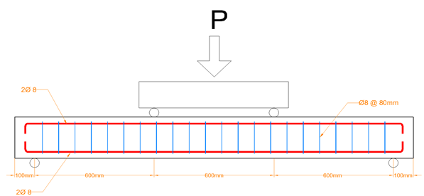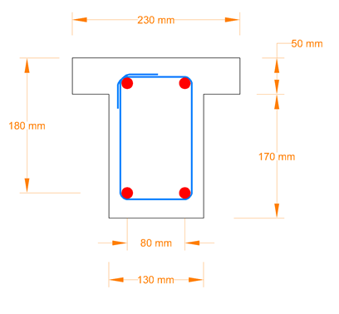
Figure. 1 Reinforcement Detail of the beams

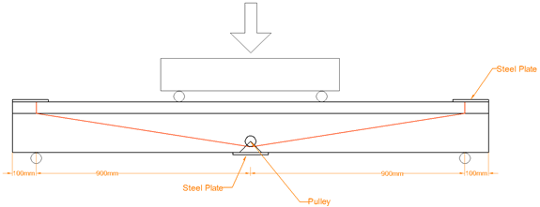
Figure. 2 Beam Strengthening Profile GA1

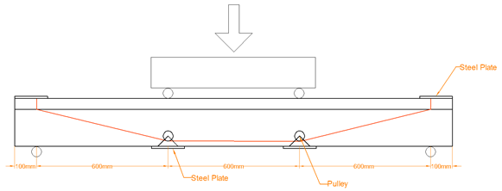
Figure. 3 Beam Strengthening Profile GA2

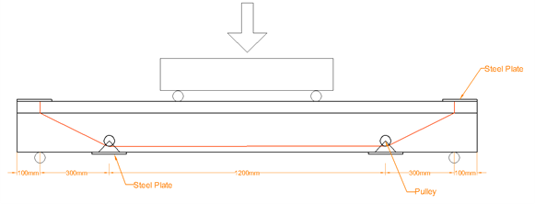
Figure. 4 Beam Strengthening Profile GA3

Anchorage system:
the tendons on the strengthened beams are anchorage in different positions as Figure 2 to 4 demonstrates that, for beam GA1, GA2, and GA3 the anchorage is at the center of the beam, 0.33 L far from both supports, and 0.17L far from both supports respectively. The anchorage is done using pulleys to eliminate friction and make all tension equal throughout the tendon, the pulleys are attached to a steel at the bottom of the beam.

Pre-stressing process:
for prestressing the tendons, turn buckles are used and their rotation for stressing the tendons are mechanically done to apply the stress of 140MPa as pre-stressing, the amount of stress in the strand is calculated using the strain gauges that are glued on the turn buckle and datalogger to read the amount of strain in the turn buckle which it has been calibrated before using UTM machine to apply the load and corresponding strain was recorded by the datalogger.

Experimental results:

General:
All the beams are tested up to failure under 4-point load, using Flexural device of maximum capacity of 600kN with load rate of 0.1kN/s.

Failure modes:
As low streel ration in tension zone makes the beams fail by yielding in the rebars in tension before crushing of concrete in compression. All the beams in this investigation are designed to have low steel ratio and they are loaded up to yielding failure in the steel bars, all showed failure in tension zone, but for the control beam there is an observation in concrete failing at midspan due to compression after a large deflection in the beam as shown in Figure 5, but other strengthened beam this case couldn’t be observed which shows an improvement in compression zone due to strengthening as bent strands tended to lift the midspan of the beam to decrease the compression load, in other hand, there is an observation of bearing failure in the concrete due to the point loads as shown in Figure 5 to 8.

Figure. 5 Control beam crushing at midspan due to compression

Figure. 6 Beam GA1 after failure small crush in compression zone due to bearing

Figure. 7 Beam GA2 after failure small crush in compression zone due to bearing

Figure. 8 Beam GA3 after failure, crush in compression zone due to bearing

Cracking patterns:
Cracking is another aspect of the study, which all strengthened beams showed an improvement in terms of first cracking load, final crack size, and crack propagation. Controlled beam started to crack at 13kN but without propagation up to 32kN then cracks started to open. As it is shown in Figure 9.
Figure. 9 First Cracking appearance load
For strengthened beams there are improvements by 62%, 31%, 35% for GA1, GA2, and GA3 respectively, it shows that GA1 profile has greatest improvement, which can be due to supporting the center of the beams directly and make it harder to deflect and prevent cracking at lower loads. On the other hand, crack sizes also have been investigated, Figure 9 shows the difference of maximum crack sizes between the beams at failure, it shows greater improvement in GA1 profile by 40% while the other profile s are showing almost no improvement in maximum crack size, but if with taking more data into account, a good improvement can be seen in the other profiles too, shows the second largest crack size of the beams which it shows clear improvement for other strengthened beams.

Service Load
Results for the crack appearance showed that beams started cracking at a certain load, but the cracks remined small and not opened up to a higher load, here service load corresponds to the maximum load before crack propagation. Figure 10 shows the service loads of the tested beams.
Figure. 10 Service Load of the beam samples
Figure 11 Maximum Crack size
Figure 11 shows improvement of the service loads of 25%, 13%, 19% for GA1, GA2, GA3 respectively. Compared to the controlled beams, it shows a non-great improvement because service load occurs in a small deflection which doesn’t give time to tendons to take great part of the load.

Load deflection response:
Another phase in the investigation, is the effect of the tendons on deflection and maximum failure load, Figure 12 shows the load vs Deflection of the 4 beams.

Figure. 12 Load vs Deflection Curve of all the beams

In Figure 12 it shows improvement in deflection after 6mm it start a clear difference between control beam and strengthened beams especially the GA1 profile as it makes it take 44kN while it takes 33kN for controlled beam to make same deflection of 10mm which shows about 33% improvement. for beams deflection below 6mm, the improvement is less compared to the higher loading, as the concrete resists at the beginning and strands take less load with small deflection. There are some highs and lows in the curve for strengthened beams, they represent some looseness in the strands and connection between the strand and the turn buckle.

Failure load:
When it comes to failure load, it shows real strengthening of the beams as the aim of the strengthening is meant to make the beams resist larger loads, Figure 13 shows the failure loads of the beams.
Figure. 13 Maximum Failure Load of the beams

The results show a great improvement in the failure load which beam GA1 is improved by 50% compared to the control beam without strengthening, and there is improvement of 40% and 47% for GA2 and GA3 respectively.

Conclusion:
- Overall, the strengthening of the beams using tendons will increase all studied aspects in the beams.
- Profile shape of GA1 improved the behavior of the beam most, as it will support the center of the beam directly and tends to lift it against the loads, while other profiles tends to lift directly larger portion of the bream and try to strengthening the beam in tension also.
- The strengthening profiles also helped to decrease the compression at the top layer of the beams and delay concrete crushing.

References
[1] Gkournelos P, Triantafillou T, Bournas D. Seismic upgrading of existing reinforced concrete buildings: A state-of-the-art review. Engineering Structures. 2021;240:112273. https://doi.org/10.1016/j.engstruct.2021.112273
[2] Grace NF, Sayed G, Soliman A, Saleh K. Strengthening reinforced concrete beams using fiber reinforced polymer (FRP) laminates. ACI Structural Journal-American Concrete Institute. 1999;96(5):865-74. https://doi.org/10.14359/741
[3] Nordin H, Täljsten B. Concrete beams strengthened with prestressed near surface mounted CFRP. Journal of composites for construction. 2006;10(1):60-8. https://doi.org/10.1061/(ASCE)1090-0268(2006)10:1(60)
[4] Lee D, Cheng L, Yan-Gee Hui J. Bond characteristics of various NSM FRP reinforcements in concrete. Journal of Composites for Construction. 2013;17(1):117-29. https://doi.org/10.1061/(ASCE)CC.1943-5614.0000318
[5] Said AI, Al-Ahmed AHA, Al-Fendawy DM. Strengthening of Reinforced Concrete T-Section Beams Using External Post-Tensioning Technique. Journal of Engineering. 2015;21(12):139-54. https://doi.org/10.31026/j.eng.2015.12.09
[6] Zhou H, Li S, Chen L, Zhang C. Fire tests on composite steel-concrete beams prestressed with external tendons. Journal of constructional steel research. 2018;143:62-71. https://doi.org/10.1016/j.jcsr.2017.12.008
[7] da Rocha Almeida MM, de Souza ASC, de Albuquerque AT, Rossi A. Parametric analysis of steel-concrete composite beams prestressed with external tendons. Journal of Constructional Steel Research. 2022;189:107087. https://doi.org/10.1016/j.jcsr.2021.107087

