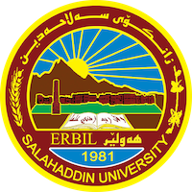
Academic Curriculum Vitae

Personal Information:
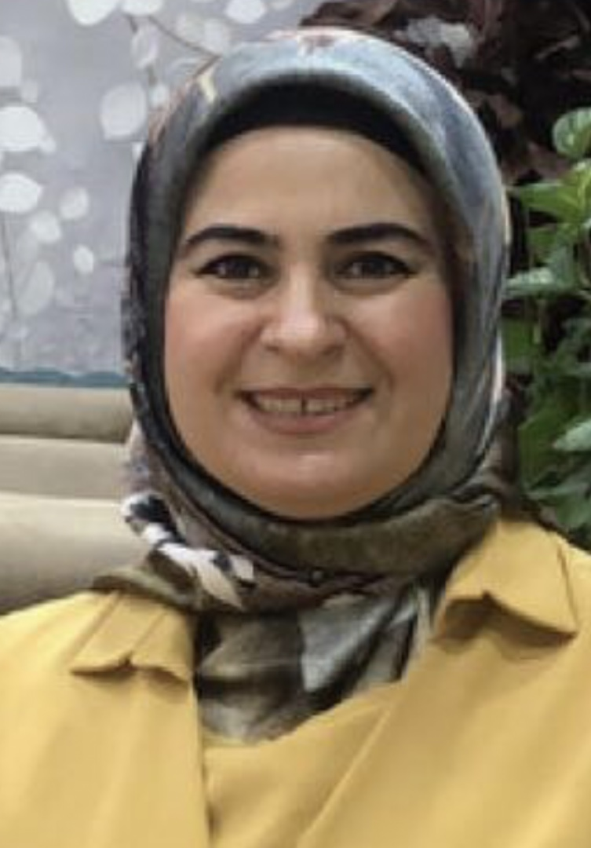
Full Name: SRWA ALAADDIN OMER
Academic Title: Assistant Lecturer
Email: sirwa.omer@su.edu.krd
Mobile: 009647504627688

Education:
- Diploma in Teacher Training Institute
- bachelor's in College of Basic Education/Salahaddin University/Kurdish Department.
- Master in College of Basic Education/Salahaddin University/Kurdish Department.

Employment:
- Teacher in the year 15-1-1997

Qualifications
- Teaching qualifications
- IT qualifications

Teaching experience:
- Teacher in the year 15-1-1997

Research and publications
- researches publication about: The Effect of Using Kagan's Structure in Knowledge Achievement and Self-esteem in the Kurdish Literature by Eighth-Grade Basic Students

Conferences and courses attended
- -

Funding and academic awards
- -

Professional memberships
- -

Professional Social Network Accounts:

- -

