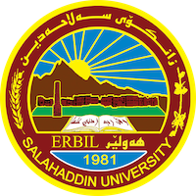
Academic Curriculum Vitae

- Full Name: Sirwa Saeed Azeez
- Academic Title: Assistant lecturer
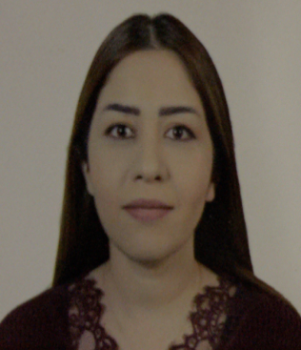
- Email: (sirwa.shangola@su.edu.krd)
- Mobile: +964 750 484 9575

Education:
- B.Sc in geology
- M.Sc in geology
- PhD student

Employment:
- Salahaddin University - College of Science - petroleum and earth sciences department from 2005 as Assistant geology.
- Salahaddin University - College of Science - petroleum and earth sciences department since 2015 as Assistant lecturer

Qualifications
- M.Sc. in geochemistry -2015
Title of thesis “Provenance and Depositional environment from
chemistry and mineral characteristic of Beduh Formation (Lower
Triassic) Northern Thrust Zone, Kurdistan Region, Iraq”.
- Word, excel, power point.
- Intermediate level –salahaddin university- language center

Teaching experience:
- undergraduate courses: Crystallography, geochemistry, mining in petroleum and earth sciences. And general geology in Environment department.

Research and publications
1. Mineralogy, geochemistry, and depositional environment of the Beduh Shale (Lower Triassic), Northern Thrust Zone, Iraq.
Published (2016), (Turkish Journal of Earth Science).

2. Mineralogical and Geochemical comparison between the shales of Beduh and Baluti formations in the Northern Thrust Zone, Kurdistan Region, Iraq: Implication for Provenance and Tectonic setting.
Published (2017), (Iraqi Geological Journal).

3. Geochemistry of sandstone from Beduh Formation in Northern Thrust Zone, Kurdistan Region, Northern Iraq: Provenance and Tectonic setting.
Published (2019), (Iraqi Geological Journal).

Conferences and courses attended
- academic writing training course

Professional memberships
- Geological syndicate in Kurdistan
- Teachers syndicate in Kurdistan
Professional Social Network Accounts:
- ReserchGate, https://www.researchgate.net/profile/Sirwa-Azeez
- LinkedIn, https://www.linkedin.com/in/sirwa-saeed-shangola-147bbb276/
- Orcid, https://orcid.org/0000-0001-6368-9042
- Google scholar, https://scholar.google.com/citations?hl=en&view_op=list_works&gmla=AJsN-F6HZ5I3saxUw4vKXVd0DJHHhmFBZZUmQtF_88npx1bhx7kNhuAzcu8rqGwNYIoc19n7OLeMKNRxJiLnwSxNeOj6DxW_kA&user=cec_u0wAAAAJ

