Questions bank
Q1: Name the mixture which contain clay, silt and sand, if you know that Wt. of sand = 5 gm, Wt. of silt = 7 gm and Wt. of sample = 14 gm.
Q2: Draw a histogram for the grain size analysis of clay and silt. If you know that sample contain silt clay and sand:
Wt. of sand = 5 gm, Wt. of silt = 7 gm and Wt. of clay = 2 gm.
Q3: why we use dispersant agent, count three types of dispersant agent.
Q4: What is Stockes low(1851) ?
Q5: Mention three type of sedimentation methods, and name the best one?
Q6: Dry and disaggregate clay samples must be in temperature <50 C°, why?
Q7:Write time equation according to Stockes’ times ?
Q8: Why we add acetic acid during preparation samples of clay?
Q9: Why we place the sample of clay in oven (80 C°) for (2 hrs)?
Q10: what is the uses of sodium dithionite in sample preparation ?
Q11: How do we remove organic matter from clay samples?
Q12: There are two main method for sample preparation, mention them and write which one is better?
Q13: Calculate d-spacing by using Bragg’s equation, if you know that n=2, and 2Θ= 4.6 ?

Q 14: Calculate the relative intensity of peak A and B.1
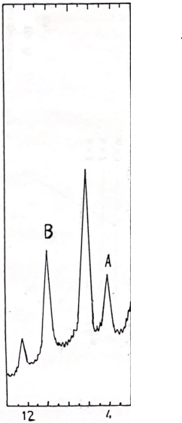
Q15: Name four types of auxiliary post – treatments.
Q16: What is the different in d (A) between kaolinite and serpentine in UN, EG, and H550C°.
Q17: Explain why chlorite and chlorite swelling have different value of d (A).
Q18: what is the reason that make montmorillonite has a range( 12 -15 ) d when treated with EG ?
Q19: Identify the clay minerals in this diffractogram.
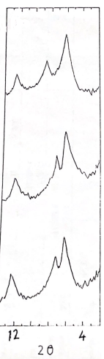
Q20: What is the name of these regular mixed layers:
(I-M)**, (I-V)*, (C-V)***.
Q21: Mention two main different between regular and irregular mixed layer?
Q22: What is Hinckley’s crystallinity index for kaolinite?
Q23: Count four main different between kaolinite and chlorite in mixture?
Q24: What will happen to kaolinite when we heat it to 550C°.

Q25: Analyze this diffractogram which contain single and mixed layer clay minerals.
