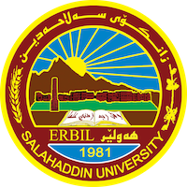
Academic Curriculum Vitae
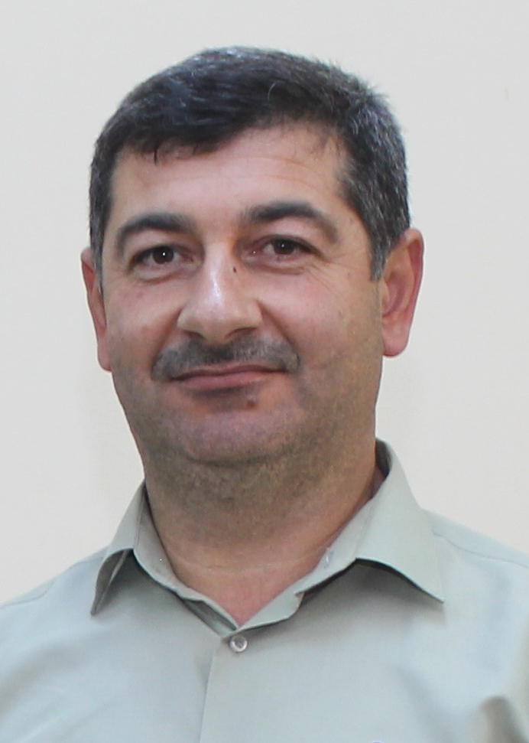
Personal Information:
Full Name: Sirwan Khuthur Malla
Academic Title: Lecturer
Email: (university email): sirwan.malla@su.edu.krd
Mobile: 009647504537629

Education:
-Ph.D. Structural Engineering, Salahaddin University-Erbil, 2014.
-M.Sc. Structural engineering, Salahaddin University-Erbil, 2006.
-B.Sc. Civil Engineering Salahaddin University-Erbil, 1997

Employment:
- Engineer, Salahadin University- College of Engineering – Civil Department,1998-2006.
- Assistant Lecturer, Salahadin University- College of Engineering – Civil Department, 2006-2014.
- Lecturer, Salahadin University- College of Engineering – Civil Department, 2014-Now.
- Deputy head civil engineering department, Salahadin University- College of Engineering – Civil Department, 2015-2017.
- Vice Dean, Salahadin University- College of Engineering, 2017-2018.

Qualifications
IT qualifications
- Applications for the Microsoft Office Programs, Word, Excel, and Power point and presentations.

Teaching experience:
- Mechanics of Material. (Undergraduate 2nd year).
- Engineering Analysis. (Undergraduate 3rd year).
- Reinforced Concrete. (Undergraduate 3rd year).
- Theory of Structures. (Undergraduate 3rd year).
- Physics for Engineering. (Undergraduate 1st year).
- Construction Engineering. (Undergraduate 2nd year).
- Building Material. (Undergraduate 1st year).
- Surveying. (Undergraduate 2nd year).
- Computer Application. (Undergraduate 4th year).
- Matrix Analysis. (Post graduate- High diploma).

Research and publications
- State all researches, publication you made.

Conferences and courses attended

Funding and academic awards

Professional memberships
- Kurdistan Engineering Union.
- Kurdistan Teacher Union.
- ACI Kurdistan Chapter
Professional Social Network Accounts:

- https://scholar.google.com/citations?hl=en&user=_ut-oVUAAAAJ.
- https://www.researchgate.net/profile/Siirwan-Mala.

