1 Explain by mechanism why Five-membered heterocycles with one heteroatom undergo electrophilic substitution reactions at C-2 and C-3 and which one is more stable (C-2 Or C-3 )?

2- What is a ylide ? What are the different types of ylides?

3-What are the best reagents to prepare 3-ethyl-2-pentene via Wittig reaction?

4- Arrange the following carbocations with reason in order of stability?
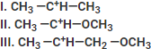

5-Predict the product for each reaction below.-

2-

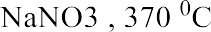

3-
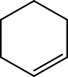

6- Which factor affects the stability of carbanion? With example.
7- Which of the protons identified in the following pairs is most acidic ?

8- Write the mechanism for the following reactions ?
A- In base Catalysis.

B-

