Salahaddin university-Erbil
College of education
Chemistry department

Visible spectrophotometric determination of
Sulfur dioxide in fruit juice

(Research project)

Prepared by
SOZ S. JAHFAR

Supervised by
Dr. SEERWAN F. SHAWKET

2021 - 2022

Abstract
Sulfur dioxide is considered to be harmful to human health when the intake amount in fruit juice is larger than the amount which is determined to be legal by formal authorities. Methods of determination in another hand is been adopted by many parties including both governmental and nongovernmental organization to control the available amount of Sulphur dioxide in the fruit juices manufactured and/or transferred from a country to another. Visible spectrophotometric method is one of the important technique that is been frequently used by formal authorities and in the researches to evaluate the amount of sulfur dioxide in the fruit juices. This article reviews some works that used visible spectrophotometric method to quantify the amount of SO₂ in fruit juices, as well as the general principles and concepts of spectroscopy. It also reviews the information discussed regarding the sulfite and sulfur dioxide. In addition, the other methods used in the determination of SO₂ are also briefly reviewed.

Keywords: Fruit juice; spectrophotometer; detection limits

Contents
Introduction ……………………………………………………………………………..………………. 4
Information about sulfur dioxide and sulfites…………………………………………….….5
History of Sulfur dioxide, its forms and properties…………………………………….……6
Reactivity of Sulfur dioxide…………………………………………………………………………..8
Antimicrobial activity…………………………….……………………………………………………..8
The toxicology………………………………………………………………………………………………9
The amount in food and regulations…………………….………………………………...……... 9
Determination of Sulphur Dioxides and Method of Analysis…………………...…..… 10
Direct Methods……………………………………………………………….……………......................10
Indirect Methods……………………………….………………………….……………………………. 11
Spectrophotometry………………………………………………………………………..................... 11
Visible Spectrophotometer……………………………………………………………..…………… 12
Methods of determination of Sulphur dioxide in fruit juices……………………….….15
Visible spectrophotometric determination of Sulphur dioxide method………...….16
Modified Monier-Williams method by Beetch and Oetzel………………………………..16
Desorption and trapping method …………………………………………….…………………….17
O- Pthaldialdehyde Method ……………………………………………………….……....................18
Conclusion ………………………………………………………………………...…………………………19
References……………………………………………………………………………………..……….....…20

Introduction
Sulfur dioxide with various forms either gaseous or liquid, or dissolved in water can produce sulfurous acid. It is also available in its neutral or acid salts (sulfates, bisulfates, and metabisulfates). One or more of these types of sulfurs are used more generally as chemical preservatives in food technology to prevent food from deterioration and spoilage due to microorganisms. In addition, sulfur dioxide is used in fermentation industry for the purpose of prevention of unwanted organisms in this industry. Sulfur dioxide acts as an antioxidant and inhibitor for such problems. It is known long time ago that sulfurous acid is has a good value in preservation for color retention and its prevention ability for microbial growth, and it has long been used for control of color and flavor changes while production. It is also has a relatively low price and it is readily available for wide variety of juices and many other food products. There are some evidence that use of sulfur dioxide returns to the Romans and old Egyptians, its use for many other food technology is confirmed in history and in various countries, such as meat preservations, dried fruits purification of sugar-beet juice , beet juice (Josyln, 1954). Is has been focused on the amount of sulfur dioxide worldwide as is it mainly effect on human health, it is also regulated for the amount of it in air in some countries. The toxicity of sulfur dioxide and its safety was studied in many reviews(Davidson, 2005). Itis shown that sulfur dioxide results in some physiologic changes such as polyneuritis, bleached incisors, visceral organ atrophy, bone marrow atrophy, renal tubular casts, stunning of growth, and spectacle eyes(FITZHUGH et al., 1946). The amount of sulfur dioxide in food products containing fruit juices are determined in parts per million ppm or milligrams per kilograms mg/kg. The allowed limit of it is vary between 10ppm to 450ppm according to the food type(FITZHUGH et al., 1946). All that said, it is vital to have a good monitoring of the determination of sulfur dioxide in food products, in this article determination sulfur dioxide has been reviewed. The chemistry of sulfur dioxide has been explained and small comparison with sulfites. The approaches toward the determination of them is been reviewed, too. There are many methods that are used for determination of sulfur dioxide and sulfites, iodiometeric, colorimetric, aeration-oxidation, gas sensing electrodes, polarography, direct distillation, pararosaniline, continuous flow, enzymatic, gas chromatography, ultraviolet are some of the methods discussed in the reviews (Ough, 1988). Among these methods the visible UV/visible spectrophotometric determination of the sulfur dioxide is one of the popular method for the determination and in this review it has been mainly focused on.

Information about sulfur dioxide
Sulfites is one of the mostly and harmful food additives that are used in foods, beverages, juices, and even pharmaceuticals (Leng et al., 2019). In addition it is defined as one of the most frequent food additive used in the food industries(S. I. F. S. Martins et al., 2000)(Adams, 1997). Sulphur dioxide, which is one of the other forms of sulfites are mostly used in foods, beverages, and drink products due to the fact that it has antibacterial property as well as antifungal property (Freedman, 1980)(Manzocco et al., 2000). Sulphur dioxide in another hand, has a power of reducing which sometime called reducing agent or in another word antioxidant, this property of Sulphur dioxide make it to prevent the oxidation process of that leads to food or drinks spoilage accordingly(Freedman, 1977)(Zare-Dorabei et al., 2018). When this additive is used in gaseous state it is easily evaporates in the solution which it doesn’t leave any sedimentations(Freedman, 1980)(Fazio & Warner, 1990).
This food additive is allowed to use in foods and juices when it is within legal limits and it is approved to be harmless in this range when it is ingested (Finster, 2008)(Rezaee et al., 2006). However, it for some diseases such as asthma it may lead to medical issues in high dilutions(Freedman, 1980). There are some study that indicates the effect of SO₂ and its influence on consumers to lead to asthma disease. It is shown that among 272 patients that have asthma 11% of them are due to drinking of orange juices, and the most dangerous case was half of these people were drinking an aqueous SO₂ solution in a concentration that is same as it is allowed in orange juice(Freedman, 1980)(Davis, 1983) . A case of subjecting to SO₂ is shown in the figure 2.1 below show the effect of SO₂ ingestion of a sixteen years old man of drinking 25ppm of SO₂ in 250 ml of water(Freedman, 1980)(Manzocco et al., 2000). Sulphur dioxide might be used as a gas and added to the drinks and also by addition of Sodium metabisulfite to acidic foods and juices as shown in the reactions below .It is, however, challenging to determine the SO₂ in low levels (Filik & Çetintaş, 2012)(Malwal et al., 2012)(Mohn & Emmenegger, 2014) .
Na₂S₂O₅ + 2HR $→$ 2NaR+H₂O + 2SO₂

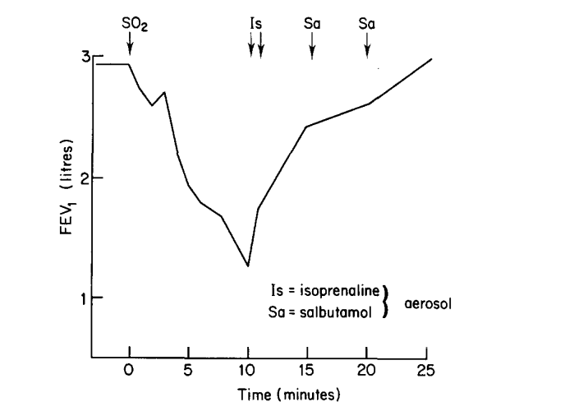
Fig.1 the effect of SO₂ ingestion of a sixteen years old man of drinking 25ppm of SO₂ in 250 ml of water

History of Sulfur dioxide, its forms and properties
Sulfur also called brimstone, available in the Free State in some area in the world. However, sulfur oxide is generally available in the volcano places. Sulfate and sulfites are available in nature, too. Sulfur when burnt in the presence of air it converts to sulfur dioxide that is a colorless gas with seriously suffocating smell. Sulfur dioxide is poorly soluble in water and is available mainly as sulfur dioxide. Sulfur dioxide changes to liquid when compressed, at 20 ⁰C it has vapour pressure of 3.25 atm(Ramer et al., 2017). Oxidation of sulfur by burning it, heating pyrites, reducing gypsum are the commercial methods of preparation of sulfur dioxide. It is available in aqueous medium according to the equilibrium reactions shown below (Schroeter, 2015):
SO₂ + H₂$↔$ [H₂SO₃]
[ H₂SO₃ ] $↔$ HSO₃⁻ + H⁺
HSO₃ ⁻ $↔$ SO₃²⁻
Sulfurous acid ions are available in three forms, a plot of their distribution is shown in the table 1 below. On the other hand density of different water solutions of sulfur dioxide is shown in the table 1 below. The salt form of sulfur dioxide is the easiest form that can be easily handled and stored. In the table 2 below the main forms of the sulfur dioxide salts are showed with their theoretical yields and solubility in water. (Schroeter, 2015)
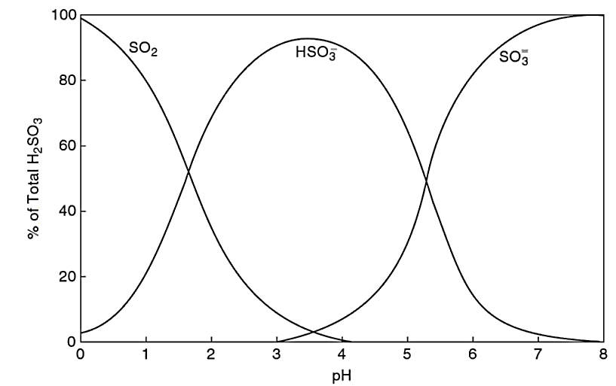

Fig.2 distribution form of ionized sulfurous acid at various pH.

Table 1: Density of different types of sulfur dioxide water solution in two different temperature.
SO₂ g per 100g |  | Density
 |  | 15.6 C |  | 20.0 ⁰C
1 |  | 1.004 |  | 1.003
2 |  | 1.0091 |  | 1.008
3 |  | 1.0191 |  | 1.018
6 |  | 1.0292 |  | 1.028
10 |  | 1.0393 |  | 1.037
Table 2: Sulfur Dioxide-Bearing Chemicals.
Compound | Formula |  | Theoretical Yield (%) |  | H₂O Solubility g/L
Sulfur dioxide | SO₂ |  | 100 |  | 110 (20⁰ C)
Potassium Sulfite | K₂SO₃ |  | 33 |  | 250 (20⁰ C)
Sodium sulfite | Na₂SO₃ |  | 50.58 |  | 289 (40⁰ C)
Sodium bisulfite | KHSO₃ |  | 61.6 |  | 3000 (20 ⁰C)
Sodium metabisulfite | Na₂S₂O₅ |  | 64.7 |  | 540 (20⁰ C)

Reactivity of Sulfur dioxide
The oxidizabillity of sulfurous acid salts is indicated by following equations(Schlesinger, 1999). It is showed that the amount of sulfur dioxide that is reacted (oxidized) after two month of storage of a red wine was proportional to the original amount of dissolved oxygen. (Pundir & Rawal, 2013)
2SO₃²⁻ + O₂ $→$2SO₄²⁻
SO₃²⁻ + H₂O₂ $→$ SO₄²⁻ + H₂O

Antimicrobial activity
The inhibition effect of sulfur dioxide is very strong when it is in the form of unionized form, and it is shown that microorganisms are much more sensitive sulfur dioxide than are yeasts and molds. The activity of sulfur dioxide is higher than is for bisulfites, and much higher than sulfites. The reason of the difference of the activities are due to the bound form of sulfur, it is studied that in grape juice the antimicrobial effectiveness of sulfur dioxide compared to sulfur dioxide in its free form compared to the bound form is 1/30 (Davidson, 2005)

The toxicology
Sulfur dioxide safety and its toxicology is been the subject of many researches, and is reviewer .on of the first researches returns to 1980s that suggested the possible toxicity of sulfur dioxide(Schlesinger, 1999). Study showed that sulfur dioxide in amounts of more than 62 mg SO₂ per Kg body weight, it caused to many physiologic issues such as renal tubular casts, stunning of grows. Sulfur dioxide in amount of greater than 33mg/L in air may cause distress or even death if inhaled (Davidson, 2005)

The amount in food and regulations
The United States food and drug administration FDA has considered the sulfites as Generally Recognized as Safe GRAS. However, this consideration is acceptable when its amounts used are as per the good manufacturing practices(Schlesinger, 1999). The FAO organization applied that when amount of sulfites in juice and wine is greater than 10 mg/L the product must labeled as containing sulfites. However, sulfites are not allowed in meat, and foods recognized as a source of vitamin B1 or in the juice that are sold or served to customers that are intended to be fresh. In the European Union directives are set for sulfur dioxide E220, Sodium sulfate E221, Sodium bisulfate E222, Sodium metabisulfates as E223, Potassium metabisulfates as E224, Calcium Sulfite as E226, Calcium bisulfate as E227, and potassium bisulfate as E228(Russell & Gould, 2003). Sulfur dioxide give bright color but may led to false in meat. Adding sulfur dioxide to juices are effective in preventing the growth of molds, yeasts, and salmonella during storage at normal or cool temperatures(Schlesinger, 1999). The amount of sulfur dioxide in food juice and food products vary from a country to another. The allowed limit of the different types of sulfite in unites states in shown in Table 3 below (Russell & Gould, 2003)

Table 3: Application of sulfites in food as antimicrobials and the concentrations used.

Food Matrix | Maximum allowed SO₂ in mg/Kg
Beer | 10-30
Fresh Fruits | 100
Beverages | 20-200
Sausages | 450
Vinegar | 50-200

Determination of Sulfur dioxides and method of Analysis:
There are many methods for the determination and analysis of sulfites in juice(Howe et al., 2018). The majority of these methods are depend on the quantification of Sulphur dioxide in the sample. However the experimental determination of these quantification are comprise of two types, which are direct and indirect methods (Pundir & Rawal, 2013)(F. C. O. L. Martins et al., 2019)(Wood et al., 2004)

Direct Method’s
Titrimetric determination
In this type of analysis a solution that contained the analyte is being treated by titration with a suitable reagent of exactly known concentration

Polarographic determination
In which a voltammetry type determination is used by using electrode of dropping mercury (Bruno et al., 1979)

Electrometric Determination
In this method, electrodes are used with use of principle of electrochemistry and the pH of solution is controlled at 0ºC (Banks & Board, 1982)(Wilbur & Anderson, 1948)

Colorimetric method
This method classically is been used for determination of the amount of elements or the chemical compounds in a solution such as fruit juice with the help of color visions. This method is been used in industries and in laboratories. The equipment used in this method is called colorimeter which has some cuvettes to hold the sample. The process of analysis some time is automated such as by auto analyzer or by flow injection analysis (West & Gaeke, 1956)(Stang et al., 1951)

Indirect Methods
In this method the analysis is based on the separation of analyte this is done through distillation in an inert environment following by absorption of the sulfur dioxide in the oxidizing agent. These oxidizing agents are usually iodine or hydrogen peroxide (Kapitány et al., 2020)(Pizzoferrato et al., 1998)

Spectrophotometry
Spectrophotometry is one of the types of electromagnetic spectroscopy based on the determination measurement by reflection or transmission techniques by means of wavelength. In this principle, photometers are used that are usually called spectrophotometers. In it the intensity of light is measured at various wavelength(Harvey Jr et al., 1955)(Kass & Ivaska, 2001). Spectrophotometry was used for the radiations of visible, ultraviolet in the beginning, however the modern spectrophotometric can be applied to the radiations of infrared, x-ray, and microwaves table 4.0 below shows the range of these electromagnetic spectrum (Behera et al., 2012), and the concept of the technique is shown in the Figure 3 below.

Table 4 Regions of electromagnetic spectrum
Region | Wavelength (nm)
Far ultraviolet range | 10-200
Near ultraviolet range | 200-400
Visible Range | 400-750
Near Infrared | 750-2200
Mid Infrared | 2500-5000
Far Infrared | $>$5000

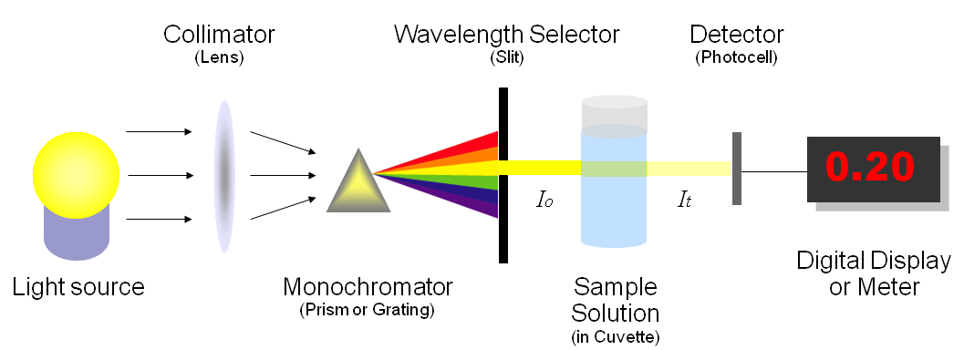
Figure 3 the concept of the spectrophotometric determination

Visible Spectrophotometer
Spectrophotometer, which works on examining the interaction of light radiations with matter, for the one called visible spectrophotometer it is working in the range of visible light wavelength range that is (400-800nm). Visible spectrophotometry is the mostly used technique among the other types of spectrophotometry especially in the pharmaceuticals. This technique is based on the absorption of the amount of the radiation by the substance in the solution for analysis. Visible spectrophotometers are generally available in the range of 200-750nm which covers lights of both ultraviolet and visible ranges (Adeeyinwo et al., 2013)(Kalivas et al., 1989). Spectrophotometric determination is an easy, simple, and rapid technique and is used for quantification of small amount of compounds. Beer lambert law it the principle of all spectrophotometric analysis, both laws are shown below;
“Beer law; the intensity of a beam of parallel monochromatic radiation decreases exponentially with the number of absorbing molecules” this means that the absorbance of light increases when the concentration of the analyte increased.
“Lambert’s Law; intensity of a beam of parallel monochromatic radiation decreases exponentially as it passes through a medium of homogeneous thickness”
Combination of these two method resulted in Beer-Lambert Law, that led to the spectrophotometry accordingly (Behera et al., 2012)
When a beam of light past through a transparent cell containing a solution of an absorbing substance, reduction of the intensity of the light may occur”
A= ε b c
A : Absorbance
ε : Molar Absorptivity
b: Path length of the cell
C: Concentration of the solute

In the visible spectroscopy the concept of analysis is to quantify the amount of light that is absorbed and diffracted by the fruit juice containing the analyte of interest. The simplest way to do this, the cell containing the juice sample is placed between the spectrophotometer and the light source, a light of visible type is then passed through it the intensity of this light will then calculated before and after the interaction with the sample. The results are compared in all the wavelengths to determine the samples dependent extinction spectrum. The data will then drawn between the extinction and the wavelength. Any spectrum’s background is corrected by using a buffer to make sure that the spectral properties in the buffer isn’t existed in the sample extinction spectrum (Paosen et al., 2017)

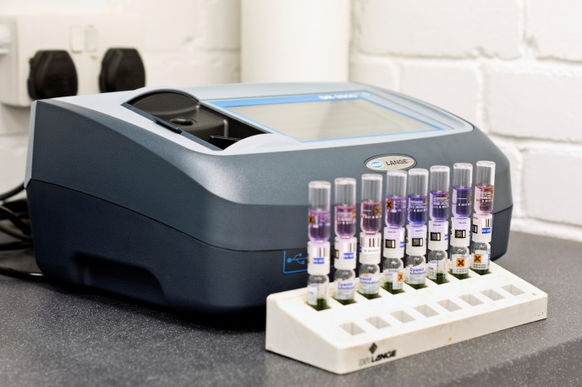
A spectrophotometer of a year 2001 (www.wheal-jane-laboratory.co.uk)

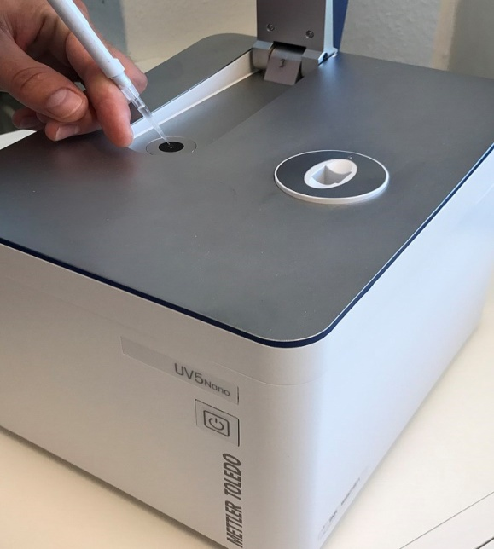
A spectrophotometer of the year of 2013 with micro volume injection.

Methods of determination of Sulphur dioxide in fruit juices

Analysis of fruit juices in quality control administrations are usually depend on new instrument and trained employees. Thus many techniques and industries are trying to bring new instrument and procedures to involve in this field. Uv-vis spectrophotometer is widely used in this aim (Urbano et al., 2006). Among the methods used the widely used methods those issued by European Committee EC and official methods which are used in the legal sector to control the amount of the Sulphur dioxide in the fruit juices, EC issued a method for determination of Sulphur dioxide this method was used in the beginning to determine the sulfur dioxide residues in the fruit juices (Ferrarini et al., 2000)(Decnop-Weever & Kraak, 1997). The method was known as EC 1108/82. This method was giving the limits of SO₂ of higher than it was allowed legally in most of the cases (Ferrarini et al., 2000). A new EC method was then developed known as EC2676/90, in it the Sulphur dioxide was determined by acidifying the juice it was then yielded a release of SO₂ from the combined fractions, there has been not known toxicity of the combined SO₂. Therefore a method to determine a low level of SO₂ in fruit juices was become a vital (Ferrarini et al., 2000). The legal amount of allowed SO₂ in fruit juices in Europe is 10mg/kg, 10 ppm (Decnop-Weever & Kraak, 1997). There are many methods for the determination of SO₂ in fruit juices. Another method that is also used to determine the SO₂ is the modified Monier-Williams method AOAC. The Ripper-Schimttiodometry, and the enzyme based assays (Ferrarini et al., 2000)(Lloyd & Cowle, 2014). The methods that are used for this purpose was mostly based in on the distillation time of the juice sample, the concentration of the sulfuric acid used, and the air rate in the distillation step of the fruit juice (Ingram & Vas, 1950)

Visible spectrophotometric determination of Sulphur dioxide method
Modified Monier-Williams method by Beetch and Oetzel

Among the other methods reviewed during this review, spectrophotometric especially the visible spectrophotometry was the most emphasized on. The visible spectrophotometers used for the determination where mostly are called UV-Vis spectrophotometer, in which the instrument is be able to read the wavelengths of both ultraviolet and visible ranges. The visible spectrophotometric method is known as fast, precise method in the determination of Sulphur dioxide(Beetch & Oetzel, 1957). Methods for determination of SO₂ was important for the manufacturers in order to know the right amount of SO₂ is been added to their products as preservatives (Bennett & Donovan, 1943)
The solution of sodium tetrachloromercurate (Cl₄HgNa₂) is used to hold the SO₂. The result of this is the production of disulfitomercurate which doesn’t need directly to be analysis of the Sulphur dioxide. In this method there has been no interfere found. The low levels of 1 ppm up to 75 ppm is been determined with this method with error of no more than 5% was obtained(Beetch & Oetzel, 1957). The reagents used in this experiment were Pararosaniline Hydrochloride, Bleached pararosaniline hydrochloride, Sodium tetrachloromercurate, Formaldehyde, Standard Sulfite, Alkaline Pyrogallol. In the results of this method, which is called modified Monier-Williams method, it is been concluded that sodium tetrachloromercurate made very stable compound of disulfitomercurate. Quantification of the Sulphur dioxide was depended on the color formation as pararosaniline hydrochloride formaldehyde were added to the absorbing solution of SO₂. In addition this method was found to be sensitive and less time consuming (Beetch & Oetzel, 1957).

Desorption and trapping method
In this experiment that the procedure of determination of SO₂ was used as it is followed by the Beetch and Oetzel for quantification of SO₂ in some juices. The results of the determination is shown in table 3. (Lloyd & Cowle, 1963)

Table3: Results of determination by desorption and trapping method
Sample | Total SO₂  ppm | Free SO₂ found by
 |  | Desorption and trapping method ppm | Direct  Iodimetry  ppm
Lemon squash | 300 | 169 ,161 (I) | 167,166
Orang squash | 269 | 168,166 (I) | 152,166
Blackcurrant Cordial | 311 | 178,180 (I) | 179,177
Lemon juice | 317 | 132,135 (I) | 132,122
Liquid glucose beverage | 30 | 11,11 (C) | 5
Lime juice Cordial A | 295 | 193,191 (I) | 196,197
Lime juice Cordial B | 237 | 116,116,112 (I) | 116,114
Lime juice Cordial B with add dehydroascorbic | 225 | 48,49 (I) | 47,43

(I) = iodimetric method , (C) = colorimetric method
In this method where it is at the same time the spectrophotometric method was compared with the Iodiometeric method showed that ranges of SO2 is lower when the spectrophotometric method is used. This desorption and trapping method was better than the conventional iodiometeric method in a way that the blank value drifting at the end-point and also the personnel judgment were very low or negligible (Lloyd & Cowle, 1963)
O-Pthaldialdehyde Method
This is another vis-spectrophotometric method for determination of Sulfite. Sulfite is supposed to be the ion that is responsible to convert to SO₂ in fruit juice Therefore it might be reasonable to use as another method to determine the SO₂ in fruit juice (Cakić et al., 2014). In this method sulfite was reacting with o-Pthaldialdehyde in presence of ammonia producing a deep blue color compound. The method was sensitive to determine 5x10⁻⁶ M of sulfite. The absorbance of the colored complex was at 628nm the absorption spectrum of this solution is shown in the figure below: (Abdel-Latif, 1994)
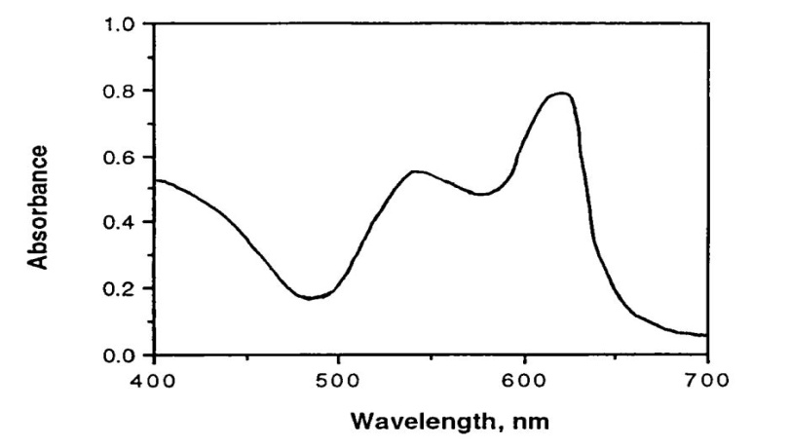

Figure 4: Absorption spectrum of sulfite solution.

Conclusion
In conclusion, it is been shown in the articles and books reviewed in this paper that Sulphur dioxide plays a vital role as preservatives in fruit juices. It is mostly used in its gaseous state and added to the juice to keep the juice unspoiled for longer time. Sulphur dioxide is been legally controlled and the allowed legal amount in most countries is 10mg/Kg. Hence, determination of it was in great attention in the researches to develop a method with a robust and simple determination. Visible spectrophotometer is an instrument that is frequently used in quantification of SO₂ in fruit juice samples. This technique yielded a low level determination of it compared with the conventional titrimetric and other methods. However, sample preparation was another concern were scientists are trying to develop the sample and sensitive, too. The extraction of SO₂ by in fruit juices is successful with sodium tetrachloromercurate II (CI₄HgNa₂).

Reference
Abdel-Latif, M. S. (1994). New spectrophotometric method for sulfite determination. Analytical Letters, 27(13), 2601–2614.
Adams, J. B. (1997). Food additive-additive interactions involving sulphur dioxide and ascorbic and nitrous acids: a review. Food Chemistry, 59(3), 401–409.
Adeeyinwo, C. E., Okorie, N. N., & Idowu, G. O. (2013). Basic calibration of UV/visible spectrophotometer. International Journal of Science and Technology, 2(3), 247–251.
Banks, J. G., & Board, R. G. (1982). Comparison of methods for the determination of free and bound sulphur dioxide in stored British fresh sausage. Journal of the Science of Food and Agriculture, 33(2), 197–203.
Beetch, E. B., & Oetzel, L. I. (1957). Sulfur Dioxide in Malt and Beer, Colorimetric Determination of Sulfur Dioxide from Malt and Beer by Complexing with Sodium Tetrachloromercurate (II). Journal of Agricultural and Food Chemistry, 5(12), 951–952.
Behera, S., Ghanty, S., Ahmad, F., Santra, S., & Banerjee, S. (2012). UV-visible spectrophotometric method development and validation of assay of paracetamol tablet formulation. J Anal Bioanal Techniques, 3(6), 151–157.
Bennett, A. H., & Donovan, F. K. (1943). The determination of sulphur dioxide in citrus juices. Analyst, 68(806), 140–142.
Bruno, P., Caselli, M., Di Fano, A., & Traini, A. (1979). Fast and simple polarographic method for the determination of free and total sulphur dioxide in wines and other common beverages. Analyst, 104(1244), 1083–1087.
Cakić, M., Stanojević, L., Savić, S., Cvetković, D., & Ilić, D. (2014). IDENTIFICATION OF BIOACTIVE COMPOUNDS IN AQUEOUS EXTRACTS OF CULTIVATED STRAWBERRIES’LEAVES (Fragariae folium) USING UHPLC-MS METHOD. Technologica Acta, 39.
Davidson, P. M. (2005). P. Antimicrobials in food/P. Michael Davidson, John N. Sofos, AL Branen. Taylor & Francis Group.
Davis, B. (1983). A GC method for the determination of sulphur dioxide in food headspaces. Journal of Chromatographic Science, 21(5), 205–208.
Decnop-Weever, L. G., & Kraak, J. C. (1997). Determination of sulphite in wines by gas-diffusion flow injection analysis utilizing spectrophotometric pH-detection. Analytica Chimica Acta, 337(2), 125–131.
Fazio, T., & Warner, C. R. (1990). A review of sulphites in foods: analytical methodology and reported findings. Food Additives & Contaminants, 7(4), 433–454.
Ferrarini, R., Celotti, E., Versari, A., & Galassi, S. (2000). The determination of total SO₂ in grape juice. A comparison methods. Food Additives & Contaminants, 17(12), 973–977.
Filik, H., & Çetintaş, G. (2012). Determination of sulfite in water and dried fruit samples by dispersive liquid–liquid microextraction combined with UV–Vis fiber optic linear array spectrophotometry. Food Analytical Methods, 5(6), 1362–1367.
Finster, K. (2008). Microbiological disproportionation of inorganic sulfur compounds. Journal of Sulfur Chemistry, 29(3–4), 281–292.
FITZHUGH, O. G., KNUDSEN, L. F., & NELSON, A. A. (1946). The chronic toxicity of sulfites. Journal of Pharmacology and Experimental Therapeutics, 86(1), 37–48.
Freedman, B. J. (1977). Asthma induced by sulphur dioxide, benzoate and tartrazine contained in orange drinks. Clinical & Experimental Allergy, 7(5), 407–415.
Freedman, B. J. (1980). Sulphur dioxide in foods and beverages: its use as a preservative and its effect on asthma. British Journal of Diseases of the Chest, 74, 128–134.
Harvey Jr, A. E., Smart, J. A., & Amis, E. S. (1955). Simultaneous spectrophotometric determination of iron (II) and total iron with 1, 10-phenanthroline. Analytical Chemistry, 27(1), 26–29.
Howe, P. A., Worobo, R., & Sacks, G. (2018). Conventional measurements of sulfur dioxide (SO2) in red wine overestimate SO2 antimicrobial activity. American Journal of Enology and Viticulture, 69(3), 210–220.
Ingram, M., & Vas, K. (1950). Combination of sulphur dioxide with concentrated orange juice. II.—The rate of the reaction. Journal of the Science of Food and Agriculture, 1(2), 63–66.
Josyln, M. B. (1954). The chemistry and technology of the pretreatment and preservation of fruit and vegetable products with sulfur dioxide and sulfites. In Advances in food research (Vol. 5, pp. 97–160). Elsevier.
Kalivas, J. H., Roberts, N., & Sutter, J. M. (1989). Global optimization by simulated annealing with wavelength selection for ultraviolet-viKalivas, J. H., Roberts, N., & Sutter, J. M. (1989). Global optimization by simulated annealing with wavelength selection for ultraviolet-visible spectrophotometry. Ana. Analytical Chemistry, 61(18), 2024–2030.
Kapitány, S., Nagy, D., Posta, J., & Béni, Á. (2020). Determination of atmospheric sulphur dioxide and sulphuric acid traces by indirect flame atomic absorption method. Microchemical Journal, 157, 104853.
Kass, M., & Ivaska, A. (2001). Spectrophotometric determination of sulphur dioxide and hydrogen sulphide in gas phase by sequential injection analysis technique. Analytica Chimica Acta, 449(1–2), 189–197.
Leng, G., Hu, Q., He, W.-F., Liu, Z., Chen, W.-J., Xu, W.-B., Yang, Q.-H., & Sun, J. (2019). A simple field method for the determination of sulfite in natural waters: based on automated dispersive liquid-liquid microextraction coupled with ultraviolet-visible spectrophotometry. Journal of Chromatography A, 1584, 72–79.
Lloyd, W. J. W., & Cowle, B. C. (1963). The determination of free sulphur dioxide in soft drinks by a desorption and trapping method. Analyst, 88(1046), 394–398.
Lloyd, W. J. W., & Cowle, B. C. (2014). IDENTIFICATION OF BIOACTIVE COMPOUNDS IN AQUEOUS EXTRACTS OF CULTIVATED STRAWBERRIES’LEAVES (Fragariae folium) USING UHPLC-MS METHOD. Technologica Acta, 39.
Malwal, S. R., Sriram, D., Yogeeswari, P., Konkimalla, V. B., & Chakrapani, H. (2012). Design, synthesis, and evaluation of thiol-activated sources of sulfur dioxide (SO2) as antimycobacterial agents. Journal of Medicinal Chemistry, 55(1), 553–557.
Manzocco, L., Calligaris, S., Mastrocola, D., Nicoli, M. C., & Lerici, C. R. (2000). Review of non-enzymatic browning and antioxidant capacity in processed foods. Trends in Food Science & Technology, 11(9–10), 340–346.
Martins, F. C. O. L., Sentanin, M. A., & De Souza, D. (2019). Analytical methods in food additives determination: Compounds with functional applications. Food Chemistry, 272, 732–750.
Martins, S. I. F. S., Jongen, W. M. F., & Van Boekel, M. A. J. S. (2000). A review of Maillard reaction in food and implications to kinetic modelling. Trends in Food Science & Technology, 11(9–10), 364–373.
Mohn, J., & Emmenegger, L. (2014). Determination of Sulphur Dioxide by Pulsed UV-Fluorescence. Environ. Technol, 76, 1–11.

Mondal, M. K. (2007). Experimental determination of dissociation constant, Henry’s constant, heat of reactions, SO2 absorbed and gas bubble–liquid interfacial area for dilute sulphur dioxide absorption into water. Fluid Phase Equilibria, 253(2), 98–107.
Ough, C. S. (1988). Acids and amino acids in grapes and wines. In Wine Analysis (pp. 92–146). Springer.
Paosen, S., Saising, J., Septama, A. W., & Voravuthikunchai, S. P. (2017). Green synthesis of silver nanoparticles using plants from Myrtaceae family and characterization of their antibacterial activity. Materials Letters, 209, 201–206.
Pizzoferrato, L., Di Lullo, G., & Quattrucci, E. (1998). Determination of free, bound and total sulphites in foods by indirect photometry-HPLC. Food Chemistry, 63(2), 275–279.
Pundir, C. S., & Rawal, R. (2013). Determination of sulfite with emphasis on biosensing methods: a review. Analytical and Bioanalytical Chemistry, 405(10), 3049–3062.
Ramer, G., Aksyuk, V. A., & Centrone, A. (2017). Quantitative chemical analysis at the nanoscale using the photothermal induced resonance technique. Analytical Chemistry, 89(24), 13524–13531.
Rezaee, M., Assadi, Y., Hosseini, M.-R. M., Aghaee, E., Ahmadi, F., & Berijani, S. (2006). Determination of organic compounds in water using dispersive liquid–liquid microextraction. Journal of Chromatography A, 1116(1–2), 1–9.
Russell, N. J., & Gould, G. W. (2003). Food preservatives. Springer Science & Business Media.
Schlesinger, R. B. (1999). Toxicology of sulfur oxides. In Air pollution and health (pp. 585–602). Elsevier.
Schroeter, L. C. (2015). Sulfur dioxide: applications in foods, beverages, and pharmaceuticals. Elsevier.
Stang, A. M., Zatek, J. E., & Robson, C. D. (1951). A Colorimetric Method for the Determination of Sulphur Dioxide in Air. American Industrial Hygiene Association Quarterly, 12(1), 5–8.
Urbano, M., De Castro, M. D. L., Pérez, P. M., García-Olmo, J., & Gomez-Nieto, M. A. (2006). Ultraviolet–visible spectroscopy and pattern recognition methods for differentiation and classification of wines. Food Chemistry, 97(1), 166–175.
West, P. W., & Gaeke, G. C. (1956). Fixation of sulfur dioxide as disulfitomercurate (II) and subsequent colorimetric estimation. Analytical Chemistry, 28(12), 1816–1819.
Wilbur, K. M., & Anderson, N. G. (1948). Electrometric and colorimetric determination of carbonic anhydrase. Journal of Biological Chemistry, 176(1), 147–154.
Wood, R., Foster, L., Damant, A., & Key, P. (2004). Analytical methods for food additives. Elsevier.
Zare-Dorabei, R., Boroun, S., & Noroozifar, M. (2018). Flow injection analysis–flame atomic absorption spectrometry system for indirect determination of sulfite after on-line reduction of solid-phase manganese (IV) dioxide reactor. Talanta, 178, 722–727.

