Salahaddin University-Erbil Midterm Examination Instrumental analysis
College of Education 2022 4th year students
Chemistry department 1.5 hs
--------------------------------------------------------------------------------------------------------------------------------
Q1/ Choose the best correct answer: [ 20marks]
a. Chemical reactions using synthetic compounds and usually involving a highly oxidized species such as a peroxide are commonly termed -------.
(1) Chemiluminescent. , (2) Fluorescence , (3) Phosphorescence
b. Light-emitting reactions which take place by the use of electrical current are ------- reaction
(1) bioluminescent. , (2) electrochemiluminescent. , (3) chemiluminescent
c. The advantage of Chemiluminescent are -------
(1) we need monochromator but we no need excitation source
(2 ) we need excitation source but we no need monochromator
(3 we no need both of monochromator and monochromator
d. Add between 0.2 % of ------- to samples and standards as acures for chemical interferences.
a) CCl₄ , b) LaCl₃ , c) LaPO₄

Q2/ Fill the blanks with suitable. [ 26 marks]
- Photoluminescence processes are subdivided into ----------- and ----------------.
- Most intensely fluorescent organic molecules contain large ------------ systems.
- In a fluorimeter instruments two -----------'s are used to select the appropriate wavelengths for ---------- and ------------. The detector is placed at -------------- to the incident light path, so that fluorescence, which is emitted in all directions, falls on the ----------- but no incident light is detected.
- In electrothermal atomization, the samples are placed in --------- which is heated -------
- Fluorimetry is not generally useful for molecular -------------.
- Phosphorescence radiative transition between states of---------, usually from the lowest vibrational level of the lowest excited ---------state, T₁ (v = 0).

Q3/ From the following data calculate the concentration of chloride by quenching of fluorescence method using Stern- Volmer equation. [14 marks]

Conc. [Cl⁻] M | 0 | 0.01 | 0.02 | 0.04 | 0.06 | 0.08 | sample
Fluo. intensity | 100 | 30.05 | 20.7 | 11 | 6.7 | 5.4 | 27.7

Q4/ Why fluorometry is more selective than UV/Vis. – spectrometry? [19 marks]

Q5/ From the following schematic diagram choose a letter to each type which represented by number labeled on the diagram for example (5 - a ) : [ 21marks]

- The schematic processes for the Jablonski diagram:

(a) Intersystem crossing (b) Absorption
(c) Phosphorescence (d) Vibrational relaxation
(e) Internal and external conversion
(f) Singlet excited state
(g) Fluorescence (h) Vibrational relaxation
(i) Internal conversion

B- The following schematic diagram is a F-AAS design:

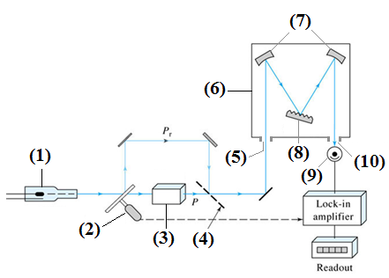
(a) Chopper (b) Photomultiplier tube
(c) Monochromator (d) Flame
(e) Exit slit (f) Hallow cathode lamp
(g) Concave mirrors (h) Entrance slit
(i) Half-silvered mirror (j) Grating
(k) Deuterium Lamp (l) Tungsten Lamp

