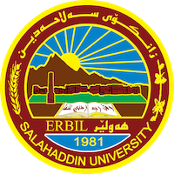

**Academic Curriculum Vitae**

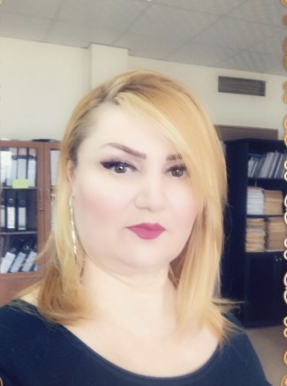

**Personal Information:**

Full Name: Solin Mohamed Taher Fazel

Academic Title: Assistant lecturer

Email: (Solin. Taher @su.edu.krd)

Mobile: 9647504480037

**Education:**

2009(A.B) Salaheddin university

2016 (M.A) Soran university

2024(PhD) Soran university

**Employment:**

Assistant lecturer at law Department, College Law, Salaheddin University (now)

Served at the Salaheddin University such as a legal assistant, Accountant and librarian.

**Qualifications**

• Continuing education (Methods of teaching) 2/2017 - 5/2017

• International English Language Testing System (IELTS) 3 teams

•British council/ Iraq: English Language Course 2017

• Cambridge University: English Language Course 1/2017 -6/2017

• Language center - Salaheddin University: English language course 2017

• Center of language: English language course (10/2018 - 12/2018)

- IT qualifications

Word, PowerPoint, Internet content management.

**Teaching experience:**

1. History of Law/ the first stage students from( 2019 – 2023) first stage under graduation .

2- Commitment provisions for the third stage under graduation (2022-2023).

3 - A Brief Introduction to Civil Contracts, Fourth stage under graduation (2024-2025)

**Research and publications**

1. Responsibility of the Pharmaceutical Industries and Research Centers in non-therapeutic Clinical Trials (- Comparative study).) master’s thesis

المسؤولية المدنية شركات الادوية و مراكز البحوث عن التجارب الطبية غير العلاجية (دراسة مقارنة ) رسالة ماجستير

1. )Civil liability of the beneficiary of prior knowledge of legislative and administrative acts (doctoral thesis title - Comparative analytical study).

المسؤولية المدنية للمستفيد من العلم المسبق بالأعمال التشريعية والاداراية - دراسة تحليلية مقارنة ) عنوان أطروحة الدكتوراه.

**Conferences and courses attended**

1- Directorate of Scientific Research Center of University of Salaheddin - Erbil. /2021.

2- Conference. Tishk international Conference, organized by the faculty of Law -Tishk international University. /2021,

3- Conference Al-Zalmi and his jurisprudence in Sharia and law, Held between the Faculties of Law and Islamic Sciences/ at University of Salaheddin - Erbil/ 2019.

**Professional memberships**

Member of the Board of Directors of the International Al-Thiqa Microfinance & Small Business Loans

Member of the Kurdistan Jurists Union

**Professional Social Network Accounts:**

* <https://academics.su.edu.krd/solin.taher>
* <https://scholar.google.com/citations?hl=en&view_op=list_works&gmla=AJsN-F4-O3xixhbVHBZYKAUvhYG0m9Zq30UkgzcFz4lyZl6KVfrHnEywbM0jzbZ6NQShMuZ50exjGM-4HuNSsKZNP_MnXhPpaA&user=lGlsbKwAAAAJ>
* <https://www.researchgate.net/profile/Solin-Fadhil>