Enzyme Linked Immuno Sorbent Assay (ELISA or EIA)

The ELISA techniques are getting more and more important in diagnostic virology. These tests not replace number of cumbersome (complicated and time consuming) classical serological techniques but have also widened the scope of the detection methods of viruses and their Ag.

The basic principles of ELISA technique are as follows:
Ag solubilized in an appropriate buffer can be coated on a plastic surface like polystyrene. When serum is added, Ab of that serum can attach to the Ag on the solid phase. The presence of these Ab can be demonstrated with the help of an anti-Ab, e.g. antihuman gammaglobulin (anti-IgG). This anti-Ab is conjugated to an enzyme, like peroxidase. Adding a substrate, hydrogen peroxide (H₂O₂) and benzidine, will detect the amount of bounded Ab by a degree of color formation. This color can be detected and quantified with suitable colorimetric apparatus.
ELISA reactions can also be used for the detection of Ags., in this case the specific Abs are attached to the solid phase and the extract containing the Ag is added. Adding an enzyme-linked Ab and a substrate leads to a color reaction, the intensity of which is related to the amount of Ag present in the material. An example is the detection of rotavirus in stool. Ags can also be labeled, enzyme labeled Ags are suitable for detecting Abs.
Although the basic ELISA techniques are simple, the practical application can be very tricky for the inexperienced worker. For routine laboratories the standardization of the ingredients is a commercial kit for the assay of Abs, like Rubella virus, Cytomegalo virus (CMV) and Hepatitis B virus (HBV), in human serum and for the assay of viral Ag in human materials.

ELISA Reaction:
Ag is coated on a solid phase, in most cases the polystyrene surface of a flat bottomed microtiter plate, when serum is added the specific Abs will attach to the Ag. This anchored Ab can be detected by adding an anti-Ab to which an enzyme is attached; enzyme is still present after washing the solid phase; when a substrate is added a color change will indicate the positive ELISA.
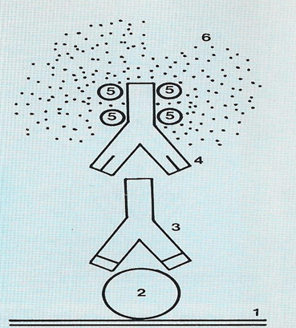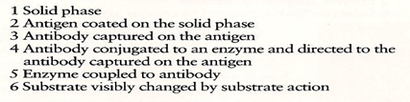

Types of ELISA Technique:
- Direct (Sandwich or double Ab) ELISA. {coated Ab Ag 2nd Ab anti-Ab linked with specific enzyme Substrate addition Color}
- Indirect ELISA. {coated Ag Ab (Serum) anti-Ab linked with specific enzyme Substrate addition Color}
- Competition ELISA. {coated Ab Ag (extract) + labeled-Ag linked with specific enzyme}
Competition method for detection of antigen by the ELISA method. Labelled antigen and extract from patient's material are added to a plate coated with antibody against the antigen. Labelled antigen causes a reaction; patient's unlabeled antigen can block the antibodies for the labeled antigen.
In the 1st figure the patient's antigen is absent, the labeled antigen gives the reaction; this is a negative test result. The colour reaction is strong.
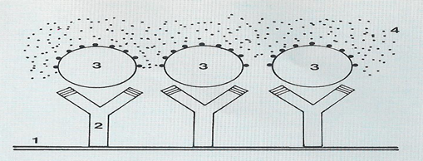
In the 2nd figure, positive test result. The patient's material contains antigen which attaches to the antibody, leaving little or no place for the labeled antigen. The colour reaction is weak or absent.
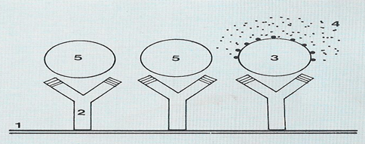
- Substrate
- Antibody
- Labelled antigen
- Coloure reaction
- Patient's antigen
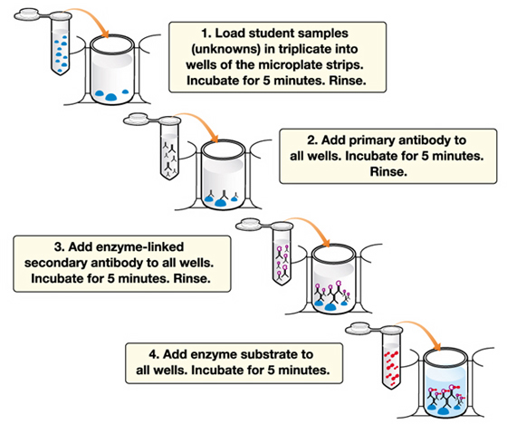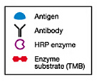
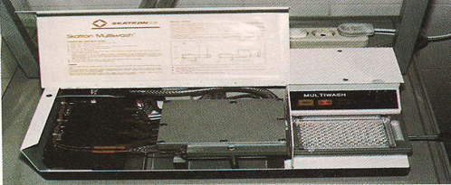
Washing System

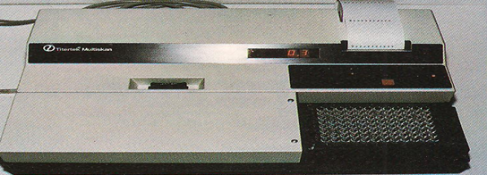
Reading System

