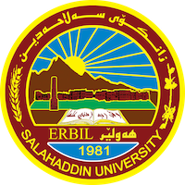

Academic Curriculum Vitae
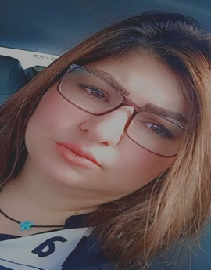

Personal Information:
Full Name:sozan talib mohammed
Academic Title: assistant teacher
Email: sozan.mohammed.su.edu.krd
Mobile:07509708851

Education:
- BA in Arabic Language, Sulaymaniyah University,2009.
- MA in Arabic Language,College of Education, ibnRush,2012.
- PhD student in Arabic language at the facuity of Languages, Salahaddin University.

Employment:
- Start date / 10/23/2009
- At Garmian University - Faculty of Arts Khanaqin - Department of Arabic Language
- Currently a teacher at Salahaddin University / College of Education, Shaqlawa, with the title of Teaching Assistant

Qualifications
- completed a teaching methods course in 2013
- English Language Course / Language Center / Salahaddin University (2023).

Teaching experience:
- have been teaching in the Department of Arabic Language / College of Education - Shaqlawa since 2014 and until now I have studied many subjects with the supervision of many undergraduate students
- I was teaching at Garmian University for one year
- I was a lecturer at Knowledge University 2015/2016

Research and publications
- Published research / master's thesis entitled (Semantic research in Baghdad University Letters and Dissertations)
- A published research titled Semantic Relationships, College of Arts, University of Baghdad, 2012
- A research published in Al-Rafidain Journal of Etiquette, University of Mosul, titled The Strategy of Non-Compulsory Guidance in the Poetry of Salih bin Abdul Quddus, Command and Prohibition as a Model 2023
- A research published in the Journal of Tikrit University for Human Sciences, titled The Strategy of Non-Compulsory Guidance in the Poetry of Salih bin Abdul Quddus, Wishing and Calling as a Model 2023

Conferences and courses attended
I participated in a wide range of local and international scientific conferences as well as scientific workshops

Funding and academic awards
- List any bursaries, scholarships, travel grants or other sources of funding that you were awarded for research projects or to attend meetings or conferences.

Professional memberships

Obtained a number of certificates of appreciation

Professional Social Network Accounts:

https://www.facebook.com/profile.php?id=100015000421062&mibextid=ZbWKwL
https://www.researchgate.net/profile/Sozan-Talib
https://www.linkedin.com/in/sozan-talib-6a877b122
https://currents.google.com/117860101821336110006?hl=en_GB
https://moodle.org/index.php?sesskey=XkDSID9gc5

