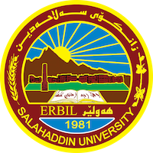
Academic Curriculum Vitae

Personal Information:
Full Name:srwa qadr esnaeel
Academic Title:lecture
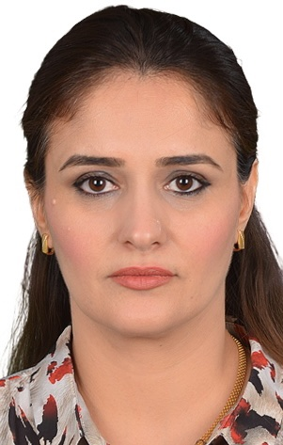

Email: (srwa.esmaeel1@su.edu.krd)
Mobile:07504681490

Education:
- Bachelor degree at in salahaddin university,college of arts (history department)in 2004
- Master of history in modern history (koya university 2010)

Employment:
Lecture in history department salahadin university college of arts.
Qualifications Teaching qualifications
- Word , excel ,access, power point. –
- Ihave. Language qualifications : Pre-Intermediate level
- Any professional qualification:
- Language English for Idwena center.

Teaching experience:
-I teached in all stage. of college of arts in salahadin university

Research and publications
كارو چالاكییەكانی بەرێوبەرایەتی شارەوانی هەولێر لەچەند بەڵگەنامەیەكدا ١٩٨٥-١٩٨٦

ئافرەت لەڕۆژنامەی هەولێر ١٩٥٠-١٩٥٣.

Conferences and courses attended
- کۆنفرانسی پرسی ئینتیما و گرفتەکانی نیشتمانسازی لە هەرێمی کوردستان
- کۆنفرانسی شوينەوار و کەلەپوری هەولێر
- هەولێر لە سەرچاوە ميژوویەکاندا - کۆنفرانسی

Funding and academic awards
- List any bursaries, scholarships, travel grants or other sources of funding that you were
- awarded for research projects or to attend meetings or conferences.

Professional memberships
- I membership in komallay mezhunusan. IFAD group
Professional Social Network Accounts:
Email Adress: srwa.esmaeel1@su.edu.krd -

It is also recommended to create an academic cover letter for your CV, for further information about the cover letter, please visit below link:
Google schooler: https://scholar.google.com/
LinkedIn: https://www.linkedin.com/jobs/
Facebook: https://www.facebook.com/
Research Gate: https://www.researchgate.net/

