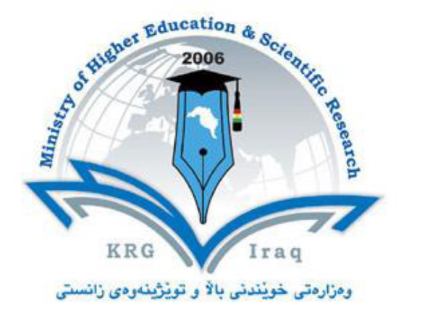

Department of Plant protection
College of Agricultural Engineering science
University of Salahaddin
Subject:
Course Book – (Class 4)
Lecturer's name Srwa Kareem Hamad
Academic Year: 2022/2023

Course Book
1. Course name | Insect Plant Interaction
2. Lecturer in charge | Srwa Karem Hamad
3. Department/ College | plant protection/ Agriculture
4. Contact | e-mail: e-mail: Srwa.hamad @su.krd.com
5. Time (in hours) per week | 2 hrs
6. Office hours | 8.30 -1.00 from Sunday to Thursday
7. Course code
8. Teacher's academic profile | Srwa Kareem Hamad, PhD. Obtained Doctor of Philosophy (PhD) in Biological control, graduated from Rhur university, Germany, 2021. My thesis title was “Host preference of aphid parasitoids in the Kurdistan region -Iraq”. I obtained my Master of Science in Medical entomology, Salahaddin University –Erbil 2012. Thesis title “Epidemological study of some human ectoparasites in Erbil -Iraq”. My bachelor’s degree (BSc) in Plant Protection, University of Salahaddin-Erbil, Iraq, 2007.
9. Keywords | Insect plant relaitonship, antagonistic, mutualistic, host plants, gall, chewing leaves, pollinator, phytophages
10. Course overview:
Plants represent an abundant resource and insect taxa that can exploit this have flourished in association with plant diversification .This course is designed for undergraduate students in the College of Engineering Agricultural Sciences. The course covers a range of topics related to the relationships herbivores and pollinators to their host plants and also indicates a diversity of types of phytophagy by insect. It aims to provide students with a comprehensive understanding of how insects make antagonistic and mutualistic relation with the host plants. This course begins with a consideration of the evolutionary interactions among insects and their plant hosts. Students then explore the different types of insects and mode of feeding and distinguished the harmful insects and beneficial insects. They learn about the advantages and disadvantage of insect and recognised them in the field.
. We then go on to describe the vast array of interactions of insects and living plants, which can be grouped into three categories, defined by the effects of the insects on the plants. Phytophagy is includes leaf chewing, sap sucking, seed predation, gall induction, and mining the living tissues of plants, Pollination is important to plant reproduction and involves mobile insects that transport pollen between conspecific plants or seeds to suitable germination sites. These interactions are mutualistic because the insects obtain food or some other resource from the plants that they service and Coevolution Reciprocal interactions over evolutionary time between phytophagous insects and their food plants, or between pollinating insects and the plants they pollinate, have been described as coevolution

11. Course objective:
To understand the relationships between the insects and their host plants as a source of food and shelter and also is to provide students with a thorough understanding of biology, natural history, population dynamic, natural enemies and diversity of insects affecting plant ecosystems.
12. Student's obligation
Students are important to attendance and punctuality in lectures and examination. Additionally, students should come prepared preparing reports about some important course subjects, writing an assignment on any field visiting, doing daily quiz, giving samples.

13. Forms of teaching
Effective teaching is essential for providing students with a well-rounded and interesting education. To give students a well-rounded learning experience, we will use the PowerPoint presentations to offer a summary of each course and data show presentations in the form of PowerPoint slides. The lecturer will give extra in-depth information through narration, while the slides will define the process of each lesson and also using a whiteboard is necessary for teaching and explaining different topics and images. Additional, giving hand note.
14. Assessment scheme
Breakdown of overall assessment and examination
40 marks for theoretical part.

The marks are divided as follow:
15 marks for 1st monthly exam and 15marks for 2nd
4 marks for daily quiz
4 for reports
2 for class conversation
.
‌
15. Student learning outcome:
In this course the students will learn strongly emphasises the relationships between plant and insects and provides the theoretical bases for these relations. Topics covered are the biology and behaviour of insects (Herbivotus and pollinators); the damage caused by insects; district organisations; extension; insect control practice. Also Recognize, evaluate, and articulate the advantages and disadvantages of the specialisations insects on the host plants.
16. Course Reading List and References‌:

1.Price,et,al.,(2011),Insect,Ecology:,Behavior,,PolpulaFons,,CommuniFes.,Cambridge,U.,P.,
2. Wheat,et,al.,(2007)2The,geneFc,basis,of,a, plant–insect,coevoluFonary,key, innovaFon.,PNAS,104,,20 427–20 431,

17. The Topics: |  | Lecturer's name
Lecture 1: Insect-Plant Interactions Lecturer's name  Lecture 2: Antagonistic interactions (+/-) and Mutualistic interactions (+/+) 1  Lecture 3: Leaf chewing insects 2  Lecture 4 : Methods of limiting herbivore populations 3  Lecture 5: Plant defenses 4  Lecture 6: Exam 5  Lecture 6: Trophic specialisation 6  Lecture 7: Gall Forming Insects 7  Lecture 8: pollination 8  Lecture 9: Host-plant selection: how to find a host plant 9  Lecture 10: A standardized host-plant selection sequence 10  Lecture 11:Environmental factors causing changes in host-plant preference  Lecture 12: second exam |  | Dr. Srwa kareem Hamad
19. Examinations:
- Define the followings.
- Explain the …..
- Mention the damage caused by this specimen?
- What are the difference between the specimens?
- What are pollination methods?
- Write the types of galls, miner, pollinations, leaf chewing insects .

