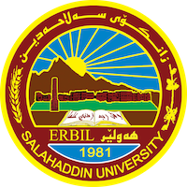
Academic Curriculum Vitae

personal Information: 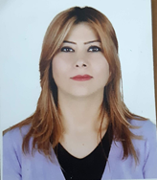
Full Name: Srwa Sofi Hasan
Academic Title: assistant lecturer
Email: (university email) srwa.hasan@su.edu.krd
Mobile: +964 07504623820

Education:
- Master degree in law/ The Right of an Adequate Standard of Living (Comparative Study between International conventions and Iraqi Constitutions).

- Bachelor of Law and Politics / Law Department/ Salahadin University 2000-2004

- High Scientific Diploma.
Employment:
- Assistant Lecturer from 2013 up to now, College of Law and Politics / Salahaddin University
- • I was employed as a researcher in 2004 at the College of Law / Salahaddin University
Qualifications
- MS Word, MS PowerPoint (Excellent) MS Excel (Very Good).
- Outlook (very good) Internet (very good).
- Computer Proficiency Certificate at Salahaddin University
- English Language proficiency certificate at Salahaddin University
- Kurdish: Mother Tongue - English: very good. -Arabic: Excellent

Teaching experience:
1. I have taught the subject of the Labor and Social Security Law to the third stage students.
2. now I taught the subject of human rights law to first stage students.
3. supervision two research of fifth stage student :
- The right to vote in Iraqi electoral legislation
- Public health offenses in the amended Iraqi Penal law No. 111 of 1969
Research and publications
The right of prisoner in correspondence (comparative study)

Professional memberships
-From 2004 up to now is a member of Kurdistan Jurists Union.
-member at Kurdistan teachers Union.

Professional Social Network Accounts:

-https://scholar.google.com/citations?hl=en&user=Lww9cBsAAAAJ
-https://www.researchgate.net/profile/Srwa-Hasan-3

