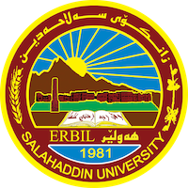
Academic Curriculum Vitae
Personal Information:
Full Name: srwa Jaafar hussein
Academic Title: assistant lecturer
Email: (srwa.hussein@su.edu.krd)
Mobile:07504488772

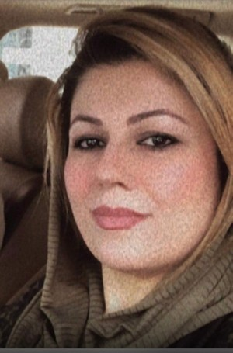

Education:
- Bachelor in Education and Psychology (Sallahaddin University 2009-2010).
- Master's degree in Psychology (Sallahaddin University 2017-2018 ).
- Dibloma in mathmatic department( a central institute 1995-1996).

Employment:
-2002 Teacher in a primary school.
- 2010. Teacher in a secondary school.
-2010 Assistant Researcher, College of Education.
-2019 Assistant Lecturer, College of Education.
Qualifications
- Teaching qualifications .
-IT qualifications; very good knowledge of computer systems and software: MS Windows , Network- Internet - Social Media. Statistical analysis software package - SPSS .
- English language efficiency qualifications
Teaching experience:
- psychological measurement and evaluation , educational psychology,problem solving ,Educational Assessment,Developmental psychology ,Childhood and adolescence psychology.learning theories.
- Educational Researches for Undergraduate and Postgraduate Students .

Research and publications
Measuring self-awareness among university youth in Erbil Governorate -
(Constructing and Application) journal of raparin university
-Risk-taking behavior and its relationship to self-confidence among students at Salahaddin University. journal of raparin university

Conferences and courses attended
- 2018; Participants in the course of teaching methods. Sallahaddin University - Erbil – Iraq.
-2023 Joint Symposium between Department of Media and Department of Sociology, College of Arts, Salahaddin University.
-2023 Awarding credits for the best graduation research and ideas for students of Salahaddin University.
-2022 5th Conference of the College of Islamic Sciences (Dignity of the Family in the Perspectives of Religion, Law and Economics).
-2022 cyber harassment and sexual exploitation(chase)
- Participants of module Conference of Colleges of Education department of computer.
- .

Professional Social Network Accounts:

https://www.researchgate.net/profile/Srwa-Jaafar
https://scholar.google.com/citations?view_op=new_profile&hl=en&imq=srwa+hussein
https://orcid.org/0009-0002-4110-0924

