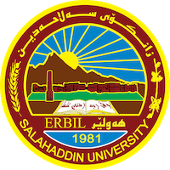
Academic Curriculum Vitae
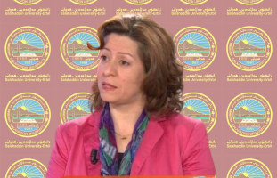
Personal Information:
Full Name: Srwa Ashad Sabir
Academic Title: lecture
Email: srwa.sabir@su.edu.krd
Mobile: 07508221058

Education:
- Graduate in: 1991
- Master degree : 1999
- Phd: 2005

Employment:

Qualifications
- 33 years experience of teaching undergraduate in college of arts
- Computer programs (word-excel-powerpoint-access)
- Language qualifications (certificate of English course ,speaking and writing)
- ) excellent in Arabic languge)
Teaching experience:
- I have 25 years experience of teaching undergraduate in college of arts
- Courses, trainings, lab supervision, etc.,

Research and publications
Conferences and courses attended

Funding and academic awards
- List any bursaries, scholarships, travel grants or other sources of funding that you were awarded for research projects or to attend meetings or conferences.

Professional memberships
Professional Social Network Accounts:

