you have trouble viewing this email, read the online version.

15 MINUTE REMINDER
JOIN WEBINAR

September 19, 2022

12:30 p.m. - 3:00 p.m. (ET)

Almost time to log on!
You recently registered for C&EN's Talented 12 Symposium, sponsored by Thermo Fisher Scientific. Don't forget to join us for this live event now, before the scheduled start time.
Click here to join webinar

Presented by:

Want to receive a curated dose of chemistry news, distilled to your inbox? Sign up for the latest in chemistry news from C&EN. Click here to subscribe.

Copyright © 2022 American Chemical Society
1155 Sixteenth Street NW | Washington, DC 20036
This email was sent to suad.mohiaedin@su.edu.krd because it relates to topics in which you expressed an interest
or ACS Publications services you have used.
Unfollow "C&EN Webinars" updates.
Customize your preferences or stop all emails from ACS Publications.
Worth remembering: Any actions taken only relate to the email address stated above.
If you forward this email you may be sharing your personal information with others.
Changes will not impact account, service, or bill-related communications.
ACS Privacy Policy

Summary
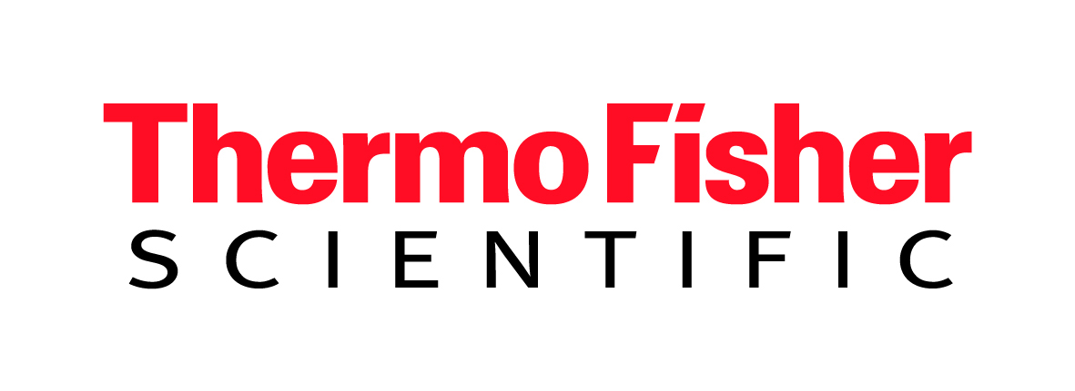
If your e-mail address is not being recognized, please click here to complete registration and access the webinar.
C&EN’s Talented 12 program celebrates young chemists working in academia, industry, and government who are just beginning to put their innovative and transformative ideas into practice. This special three-day event features remarks from keynote speakers. Don’t miss these exciting TED-style talks by the rising stars in our 2022 class in which they lay out their vision for the future of their fields.
Part 1: Opening Remarks: Thermo Fisher Scientific; Keynote: Zhenan Bao; T12 Speakers: Alex Komor Base-Editing Ace, David Romney Enzyme Architect, and Maher El-Kady Graphene Vanguard
Part 2: T12 Speakers: Abigal Dommer Molecular Modeler, Bichlien Nguyen IT Innovator, Adeyemi Adeleye Environmental Chemist, and Cate Levey Climate-Tech Champion
Part 3: Remarks and Introduction: Carolyn Bertozzi, ACS Central Science Editor-in-Chief; Speaker: Professor Dame Clare P. Grey, 2022 ACS Central Science Disruptors and Innovators Prize Lecture
Part 4: Closing Remarks: Thermo Fisher Scientific; Keynote: Ben L. Feringa; T12 Speakers: Ming Joo Koh Organic Chemist, Weixue Wang Assay Inventor, Gabe Gomes Machine Learning Maestro, Helen Tran Polymer Designer
Fill out and submit the form to attend this virtual symposium, which will cover a range of exciting, cutting-edge research.
View the full list of speakers & agenda
Speakers
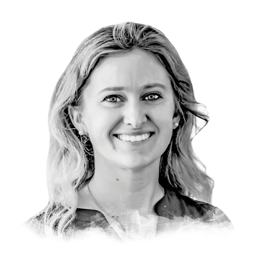
Alexis Komor
University of California San Diego
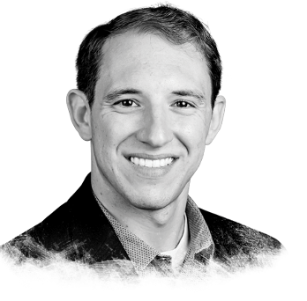
David Romney
Aralez Bio
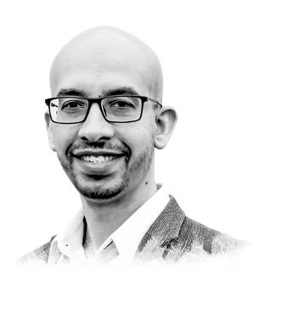
Maher El-Kady
Nanotech Energy and University of California, Los Angeles
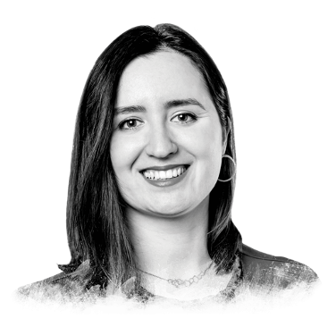
Alexandra Velian
University of Washington

